Year 8 English

The Sonnet
Student Anthology



Year 8 Module 1: The Sonnet
Contents

Key vocabulary 2
Sonnet timeline 4
Subject terminology 5
The Petrarchan sonnet vs the Shakespearean sonnet 6
Reading strategy: how to read a sonnet 7
Writing strategy: how to write about sonnets 8

The sonnets
‘Sonnet’ Billy Collins 11
‘Sonnet 101’ Petrarch 12
‘Sonnet 227’ Petrarch 13
‘Sonnet 18’ William Shakespeare 14
‘Sonnet 130’ William Shakespeare 15
‘Sonnet 1: Loving in Truth’ Sir Philip Sydney 16
‘To all those happy blessings which ye have’ Edmund Spenser 17
‘Death be not proud’ (Holy Sonnet 10) John Donne 18
‘Sonnet 19: when I consider how my light is spent’ John Milton 19
‘Sonnet written at the close of spring’ Charlotte Smith 20
‘Sonnet 24’ Elizabeth Barrett Browning 21
‘London 1802’ William Wordsworth 22
‘Scorn not the Sonnet’ William Wordsworth 23
‘Bright Star’ John Keats 24
‘Ozymandias’ Percy Bysshe Shelley 25
‘After Death’ Christina Rosetti 26
‘The Pity of it’ Thomas Hardy 27
‘I Shall Forget You Presently’ Edna St Vincent Millay 28
‘The Waste Land’ (lines 235-48) T. S Eliot 29
‘Carrion Comfort’ Gerrard Manley Hopkins 30
‘Anthem for Doomed Youth’ Wilfred Owen 31
‘The Poet as Hero’ Siegfried Sassoon 32
‘Yet do I Marvel’ Countee Cullen 33
‘The Lynching’ Claude McKay 34
‘Anne Hathaway’ Carol Ann Duffy 35
‘The Trick’ Imtiaz Dharker 36
‘Are all the breakups in your poems real?’ Aimee Nezhukumatathil 37
‘Incandescent War Poem Sonnet’ Bernadette Mayer 38

Key vocabulary

Say it! Spell it! Know it!


Word | Say it | Spell it | Know it (definition & example)
Romantic (adj)  Romance (n)  Old English romaunt ‘chivalry’ | roh-man-tik | ro-man-tic | It’s a bit like a close loving relationship.  After dinner, they took a romantic stroll by the sea.  It’s a bit like having a lot of ideas that are not related to real life.  She regarded his plans to quit his job and write a novel as romantic nonsense.
Enduring (adj)  Endure (v)  Latin durus ‘hard’ | En-dyoor-ing | en-dur-ing | It’s a bit like when something lasts for a long time.  I shall be left with enduring memories of the time I spent in Italy.
Mortality (n)  Mortal (adj)  Latin mortalis ‘mortal’ | mor-tal-it-ee | mor-tal-i-ty | It’s a bit like knowing we won’t live forever.  Her death made him more aware of his own mortality.
Humanity (n)  Humane (adj)  Latin humanus ‘human’ | hyoo-man-i-tee | hu-man-i-ty | It’s a bit like when you think about people in general.  The massacre was a crime against humanity.
Morality (n)  Moral (adj)  Latin moralis ‘manners’ | muh-ral-i-tee | mo-ral-i-ty | It’s a bit like knowing what is right, honest and acceptable.  I have to question the morality of forcing poor people to pay for their medical treatment.
Cognitive (adj)  dissonance (n)  Latin cognitivus ‘know’  Latin dissonantia’ ‘disagreeing in sound’ | kog-ni-tiv  dis-uh-nuns | cog-ni-tive  dis-so-nance | It’s a bit like when you have two different beliefs.  He suffered from cognitive dissonance as he wanted to fight for his country but knew that war was wrong.
Abandonment (n)  Abandon (v)  Old French bandon ‘control’ | Uh-ban-duhn-muhnt | a-ban-don-ment | It’s a bit like leaving someone or something, or stopping something, usually forever.  The abandonment of the island followed nuclear tests in the area
Revulsion (n)  Latin re ‘back’ vellere ‘pull’ | ri-vuhl-shun | re-vul-sion | It’s a bit like a strong feeling that something is extremely unpleasant.  He expressed his revulsion at whale hunting.
Resentment (n)  Resent (v)  French resentir ‘feel pain’ | ri-zent-ment | re-sent-ment | It’s a bit like a feeling of anger because you have been forced to accept something that you do not like.  The decision to shorten the school holidays caused resentment among both students and teachers.
Satirical (adj)  Satire (n)  Latin satira ‘poetic medley’ | suh-tir-i-kal | sa-tir-i-cal | It’s a bit like criticising people or ideas in a funny way.  His speech was a satirical attack on the government.
Admiration (n)  Admire (v)  Latin mirari ‘wonder’ | Ad-muh-rey-shuhn | Ad-mir-a-tion | It’s a bit like the feeling of liking someone or something.  I’ve got a lot of admiration for people who do that sort of work.
Mock (v)  Mockery (n)  French mocquer ‘deride’ | mok | mock | It’s a bit like making something appear stupid or not useful.  The wind mocked their attempts to reach the shore by pushing the boat further out to sea.
Idolise (v)  Idol (n)  Greek eidos ‘form,shape’ | ahyd-l-ahyz | i-dol-ise | It’s a bit like to admire and respect someone very much, often too much.  The star athlete realised that many young people had begun to idolise him for his talents.
Cherished (adj)  Cherish (v)  French cher ‘dear’ | Cher-ish-d | Cher-ished | It’s a bit like caring for something or someone who is important to you.  Her most cherished possession was a letter from her grandfather.
Protest (v)  Protest (n)  Latin pro ‘forth’ testari ‘assert’ | proh-test | pro-test | It’s a bit like when you show you don’t agree with something.  A big crowd of demonstrators were there to protest cuts in health spending.

Literary Timeline
How does this unit represent the key literary movements?

Greek Mythology


Norse mythology & Viking raids

Medieval period


The Renaissance

The Enlightenment


Romanticism

The Victorian era


Modernism
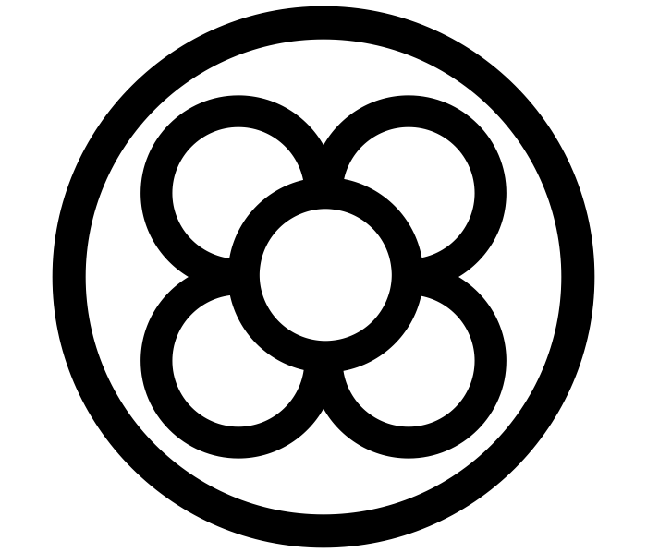
Contemporary


The Sonnet

Originating in the medieval period during the thirteenth century, the sonnet has gone on to transcend all subsequent literary periods. In this unit, students will get a firm grounding of its conception and early use, but also chart its development, both stylistically and thematically, across the age


Subject Terminology
What is in the poet’s toolkit?
Poetic devices | Definition
Sonnet | A sonnet is a fourteen-line poem with a fixed rhyme scheme. Often, sonnets use iambic pentameter: five sets of unstressed syllables followed by stressed syllables for a ten-syllable line.
Petrarchan sonnet | Divides the 14 lines into two sections: an eight-line stanza (octave) rhyming ABBAABBA, and a six-line stanza (sestet) rhyming CDCDCD or CDECDE
Shakespearean sonnet | The variation of the sonnet form that Shakespeare used—comprised of three quatrains and a concluding couplet, rhyming abab cdcd efef gg
Octave | An octave is a verse form consisting of eight lines of iambic pentameter
Sestet | A sestet is the name given to the second division of an Italian sonnet comprised of six lines
Quatrain | A quatrain features four lines of verse.
Volta | In poetry, the volta, or turn, is a rhetorical shift or dramatic change in thought and/or emotion
Couplet | A pair of successive lines of verse, typically rhyming and of the same length
Syllable | A unit of pronunciation having one vowel sound, with or without surrounding consonants, forming the whole or a part of a word
Hendecasyllable | A line of eleven syllables
Iambic Pentameter | A line of verse with five metrical feet, each consisting of one short (or unstressed) syllable followed by one long (or stressed) syllable
Meter | Meter is the basic rhythmic structure of a line within a poem or poetic work. Meter functions as a means of imposing a specific number of syllables and emphasis when it comes to a line of poetry that adds to its musicality
Assonance | The repetition of the same or similar vowel sounds within words, phrases, or sentences.
Consonance | A literary device that refers to the repetition of the same consonant sounds in a line of text.
Plosive | Denoting a consonant that is produced by stopping the airflow using the lips, teeth, or palate, followed by a sudden release of air. The basic plosives in English are t, k, and p (voiceless) and d, g, and b (voiced).
Fricative | Denoting a type of consonant made by the friction of breath in a narrow opening, producing a turbulent air flow. e.g. f and th
Symbolism | A symbol is something that stands for or suggests something else; it represents something beyond literal meaning. In literature, a symbol can be a word, object, action, character, or concept that embodies and evokes a range of additional meaning and significance.
Metaphor | A metaphor is a figure of speech that describes an object or action in a way that isn't literally true, but helps explain an idea or make a comparison. ... A metaphor states that one thing is another thing.
Extended metaphor | An extended metaphor is a version of metaphor that extends over the course of multiple lines, paragraphs, or stanzas of prose or poetry.

The Petrarchan Sonnet vs The Shakespearean Sonnet
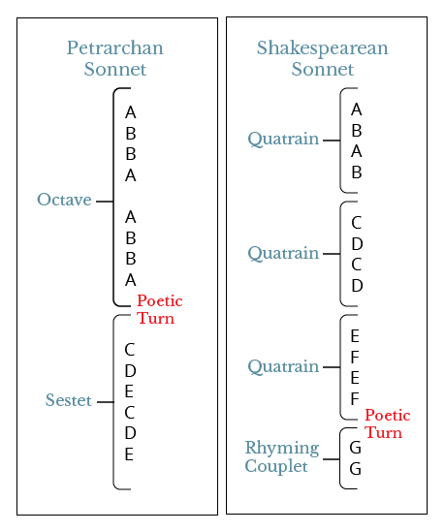
Petrarchan Sonnet
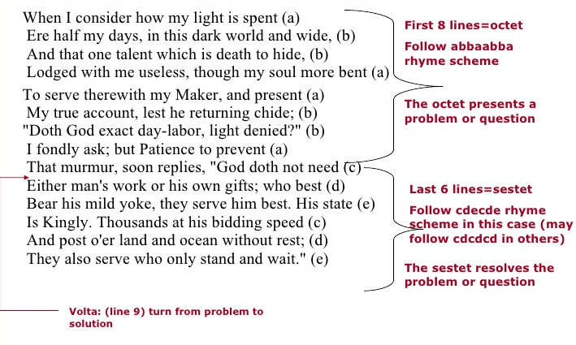
Shakespearean Sonnet
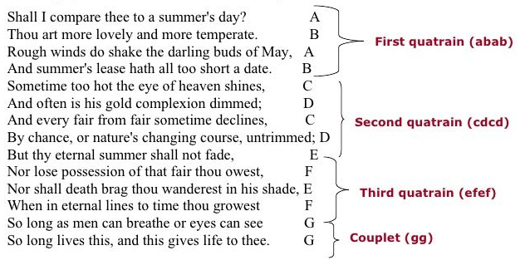

Reading strategy: how to read a sonnet

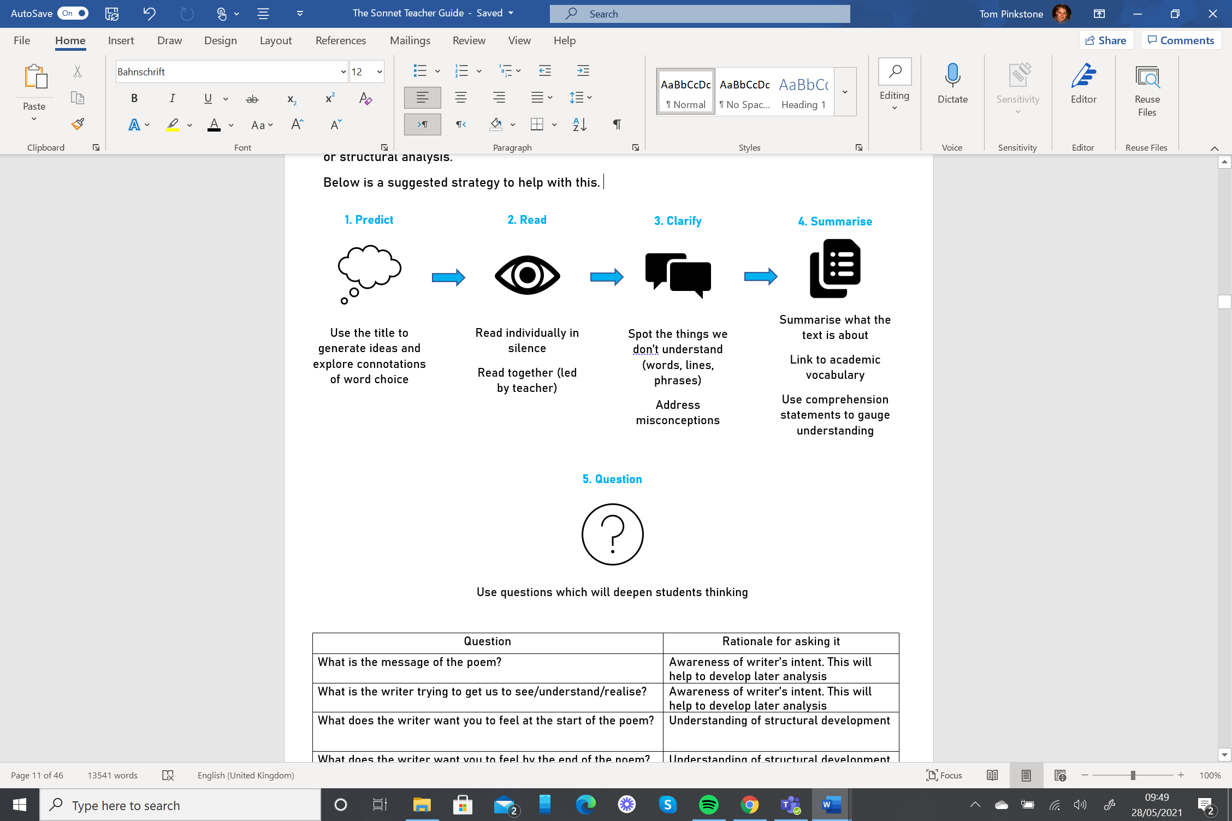
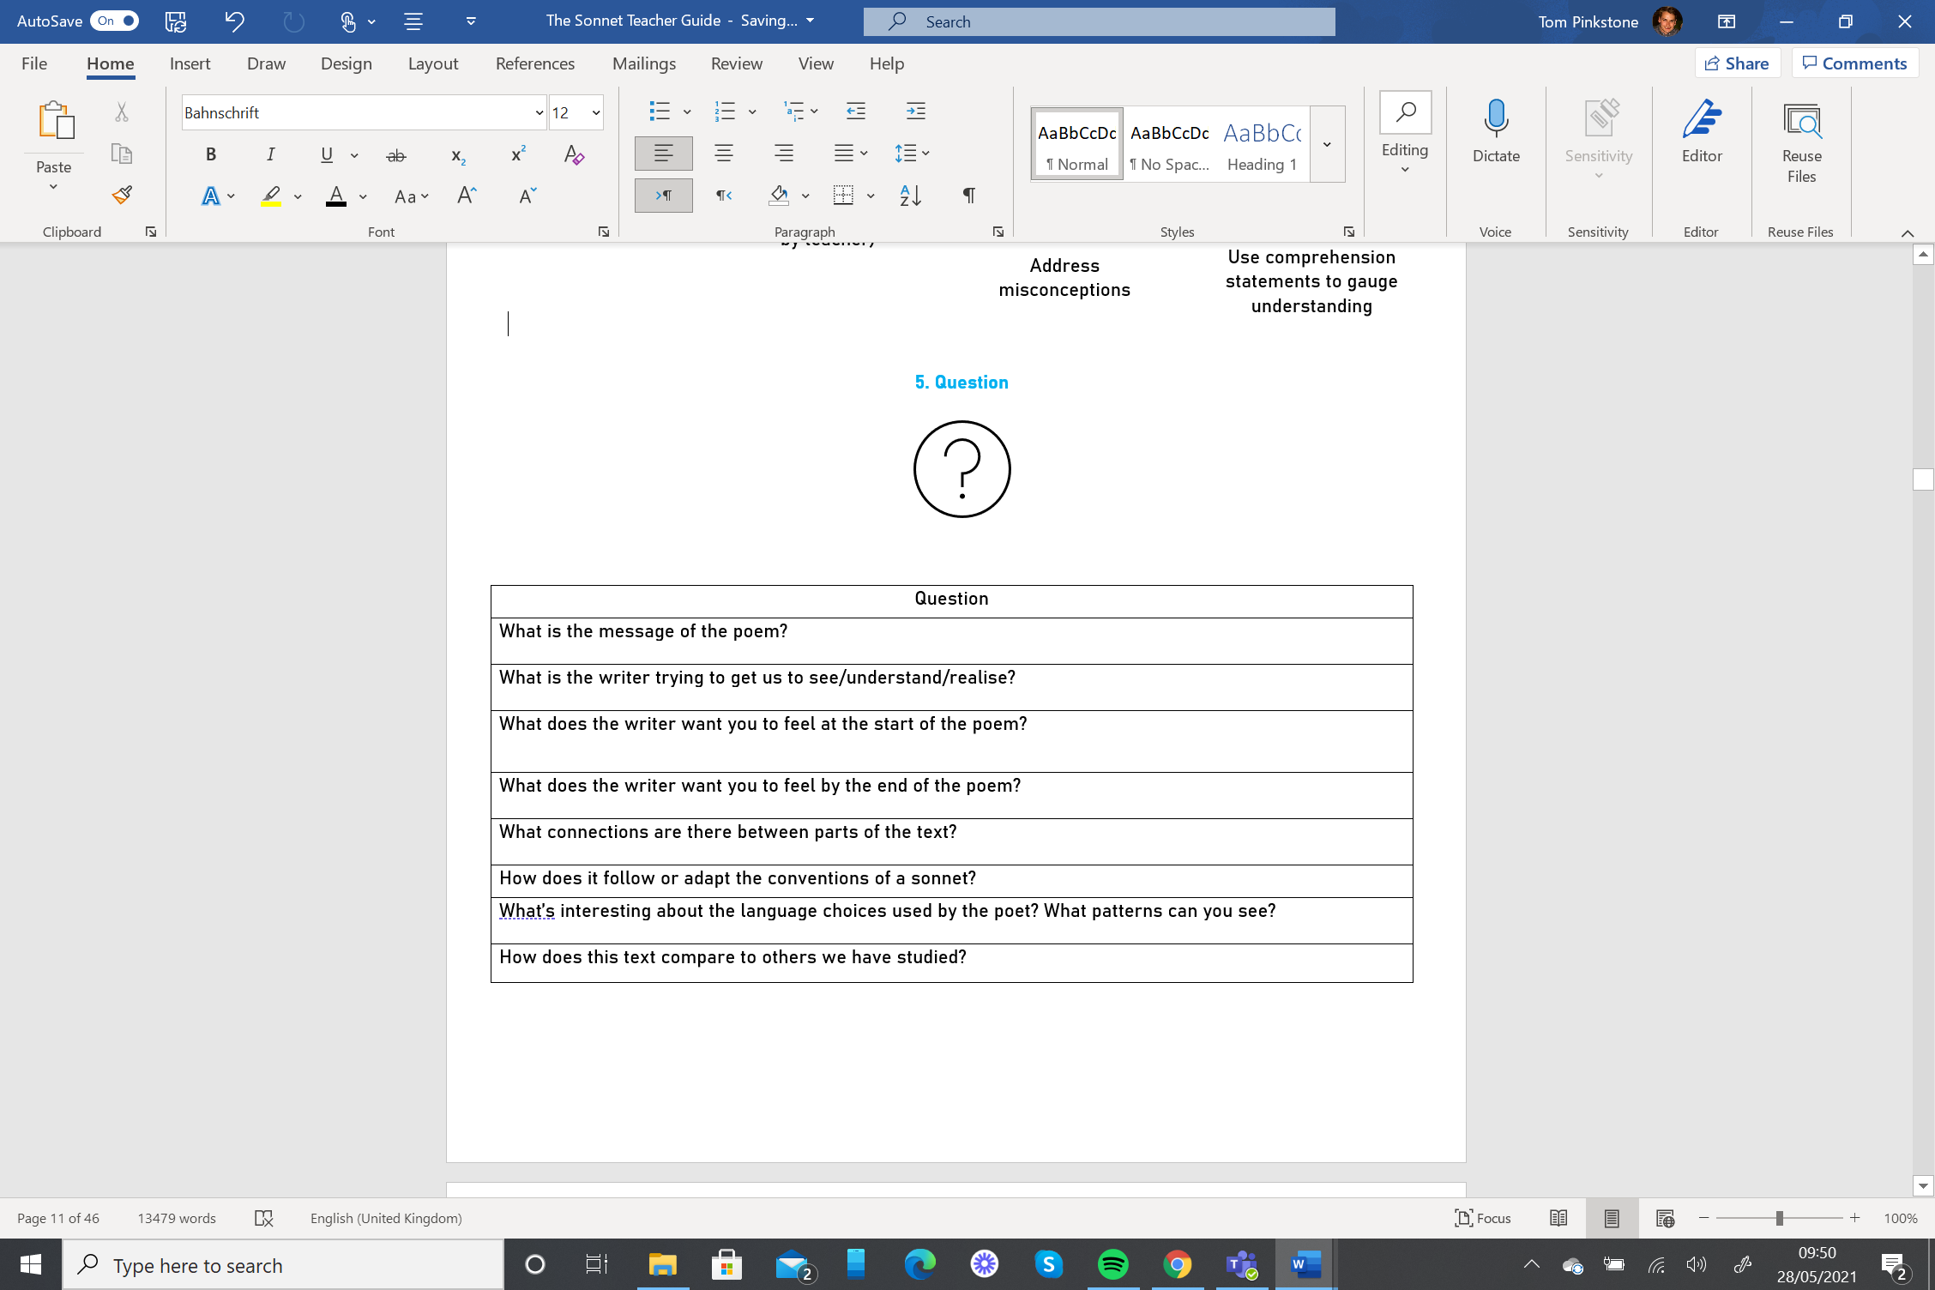

Writing strategy: how to write about sonnets
Using powerful and grammatically impactful sentences
The Deconstructed Essay
Overview video on National College
Year 7
Sentences 1, 3 and 4 should be taught explicitly during Year 7 and practised to the point of mastery.
Sentence 1. Construct personal viewpoints in the form of thesis statements
Teach | Model | Write
One sentence to answer the question with two different viewpoints  Begin with a subordinating conjunction: Whereas, Despite, Although, At first glance, Because  Use a comma to pivot between viewpoints  Use at least three adjectives (and appositives) | Think of the surface meaning and then a deeper meaning which is less obvious and more interesting. (At first glance)  Acknowledge two or more contrasting interpretations (Although, Despite, Whereas)  Acknowledge a causal link between two ideas (Because)  Select adjectives + appositives from the excellent epithets.  At first glance Wordsworth’s ‘London 1802’ is about the speaker’s admiration of the poet John Milton, but at a deeper level he uses this sonnet to criticise the lack of morality in English society.  Although ‘Sonnet 18’ is romantic and idealised, Sonnet 130 is satirical. | At first glance [text] is about _______, but at a deeper level ________.  Although [the text] appears to be about _________, it is also referring to _________.  Because [first idea], [second idea.]  Despite [character + epithet], they can also be seen as [character + epithet.]
Sentence 2 - Focus on the effects of the whole text and controlling ideas – might best be taught later on (we have recommended that it be given particular attention in Year 9. However, when students come to reconstruct the notion of controlling ideas, they should be writing this immediately after their thesis statement.
Sentence 3. Use the thesis statement to create topic sentences
Teach | Model | Write
Each epithet will become the main point of a topic sentence.  Adjectives must be transformed into noun phrases. E.g., Implacable becomes implacability  Noun phrase must be followed by a verb.  The rest of the sentence must link to the question being answered. | Think about the epithets used in the thesis statement to consider how each can be turned into a noun to be explored in a separate topic sentence.  Consider how each noun phrase links to the question being answered.  Shakespeare’s use of satire implies he is mocking the way sonnet are often written. | [character, theme, or writer] + [change adjective to noun] + [verb] + [link back to question].

Sentence 4. Select and embed relevant textual detail
Teach | Model | Write
Select evidence that relates to the point being made in topic sentences  Use short, precise parts of the text (not whole lines)  Place the quote within a sentence  Place the quote inside single quotation marks  Reference what the quote is suggesting | Select a part of the text which is interesting and that you’ll have something that isn’t obvious to say about it.  Embed “quotations” into sentences.  Use a comma before beginning a quotation of sentence length.  In Shakespeare’s Sonnet 18, the speaker compares their beloved to a “summer’s day”. | The writer refers to ________ as ‘________’ and ‘______’.  The writer compares ________ to ‘_______’.  When the text states, ‘_______’ it reminds the reader of ________.  [Character] says, “__________,” conveying _______.  [Writer] repeats, “__________,” because _______.

Year 8
Sentences 5, 6 and 7 should be taught explicitly during Year 7 and practised to the point of mastery. Sentences 1, 3 and 4 should be integrated and practised alongside the new essay sentences.
Sentence 5. Analyse a writer’s use of language, structure and form
Teach | Model | Write
Use terminology accurately  Think about effect not meaning | Why might the writer have used this specific word or phrase?  Is it part of a pattern of similar words?  What effect does it create?  Don’t just repeat a dictionary definition.  (Ozymandias) This adaptation of the Petrarchan sonnet form conveys to the reader a sense of defiance to represent the corruption of humanity through abuses of power.  (Ozymandias) Shelley uses words such as decay and bare to depict just how powerless this once-mighty pharaoh has become. There is absolutely nothing left. The leader, much like his land, and much like the broken statue depicting him, has fallen. | This [literary device] conveys a sense of ______.  [Writer] uses [device] to depict/portray/suggest _____.  Furthermore, the word ‘______’ evokes an image/atmosphere/feeling of _____ .

Sentence 6. Evaluate the writer’s intent
Teach | Model | Write
Use of adverb opener with a comma to follow  Reference to theme or literary concept | Consider why the writer might have written the text.  What message might they want the reader to think about?  (Anthem for Doomed Youth) Thus, Owen is drawing the reader’s attention to his revulsion of the ceremony that surrounds war and protests accepted symbols of nationalism. | Thus, [writer] is drawing the reader’s attention to______.  Hence, [writer] is challenging ideas about______.  Consequently, [writer] is highlighting_____.

Sentence 7. Compare texts in relation to literary concepts, ideas and methods
Teach | Model | Write
Identify a clear similarity or difference between the two poems  Use comparative discourse markers  Use commas after comparative discourse markers  Reference to theme or literary concept | Think of interesting similarities and differences in relation to ideas, concepts or methods between the novels studied.  Resentment is equally significant in both texts. Nonetheless, in ‘ Yet I do marvel’ Cullen directs this towards a God, who allows the human suffering, whereas in ‘The Lynching’ McKay directs it to humanity itself and how their actions create the death of Christ himself. | Both texts explore the concept of ______ .  ________ is equally significant in both texts. In [Julius Caesar] it is conveyed through ______, whereas in [MLK’s speech] it is portrayed as ______  Conversely, in [Julius Caesar, Shakespeare] presents [focus of the question] as _______.  Similarly, in [Paradise Lost, Milton] _________.  Likewise, in [text] ______.

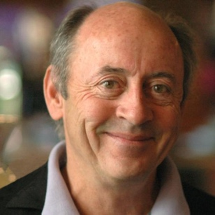
The Sonnets
Sonnet
Billy Collins, 1941-

All we need is fourteen lines, well, thirteen now, and after this one just a dozen
to launch a little ship on love's storm-tossed seas, then only ten more left like rows of beans.
How easily it goes unless you get Elizabethan
and insist the iambic bongos must be played
and rhymes positioned at the ends of lines,
one for every station of the cross.
But hang on here wile we make the turn
into the final six where all will be resolved,
where longing and heartache will find an end, where Laura will tell Petrarch to put down his pen, take off those crazy medieval tights,
blow out the lights, and come at last to bed.


Sonnet 101
Petrarch 1304-1374

Lasso, ben so che dolorose prede
di noi fa quella ch'a nullo huom perdona,
et che rapidamente n'abandona
il mondo, et picciol tempo ne tien fede;
veggio a molto languir poca mercede,
et già l'ultimo dí nel cor mi tuona:
per tutto questo Amor non mi spregiona,
che l'usato tributo agli occhi chiede.
So come i dí, come i momenti et l'ore,
ne portan gli anni; et non ricevo inganno,
ma forza assai maggior che d'arti maghe.
La voglia et la ragion combattuto ànno
sette et sette anni; et vincerà il migliore,
s'anime son qua giú del ben presaghe.

Sonnet 227

Petrarch 1304-1374

Breeze, blowing that blonde curling hair,
stirring it, and being softly stirred in turn,
scattering that sweet gold about, then
gathering it, in a lovely knot of curls again,
you linger around bright eyes whose loving sting
pierces me so, till I feel it and weep,
and I wander searching for my treasure,
like a creature that often shies and kicks:

now I seem to find her, now I realise
she’s far away, now I’m comforted, now despair,
now longing for her, now truly seeing her.
Happy air, remain here with your
living rays: and you, clear running stream,
why can’t I exchange my path for yours?


Sonnet 18
William Shakespeare 1564-1616

Shall I compare thee to a summer’s day?
Thou art more lovely and more temperate.
Rough winds do shake the darling buds of May,
And summer’s lease hath all too short a date.
Sometime too hot the eye of heaven shines,
And often is his gold complexion dimmed;
And every fair from fair sometime declines,
By chance, or nature’s changing course, untrimmed;
But thy eternal summer shall not fade,
Nor lose possession of that fair thou ow’st,
Nor shall death brag thou wand'rest in his shade,
When in eternal lines to Time thou grow'st.
So long as men can breathe, or eyes can see,
So long lives this, and this gives life to thee.

Sonnet 130
William Shakespeare 1564-1616

My mistress' eyes are nothing like the sun;
Coral is far more red than her lips' red;
If snow be white, why then her breasts are dun;
If hairs be wires, black wires grow on her head.
I have seen roses damask'd, red and white,
But no such roses see I in her cheeks;
And in some perfumes is there more delight
Than in the breath that from my mistress reeks.
I love to hear her speak, yet well I know
That music hath a far more pleasing sound;
I grant I never saw a goddess go;
My mistress, when she walks, treads on the ground:
And yet, by heaven, I think my love as rare
As any she belied with false compare.


Sonnet 1: Loving in truth
Sir Philip Sydney 1554-1586

Loving in truth, and fain in verse my love to show,
That she, dear she, might take some pleasure of my pain,—
Pleasure might cause her read, reading might make her know,
Knowledge might pity win, and pity grace obtain,—
I sought fit words to paint the blackest face of woe;
Studying inventions fine her wits to entertain,
Oft turning others' leaves, to see if thence would flow
Some fresh and fruitful showers upon my sunburn'd brain.
But words came halting forth, wanting invention's stay;
Invention, Nature's child, fled step-dame Study's blows;
And others' feet still seem'd but strangers in my way.
Thus great with child to speak and helpless in my throes,
Biting my truant pen, beating myself for spite,
"Fool," said my Muse to me, "look in thy heart, and write.

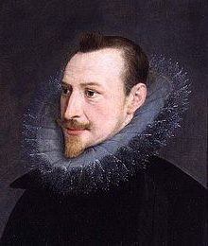
To all those happy blessings which ye have
Edmund Spencer 1552-1599

To all those happy blessings which ye have,
With plenteous hand by heaven upon you thrown:
This one disparagement they to you gave,
That ye your love lent to so meane a one.
Yee whose high worths surpassing paragon,
Could not on earth have found one fit for mate,
Ne but in heaven matchable to none,
Why did ye stoup unto so lowly state.
But ye thereby much greater glory gate,
Then had ye sorted with a princes pere:
For now your light doth more it selfe dilate,
And in my darknesse greater doth appeare.
Yet since your light hath once enlumind me,
With my reflex yours shall encreased be.


Death be not proud (Holy Sonnet 10)
John Donne 1572-1631

Death, be not proud, though some have called thee
Mighty and dreadful, for thou are not so;
For those whom thou think'st thou dost overthrow
Die not, poor Death, nor yet canst thou kill me.
From rest and sleep, which but thy pictures be,
Much pleasure; then from thee much more must flow,
And soonest our best men with thee do go,
Rest of their bones, and soul's delivery.
Thou'art slave to fate, chance, kings, and desperate men,
And dost with poison, war, and sickness dwell,
And poppy'or charms can make us sleep as well
And better than thy stroke; why swell'st thou then?
One short sleep past, we wake eternally,
And death shall be no more; Death, thou shalt die.

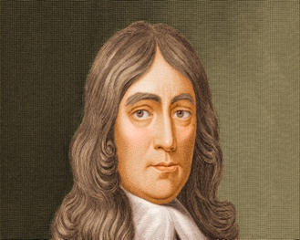
Sonnet 19: When I consider how my light is spent
John Milton 1608-1674

When I consider how my light is spent,
Ere half my days, in this dark world and wide,
And that one Talent which is death to hide
Lodged with me useless, though my Soul more bent
To serve therewith my Maker, and present
My true account, lest he returning chide;
“Doth God exact day-labour, light denied?”
I fondly ask. But patience, to prevent
That murmur, soon replies, “God doth not need
Either man’s work or his own gifts; who best
Bear his mild yoke, they serve him best. His state
Is Kingly. Thousands at his bidding speed
And post o’er Land and Ocean without rest:
They also serve who only stand and wait.”

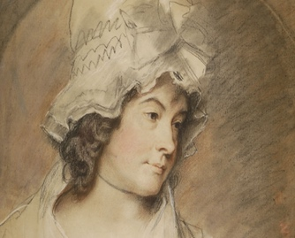
Sonnet written at the close of spring
Charlotte Smith 1749-1806

THE GARLANDS fade that Spring so lately wove,
Each simple flower which she has nurs’d in dew,
Anemones, that spangled every grove,
The primrose wan, and harebell mildly blue.
No more shall violets linger in the dell,
Or purple orchis variegate the plain,
Till Spring again shall call forth every bell
And dress with hurried hands her wreaths again.
Ah, poor humanity! so frail, so fair,
And the fond visions of thy early day,
Till tyrant passion and corrosive care
Bid all thy fairy colours flee away!
Another May new birds and flowers shall bring;
Ah! why has happiness no second spring?

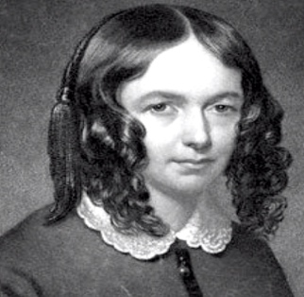
Sonnet 24
Elizabeth Barrett Browning 1806-1861

Let the world’s sharpness, like a clasping knife,
Shut in upon itself and do no harm
In this close hand of Love, now soft and warm,
And let us hear no sound of human strife
After the click of the shutting. Life to life—
I lean upon thee, Dear, without alarm,
And feel as safe as guarded by a charm
Against the stab of worldlings, who if rife
Are weak to injure. Very whitely still
The lilies of our lives may reassure
Their blossoms from their roots, accessible
Alone to heavenly dews that drop not fewer,
Growing straight, out of man’s reach, on the hill.
God only, who made us rich, can make us poor.
Let the world’s sharpness, like a clasping knife,
Shut in upon itself and do no harm
In this close hand of Love, now soft and warm,
And let us hear no sound of human strife
After the click of the shutting. Life to life—
I lean upon thee, Dear, without alarm,
And feel as safe as guarded by a charm
Against the stab of worldlings, who if rife
Are weak to injure. Very whitely still
The lilies of our lives may reassure
Their blossoms from their roots, accessible
Alone to heavenly dews that drop not fewer,
Growing straight, out of man’s reach, on the hill.
God only, who made us rich, can make us poor.

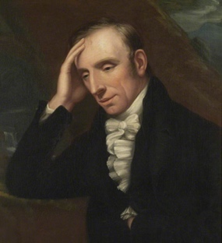
London 1802
William Wordsworth 1770-1850

Milton! thou shouldst be living at this hour:
England hath need of thee: she is a fen
Of stagnant waters: altar, sword, and pen,
Fireside, the heroic wealth of hall and bower,
Have forfeited their ancient English dower
Of inward happiness. We are selfish men;
O raise us up, return to us again,
And give us manners, virtue, freedom, power!
Thy soul was like a Star, and dwelt apart;
Thou hadst a voice whose sound was like the sea:
Pure as the naked heavens, majestic, free,
So didst thou travel on life’s common way,
In cheerful godliness; and yet thy heart
The lowliest duties on herself did lay.

Scorn not the Sonnet
William Wordsworth 1770-1850

Scorn not the Sonnet; Critic, you have frowned,
Mindless of its just honours; with this key
Shakespeare unlocked his heart; the melody
Of this small lute gave ease to Petrarch's wound;
A thousand times this pipe did Tasso sound;
With it Camöens soothed an exile's grief;
The Sonnet glittered a gay myrtle leaf
Amid the cypress with which Dante crowned
His visionary brow: a glow-worm lamp,
It cheered mild Spenser, called from Faery-land
To struggle through dark ways; and, when a damp
Fell round the path of Milton, in his hand
The Thing became a trumpet; whence he blew
Soul-animating strains—alas, too few!

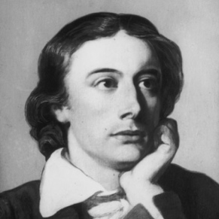
Bright Star
John Keats 1795-1821

Bright star! would I were steadfast as thou art—
Not in lone splendour hung aloft the night,
And watching, with eternal lids apart,
Like Nature's patient sleepless Eremite,
The moving waters at their priestlike task
Of pure ablution round earth's human shores,
Or gazing on the new soft fallen mask
Of snow upon the mountains and the moors—
No—yet still steadfast, still unchangeable,
Pillow'd upon my fair love's ripening breast,
To feel for ever its soft fall and swell,
Awake for ever in a sweet unrest,
Still, still to hear her tender-taken breath,
And so live ever—or else swoon to death.

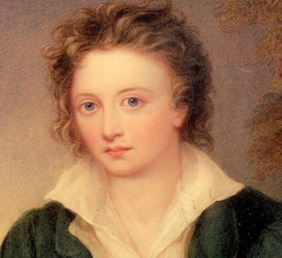
Ozymandias
Percy Bysshe Shelley 1792-1822

I met a traveller from an antique land
Who said: "Two vast and trunkless legs of stone
Stand in the desert . . . Near them, on the sand,
Half sunk, a shattered visage lies, whose frown,
And wrinkled lip, and sneer of cold command,
Tell that its sculptor well those passions read
Which yet survive, stamped on these lifeless things,
The hand that mocked them, and the heart that fed:
And on the pedestal these words appear:
'My name is Ozymandias, king of kings:
Look on my works, ye Mighty, and despair!'
Nothing beside remains. Round the decay
Of that colossal wreck, boundless and bare
The lone and level sands stretch far away."

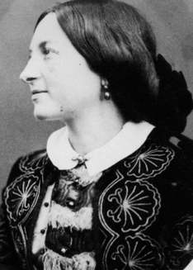
After Death
Christina Rosetti 1830-1894

The curtains were half drawn, the floor was swept
And strewn with rushes, rosemary and may
Lay thick upon the bed on which I lay,
Where through the lattice ivy-shadows crept.
He leaned above me, thinking that I slept
And could not hear him; but I heard him say,
‘Poor child, poor child’: and as he turned away
Came a deep silence, and I knew he wept.
He did not touch the shroud, or raise the fold
That hid my face, or take my hand in his,
Or ruffle the smooth pillows for my head:
He did not love me living; but once dead
He pitied me; and very sweet it is
To know he still is warm though I am cold.

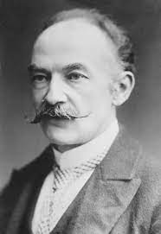
The Pity of it

Thomas Hardy 1840-1928

April 1915

I walked in loamy Wessex lanes, afar
From rail-track and from highway, and I heard
In field and farmstead many an ancient word
Of local lineage like 'Thu bist,' 'Er war,'

'Ich woll', 'Er sholl', and by-talk similar,
Nigh as they speak who in this month's moon gird
At England's very loins, thereunto spurred
By gangs whose glory threats and slaughters are.

Then seemed a Heart crying: 'Whosoever they be
At root and bottom of this, who flung this flame
Between kin folk kin tongued even as are we,

'Sinister, ugly, lurid, be their fame;
May their familiars grow to shun their name,
And their brood perish everlastingly.'

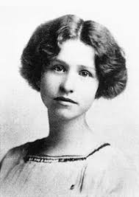
I Shall Forget You Presently
Edna St Vincent Millay 1892-1950

I shall forget you presently, my dear,
So make the most of this, your little day,
Your little month, your little half a year,
Ere I forget, or die, or move away,
And we are done forever; by and by
I shall forget you, as I said, but now,
If you entreat me with your loveliest lie
I will protest you with my favourite vow.
I would indeed that love were longer-lived,
And vows were not so brittle as they are,
But so it is, and nature has contrived
To struggle on without a break thus far, –
Whether or not we find what we are seeking
Is idle, biologically speaking.
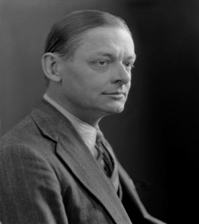
The Waste Land (lines 235-48)
T. S. Eliot 1888-1965

The time is now propitious, as he guesses,
The meal is ended, she is bored and tired,
Endeavours to engage her in caresses
Which still are unreproved, if undesired.
Flushed and decided, he assaults at once;
Exploring hands encounter no defense;
His vanity requires no response,
And makes a welcome of indifference.
(And I Tiresias have foresuffered all
Enacted on this same divan or bed;
I who have sat by Thebes below the wall
And walked among the lowest of the dead.)
Bestows one final patronising kiss,
And gropes his way, finding the stairs unlit...

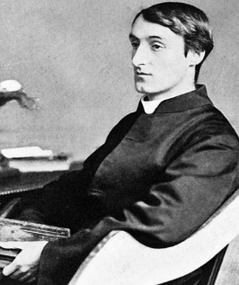
Carrion Comfort
Gerrard Manley Hopkins 1844-1889

Not, I'll not, carrion comfort, Despair, not feast on thee;
Not untwist—slack they may be—these last strands of man
In me ór, most weary, cry I can no more. I can;
Can something, hope, wish day come, not choose not to be.

But ah, but O thou terrible, why wouldst thou rude on me
Thy wring-world right foot rock? lay a lionlimb against me? scan
With darksome devouring eyes my bruisèd bones? and fan,
O in turns of tempest, me heaped there; me frantic to avoid thee and flee?

Why? That my chaff might fly; my grain lie, sheer and clear.
Nay in all that toil, that coil, since (seems) I kissed the rod,
Hand rather, my heart lo! lapped strength, stole joy, would laugh, chéer.
Cheer whom though? The hero whose heaven-handling flung me, fóot tród
Me? or me that fought him? O which one? is it each one? That night, that year
Of now done darkness I wretch lay wrestling with (my God!) my God.

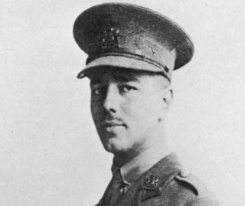
Anthem for Doomed Youth
Wilfred Owen 1893-1918

What passing-bells for these who die as cattle?
— Only the monstrous anger of the guns.
Only the stuttering rifles' rapid rattle
Can patter out their hasty orisons.
No mockeries now for them; no prayers nor bells;
Nor any voice of mourning save the choirs,—
The shrill, demented choirs of wailing shells;
And bugles calling for them from sad shires.

What candles may be held to speed them all?
Not in the hands of boys, but in their eyes
Shall shine the holy glimmers of goodbyes.
The pallor of girls' brows shall be their pall;
Their flowers the tenderness of patient minds,
And each slow dusk a drawing-down of blinds.

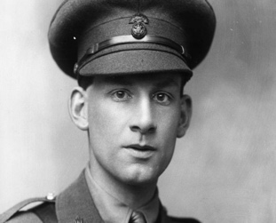
The Poet as Hero
Siegfried Sassoon 1886-1967

You've heard me, scornful, harsh, and discontented,
Mocking and loathing War: you've asked me why
Of my old, silly sweetness I've repented—
My ecstasies changed to an ugly cry.

You are aware that once I sought the Grail,
Riding in armour bright, serene and strong;
And it was told that through my infant wail
There rose immortal semblances of song.

But now I've said good-bye to Galahad,
And am no more the knight of dreams and show:
For lust and senseless hatred make me glad,
And my killed friends are with me where I go.
Wound for red wound I burn to smite their wrongs;
And there is absolution in my songs.

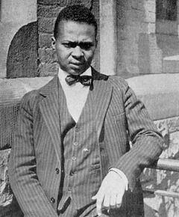
Yet Do I Marvel
Countee Cullen 1903-1946

I doubt not God is good, well-meaning, kind
And did He stoop to quibble could tell why
The little buried mole continues blind,
Why flesh that mirrors Him must some day die,
Make plain the reason tortured Tantalus
Is baited by the fickle fruit, declare
If merely brute caprice dooms Sisyphus
To struggle up a never-ending stair.
Inscrutable His ways are, and immune
To catechism by a mind too strewn
With petty cares to slightly understand
What awful brain compels His awful hand.
Yet do I marvel at this curious thing:
To make a poet black, and bid him sing!

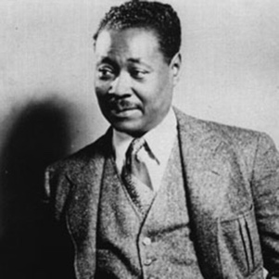
The Lynching
Claude McKay 1889-1948

His spirit is smoke ascended to high heaven.
His father, by the cruelest way of pain,
Had bidden him to his bosom once again;
The awful sin remained still unforgiven.
All night a bright and solitary star
(Perchance the one that ever guided him,
Yet gave him up at last to Fate's wild whim)
Hung pitifully o'er the swinging char.
Day dawned, and soon the mixed crowds came to view
The ghastly body swaying in the sun:
The women thronged to look, but never a one
Showed sorrow in her eyes of steely blue;
And little lads, lynchers that were to be,
Danced round the dreadful thing in fiendish glee.


Anne Hathaway
Carol Ann Duffy 1955-

‘Item I gyve unto my wief my second best bed…’
(from Shakespeare’s will)
The bed we loved in was a spinning world
of forests, castles, torchlight, cliff-tops, seas
where he would dive for pearls. My lover’s words
were shooting stars which fell to earth as kisses
on these lips; my body now a softer rhyme
to his, now echo, assonance; his touch
a verb dancing in the centre of a noun.
Some nights I dreamed he’d written me, the bed
a page beneath his writer’s hands. Romance
and drama played by touch, by scent, by taste.
In the other bed, the best, our guests dozed on,
dribbling their prose. My living laughing love –
I hold him in the casket of my widow’s head
as he held me upon that next best bed.


The Trick
Imtiaz Dharker 1954-

‘In a wasted time, it’s only when I sleep
that all my senses come awake. In the wake
of you, let day not break. Let me keep
the scent, the weight, the bright of you, take
the countless hours and count them all night through
till that time comes when you come to the door
of dreams, carrying oranges that cast a glow
up into your face. Greedy for more
than the gift of seeing you, I lean in to taste
the colour, kiss it off your offered mouth.
For this, for this, I fall asleep in haste,
willing to fall for the trick that tells the truth
that even your shade makes darkest absence bright,
that shadows live wherever there is light.


Are all the breakups in your poems real?
Aimee Nezhukumatathil 1974-

If by real you mean as real as a shark tooth stuck
in your heel, the wetness of a finished lollipop stick,
the surprise of a thumbtack in your purse—
then Yes, every last page is true, every nuance,
bit, and bite. Wait. I have made them up—all of them—
and when I say I am married, it means I married
all of them, a whole neighborhood of past loves.
Can you imagine the number of bouquets, how many
slices of cake? Even now, my husbands plan a great meal
for us—one chops up some parsley, one stirs a bubbling pot
on the stove. One changes the baby, and one sleeps
in a fat chair. One flips through the newspaper, another
whistles while he shaves in the shower, and every single
one of them wonders what time I am coming home.


Incandescent War Poem Sonnet
Bernadette Mayer 1945-

Even before I saw the chambered nautilus
I wanted to sail not in the us navy
Tonight I'm waiting for you, your letter
At the same time his letter, the view of you
By him and then by me in the park, no rhymes
I saw you, this is in prose, no it's not
Sitting with the molluscs & anemones in an
Empty autumn enterprise baby you look pretty
With your long eventual hair, is love king?
What's this? A sonnet? Love's a babe we know that
I'm coming up, I'm coming, Shakespeare only stuck
To one subject but I'll mention nobody said
You have to get young Americans some ice cream
In the artificial light in which she woke

