The Gothic
Year 9
Student Anthology



Year 9 Module 1: The Gothic Tradition
Contents
Literary timeline 2
Excellent epithets 3
Subject vocabulary 4
Gothic conventions 6
An example of the Gothic 8
Elements of romance 8
Lamkin 9
The Castle of Otranto, Horace Walpole 10
The Mysteries of Udolpho, Ann Radcliff 10
Life of Emily Brontë 11
Wuthering Heights plot overview 12
Chronology of the novel 13
Genealogy 15
Opening description of Wuthering Heights 16
Secondary Text: Jane Eyre 18
How does Bronte present Cathy and Heathcliff as Outsiders? 21
The Oval Portrait, Edgar Allan Poe 22
The Tell-Tale Heart, Edgar Allan Poe 25
The Werewolf, Angela Carter 27
Catherine’s dual nature 29
The Yellow Wallpaper, Charlotte Perkins Gilman 31
Heathcliff’s love for Catherine 32
Beloved, Toni Morrison 34
Brontë’s use of the supernatural 35
Frankenstein, Mary Shelley 36
Rebecca, Daphne Du Maurier 39
History repeats itself 40
Great Expectations, Charles Dickens 42
How does Brontë use time as a structural technique within the novel? 43
Strange Case of Dr Jekyll and Mr Hyde, Robert Louis Stevenson 45
How does Brontë portray Heathcliff as inherently evil? 47
The Mysteries of Udolpho, Ann Radcliff 48
Heathcliff’s brutality and violence 50

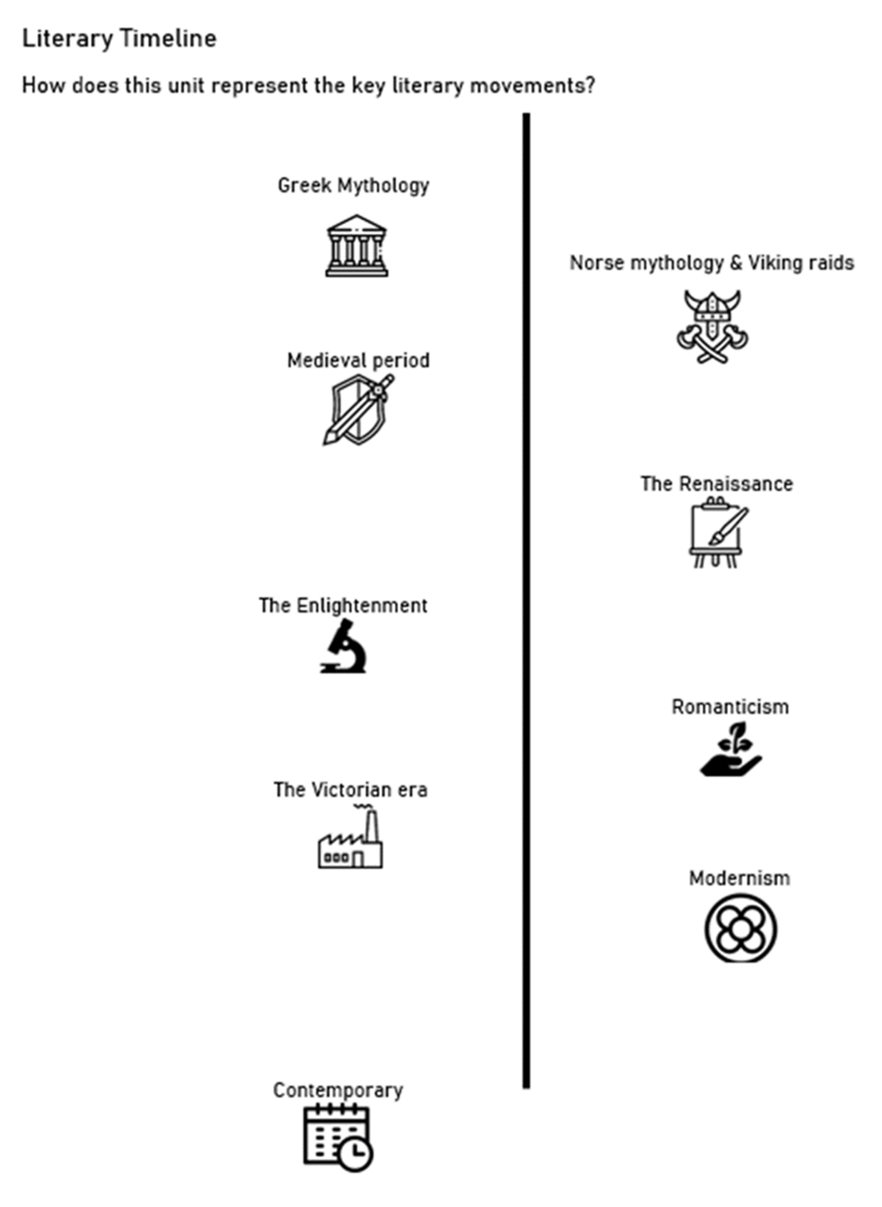
Emily Brontë
Wuthering Heights (1847)
Horace Walpole
The Castle of Otranto (1764)

Ann Radcliffe The Mysteries of Udolpho (1794)

Mary Shelley Frankenstein
(1818)

Edgar Allan Poe The Oval Portrait (1842)

Charlotte Brontë
Jane Eyre
(1847)

Anne Brontë
The Tenant of Wildfell Hall (1848)

Charles Dickens Great Expectations (1861)

Charlotte Perkins Gilman
The Yellow Wallpaper (1892)

Bram Stoker
Dracula (1897)

Henry James
The Turn of the Screw (1898)

Daphne Du Maurier
Rebecca (1938)

Angela Carter
The Werewolf (1979)

Toni Morrison
Beloved (1987)

Robert Louis Stevenson
Strange Case of Dr Jekyll and Mr Hyde (1886)

The period that Gothic Literature fell was mainly at the time of Romanticism at the end of the 18th century and this led in to the Victorian era and reflected Victorian society and their fears and anxieties.
Excellent Epithets
Cathy – Appositives: protagonist, heroine, mother, Catherine Earnshaw, Catherine Linton, outsider
Imperious (adj)  Imperiousness (n) | arrogant, domineering and bossy
Beauteous (adj)  Beauty (n) | Beautiful, pleasing to look at, attractive
Dissident (adj)  Dissident (n) | a person who actively challenges an established rule, political or religious system
Heathcliff - Appositives: antagonist, Byronic hero, outsider, gypsy
Malevolent (adj)  Malevolence (n) | having or showing a wish to do evil to others
Irascible (adj)  Irascibility (n) | having or showing a tendency to be easily angered.
Ostracised (adj)  Ostracise (v) | excluded from a society or group.
Nelly – Appositives: narrator, maid, mother figure
Sagacious (adj)  Sagacity (n) | having or showing keen mental discernment and good judgement; wise or shrewd
Benign (adj)  Benignity (n) | Good hearted and kindly towards others
Composed (adj)  Composedness (n) | having one's feelings and expression under control; calm.
Jane Eyre- Appositives: female protagonist,
Solicitous (adj)  Solicitude (n) | characterized by or showing interest or concern for others around them
Genial (adj)  Geniality (n) | Particularly friendly or cheerful, welcoming and warm-natured
Devout (adj)  Devotion (n) | Totally committed to a cause, belief or person
Miss Havisham- Appositives: female, spinster, antagonist, aunt, outcast
Acrimonious (adj)  Acrimony (n) | Angry, bitter or rancorous especially in feeling, language or manner
Eccentric (adj)  Eccentricity (n) | of a person or their behaviour) unconventional and slightly strange.
Covetous (adj)  Covetousness (n) | having or showing a great desire to possess something belonging to someone else or see others unhappy with nothing

Subject Vocabulary
Gothic (n)  Gothic (adj) | Initially referring to Germanic people before emerging as an art form and representation of culture and associated youth culture. The form of literature grew out of the Romantic literary movement.  Latin: Gothicus
Metaphor (conceptual)  Metaphorical (adj) | A metaphor is an example of figurative language. Conceptual metaphors are ideas that are understood in terms of another through the use of a source and target; drawing on a reader’s experience and shared understanding.  Greek: ‘transport, transfer’ – meta (over, across) + pherein (carry)
Characterisation (n)  Characterise (v) | A writer’s creation or construction of a fictional character  Greek: kharaktērizein "to designate by a characteristic mark," Characterise + ation
Romanticism (n)  Romantic (adj) | A literary movement that began in German and spread to England and France.  French: romantique "pertaining to romance," romant “a romance”
Byronic (adj)  Byron (n) | Characteristics that resembled British poet George Gordon, 6th Baron Byron (1788-1824) or his poetry.  Byronic hero in Gothic literature refers to an outcast in a story who is conflicted yet intelligent and arrogant.
Convention (n)  Conventional (adj) | The way something is done or a set of rules.  Old French: convencion "agreement," com "with, together" + venire "to come"
Trope (n)  Tropological (adj) | a figurative or metaphorical use of a word or expression  Latin: tropus “a figure of speech,” trep “to turn”
Sublime (n)  Sublime (adj) | Of great excellence, beauty or extreme in relation to attitude or behaviour.  French: sublime Sub (up to) + lim (threshold, limit)
Empathy (n)  Empathise (v) | Passion, state or emotion; appreciation of a viewed object or person.  Greek: empatheia en (in) + pathos (feeling)
Physiognomy (n)  Physiognomise (v) | Judging a person based on facial features or physical appearance  Latin: physonomia physio (nature) + gno (to know)
Psychological (adj)  Psychology (n) | affecting or pertaining to a person's mental or emotional state, the study of the soul. German (coined from Greek origin): psykhē: psychic factor, the mental effect.
Desire (n)  Desire (v) | a craving or yearning; an emotion directed toward attainment or possession of an object.  French: desir – to wish or to long for
Occult (n)  Occult (adj) | A secret that is not divulged or aspects that are hidden, concealed.  Latin: occultus
Human Condition (n) | all of the characteristics and key events that compose the essentials of human existence, including birth, growth, emotion, aspiration, conflict, and mortality.  French: condicion
Fin-de-siècle (adj) | the end of a century, yet at the end of the 19th century in Britain, the term did not just refer to a set of dates, but rather a whole set of artistic, moral, and social concerns.  French: siècle
Duality (n)  Dualistic (adj) | Twofold nature, state of being two or divided in two  Latin: dualitas duo “two”
Disturbed (adj)  Disturb (n) | agitated, put out of a settled state or regular order, emotionally unstable  French: destorber Dis (completely) + turb (turmoil)
Solitude (n)  Solitary (adj) | Being alone; lonely place, desert, wilderness  Latin: solitudinem

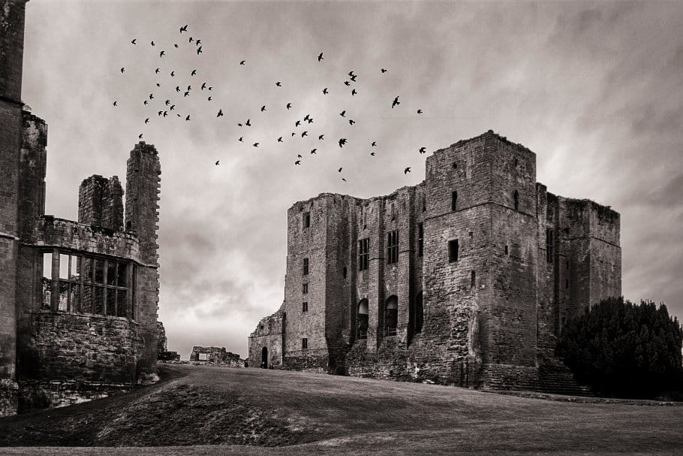
Gothic conventions
The Gothic novel was invented almost single-handedly by Horace Walpole, whose The Castle of Otranto (1764) contains essentially all the elements that constitute the genre. Walpole's novel was imitated in the eighteenth century, but enjoyed widespread influence in the nineteenth century (Victorian era) in part because of that era's indulgence in dark-romantic themes. Today, the Gothic continues to influence the novel, the short story, and poetry, and provides a major source of themes and elements in film making. (In fact, Gothic elements have been used so often in film that some have become predictable clichés! For example, when people enter an abandoned room in a supposedly abandoned house, the door often closes and locks behind them.)
Common gothic conventions include the following:
1. Mystery and Fear
One of the crucial components of a captivating Gothic story evokes feelings of terror and horror. Many Gothic works contain scenes, events and objects such as burials, flickering candles, evil potions, and other frightful concepts that, seemingly, cannot be explained by science. This satisfies the Science vs. Religion debate raging in Victorian society at the time.

We see this in Ann Radcliffe’s 1794 novel, The Mysteries of Udolpho, considered the first Gothic story. The story centres around Emily St. Aubert, an orphaned girl who was subjected to cruelties by guardians and imprisoned in castles. The work included strange, fearful events and a haunting atmosphere that came to define the genre in the years to come.

2. Omens and Curses
Foreshadowing, a literary device used to hint at events to come, occurs in the form of visions, omens, and curses throughout many narratives in Gothic literature. Often, tragedies are preceded by bad luck, intended to derail the lives of main characters. For example, an object might fall and break or a shadowy figure might be lurking in the dark. Edgar Allan Poe uses this element in his short story, “The Black Cat,” published in 1843 (which we will read later on in this unit). The superstitious nature of the title is ominous in itself, and Poe furthers the foreshadowing by naming one of the cats “Pluto,” a reference to the god of the dead (the equivalent of Hades) in Roman mythology.

3. Atmosphere and Setting
Gothic novelists set the tone by carefully choosing the physical location of a scene, as the atmosphere and environment of a Gothic novel directly contributed to the feeling of fear and uneasiness. Authors often used settings like dark forests, unnerving mountain regions, ominous climatic conditions, and threatening storms. Castles, romanticized in the Medieval period, played a large role in early Gothic writings.


4. Supernatural and Paranormal Activity
Much of Gothic literature’s allure comes from the genre’s suggestion of supernatural or inexplicable events, such as inanimate objects coming to life, ghosts, spirits, and vampires like that of Bram Stoker’s 1897 Gothic fantasy, Dracula.

5. Romance
As it’s widely believed Gothic literature stemmed from Romantic literature, the two genres share overlapping characteristics. Many Gothic novels are plagued by a passionate romance that often leads to sorrow and tragedy. The works of Charles Dickens centred on a Romantic-style love affair, but also featured horrific villains and Gothic settings.

6. Villain
Much like that of various literary genres, villains play a pivotal role in Gothic literature. In traditional Gothic novels, villains took the form of oppressive, male characters, often in authoritative positions like that of priests or kings. They’re complex, and initially sympathetic as to fool the reader of their deceptive nature. Villains like Dracula and Mr. Hyde from Robert Louis Stevenson’s, The Strange Case of Dr. Jekyll and Mr. Hyde are examples of complex, villainous characters.

7. Emotional Distress

Often, Gothic writers use melodrama or “high emotion” to convey a thought. This exaggerated, impassioned language helps convey the panic and terror inherent in many characters. Themes of madness and emotional distress were seen in many of the 20th century Gothic novels that depicted the condition of psychosis. For example, Charlotte Perkins Gilman’s short story, ‘The Yellow Wallpaper’, is written from the perspective of a woman suffering from depression and struggling to understand what is real and what is not. The modern term ‘gaslighting’ to refer to forms of emotional torment comes from this concept – the play ‘Gaslight’, set in 1880, has the male character (Jack) want to make his wife (Bella) believe she is going mad. Although this play was written in 1938, it taps into the Victorian anxiety about women and presumed female madness.

8. Nightmares
Nightmares serve as a particularly important omen within Gothic literature. Nightmares have an ancient association with the act of foretelling and were used to exacerbate the haunting aspects of a novel’s plot. The dreams allow authors to better demonstrate the emotions of their characters in a more immediate and frightening state.

9. Anti-hero
More often than not, the protagonist takes the form of the anti-hero, a flawed protagonist (main character) with monstrous elements popularized by this genre of writing. Originally, protagonists were males as well, but as the feminist movement emerged, English novelists like Clara Reeve began introducing female protagonists into their works. Protagonists tend to hold a high social rank and strong physical presence. Their doom is foreshadowed, and they are burdened by sorrow or a horrific tragedy. Often, they’re easily influenced, driven much by passion.

10. Damsel in distress
Gothic works often include a woman who suffers at the expense of a villain. They carry feelings of sadness, oppression, and loneliness, and many were depicted as virginal in early Gothic pieces. The damsel’s character is often held captive in a castle, terrorized by a nobleman, and rendered powerless. This brooding woman appealed to the readers’ pathos, particularly with the example of Horace Walpole’s character Matilda, whose unwavering loyalty to her father ultimately makes her weak and powerless.

This extract has been adapted from https://1wbt411gsq722n1thn3wskiq-wpengine.netdna-ssl.com/wp-content/uploads/2020/11/Elements-of-the-Gothic-Novel-Handout.pdf

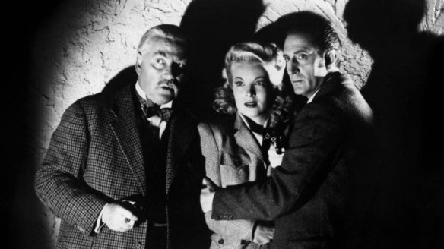
An Example of the Gothic

The 1943 Sherlock Holmes film, Sherlock Holmes Faces Death (one of the classic Basil Rathbone and Nigel Bruce films), contains all the elements of the Gothic. Here is a brief rundown of the items above:

- Setting. It's not quite a castle, but it is a huge mansion with several levels, including a basement and a hidden sub-basement. Dark and drafty. Ominous.
- Atmosphere of Mystery. It's a multiple murder mystery, with cryptic notes, hidden passageways, wind, lightning, and everyone a suspect.
- Ancient Prophecy. There is the Musgrave Ritual. Obscure, compelling, ancient.
- Omens and portents. The crow at the tavern, the intrusive lightning strike, the taunting notes from the butler.
- Supernatural or inexplicable events. How the victims died. The lightning seems to strike at just the right time.
- Overwrought emotion. The female lead screams and panics a bit.
- Women in distress and 8. Women threatened by a male. Toned down here, but the murderer had designs on the heroine.
- The wind blows, signs bang into the wall, lightning, a few characters are trapped in various ways.

Elements of Romance
In addition to the standard Gothic machinery above, many Gothic novels contain elements of romance as well. Elements of romance include these:

1. Powerful love. Heart stirring, often sudden, emotions create a life or death commitment. Many times this love is the first the character has felt with this overwhelming power.
2. Uncertainty of reciprocation. What is the beloved thinking? Is the lover's love returned or not?
3. Unreturned love. Someone loves in vain (at least temporarily). Later, the love may be returned.
4. Tension between true love and father's control, disapproval, or choice. Most often, the father of the woman disapproves of the man she loves.
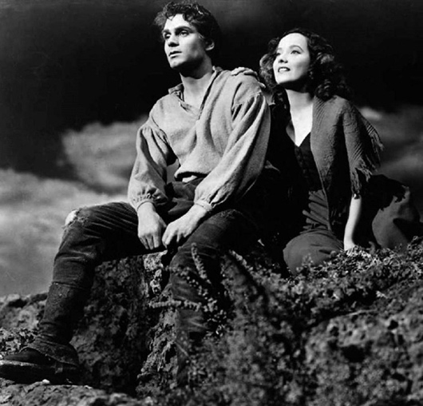
5. Lovers parted. Some obstacle arises and separates the lovers, geographically or in some other way. One of the lovers is banished, arrested, forced to flee, locked in a dungeon, or sometimes, disappears without explanation. Or, an explanation may be given (by the person opposing the lovers' being together) that later turns out to be false.
6. Illicit love or lust threatens the virtuous one. The young woman becomes a target of some evil man's desires and schemes.
7. Rival lovers or multiple suitors. One of the lovers (or even both) can have more than one person vying for affection.

This has been adapted from https://www.sgasd.org/cms/lib/PA01001732/Centricity/Domain/553/Frankenstein%20Gothic%20and%20Romantic%20Notes.pdf

Lamkin
‘Lamkin’ or ‘Lambkin’ is an English-language ballad. It gives an account of the murder of a woman and her infant son by a man, in some versions, a disgruntled mason, in others, a devil, bogeyman or a motiveless villain.
Versions of the ballad are found in Scotland, England and America and the story still inspires writes today. The version below, ‘Long Lankin’ is by Steeleye Span. There are also two novels of the same title written by Lindsey Barraclough and John Banville..

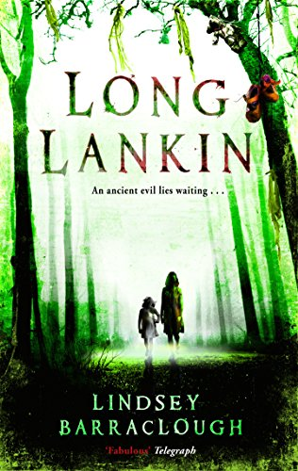
‘Long Lankin’
Said the Lord unto his Lady as he rode over the moss
"Beware of Long Lankin that lives amongst the gorse
Beware the moss, beware the moor, beware of Long Lankin
Be sure the doors are bolted well
Lest Lankin should creep in."
Said the Lord unto his Lady as he rode away
"Beware of Long Lankin that lives amongst the hay
Beware the moss, beware the moor, beware of Long Lankin
Be sure the doors are bolted well
Lest Lankin should creep in."
"Where's the master of the house?", says Long Lankin
"He's 'way to London", says the nurse to him
"Where's the lady of the house?", says Long Lankin
"She's up in her chamber", says the nurse to him
"Where's the baby of the house?", says Long Lankin
"He's asleep in the cradle", says the nurse to him
"We will pinch him, we will prick him
We will stab him with a pin
And the nurse shall hold the basin
For the blood all to run in."
So they pinched him and they pricked him
Then they stabbed him with a pin
And the false nurse held the basin
For the blood all to run in.
"Lady, come down the stairs, " says Long Lankin
"How can I see in the dark?", she says unto him
"You have silver mantles", says Long Lankin
"Lady, come down the stairs by the light of them"
Down the stairs the lady came, thinking no harm
Lankin, he stood ready to catch her in his arms.
There was blood all in the kitchen
There was blood all in the hall
There was blood all in the parlor
Where my lady she did fall.
Now Long Lankin shall be hanged
From the gallows, oh, so high
And the false nurse shall be burned
In the fire close by.
Said the Lord unto his Lady as he rode over the moss
"Beware of Long Lankin that lives amongst the gorse.
Beware the moss, beware the moor, beware of Long Lankin
Make sure the doors are bolted well
Lest Lankin should creep in.
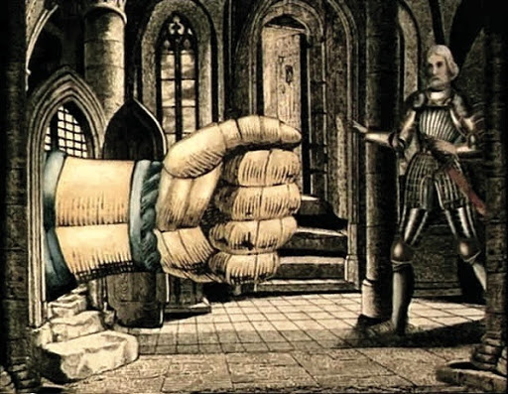
Horace Walpole: The Castle of Otranto (1764)

What Gothic conventions are displayed? How is the fatal event described?
The first thing that struck Manfred’s eyes was a group of his servants endeavouring to raise something that appeared to him a mountain of sable plumes. He gazed without believing his sight.
“What are ye doing?” cried Manfred, wrathfully; “where is my son?”
A volley of voices replied, “Oh! my Lord! the Prince! the Prince! the helmet! the helmet!”
Shocked with these lamentable sounds, and dreading he knew not what, he advanced hastily,—but what a sight for a father’s eyes!—he beheld his child dashed to pieces, and almost buried under an enormous helmet, an hundred times more large than any casque ever made for human being, and shaded with a proportionable quantity of black feathers.
The horror of the spectacle, the ignorance of all around how this misfortune had happened, and above all, the tremendous phenomenon before him, took away the Prince’s speech. Yet his silence lasted longer than even grief could occasion. He fixed his eyes on what he wished in vain to believe a vision; and seemed less attentive to his loss, than buried in meditation on the stupendous object that had occasioned it. He touched, he examined the fatal casque; nor could even the bleeding mangled remains of the young Prince divert the eyes of Manfred from the portent before him.

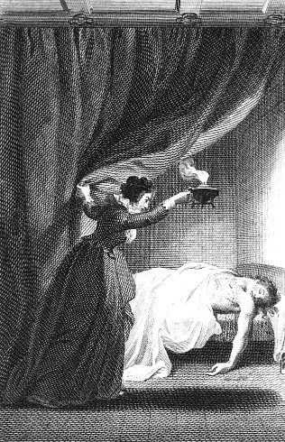
Ann Radcliffe: The Mysteries of Udolpho (1794)

How is the extract similar or different to the first? To what extent is this text Gothic? How is the character’s state of anxiety described?
But no voice spoke in reply. In the agony of terror she bade Michael bring water from the rivulet, that flowed along the road; and, having received some in the man's hat, with trembling hands she sprinkled it over her father's face, which, as the moon's rays now fell upon it, seemed to bear the impression of death. Every emotion of selfish fear now gave way to a stronger influence, and, committing St. Aubert to the care of Michael, who refused to go far from his mules, she stepped from the carriage in search of the chateau she had seen at a distance. It was a still moon-light night, and the music, which yet sounded on the air, directed her steps from the high road, up a shadowy lane, that led to the woods. Her mind was for some time so entirely occupied by anxiety and terror for her father, that she felt none for herself, till the deepening gloom of the overhanging foliage, which now wholly excluded the moon-light, and the wildness of the place, recalled her to a sense of her adventurous situation. The music had ceased, and she had no guide but chance. For a moment she paused in terrified perplexity, till a sense of her father's condition again overcoming every consideration for herself, she proceeded. The lane terminated in the woods, but she looked round in vain for a house, or a human being, and as vainly listened for a sound to guide her.
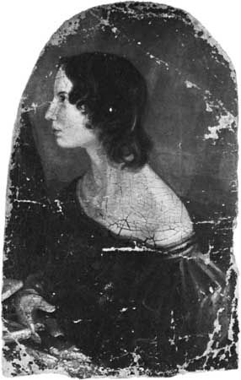
Life of Emily Brontë
Emily Brontë, oil painting by Branwell Brontë, 1833; in the National Portrait Gallery, London.

Emily Brontë was born on 30th July 1818, Thornton, Yorkshire, England and died on 19th December 1848 aged just 30. Emily was perhaps the greatest of the three Brontë sisters, but the record of her life is extremely meagre, for she was silent and reserved and left no correspondence of interest, and her single novel darkens rather than solves the mystery of her life.

Her father, Patrick Brontë (1777–1861) became rector of Haworth in 182, remaining there for the rest of his life. After the death of their mother in 1821, the children were left very much to themselves in the bleak moorland rectory. The children were educated, during their early life, at home, except for a single year that Charlotte and Emily spent at the Clergy Daughters’ School at Cowan Bridge in Lancashire. In 1835, when Charlotte secured a teaching position at Miss Wooler’s school at Roe Head, Emily accompanied her as a pupil but suffered from homesickness and remained only three months. In 1838 Emily spent six exhausting months as a teacher in Miss Patchett’s school at Law Hill, near Halifax, and then resigned.
To keep the family together at home, Charlotte planned to keep a school for girls at Haworth. In February 1842 she and Emily went to Brussels to learn foreign languages and school management at the Pension Héger. Although Emily pined for home and for the wild moorlands, it seems that in Brussels she was better appreciated than Charlotte. Her passionate nature was more easily understood than Charlotte’s reserved personality. In October, however, when her aunt died, Emily returned permanently to Haworth.
In 1845 Charlotte came across some poems by Emily, and this led to the discovery that all three sisters—Charlotte, Emily, and Anne—had written verse. A year later they published jointly a volume of verse, Poems by Currer, Ellis and Acton Bell, the initials of these pseudonyms being those of the sisters; it contained 21 of Emily’s poems, and a consensus of later criticism has accepted the fact that Emily’s verse alone reveals true poetic genius. The venture cost the sisters about £50 in all, and only two copies were sold.
By midsummer of 1847 Emily’s Wuthering Heights and Anne’s Agnes Grey had been accepted for joint publication, but publication was delayed until the appearance of their sister Charlotte’s Jane Eyre, which was immediately and hugely successful. Wuthering Heights, when published in December 1847, did not fare well; critics were hostile, calling it too savage, too animal-like, and clumsy in construction. Only later did it come to be considered one of the finest novels in the English language.
Soon after the publication of her novel, Emily’s health began to fail rapidly. She had been ill for some time, but now her breathing became difficult, and she suffered great pain. She died of tuberculosis in December 1848.

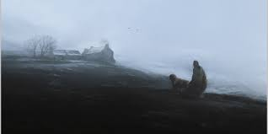
Wuthering Heights
Plot Overview

In the late winter months of 1801, a man named Lockwood rents a manor house called Thrushcross Grange in the isolated moor country of England. Here, he meets his dour landlord, Heathcliff, a wealthy man who lives in the ancient manor of Wuthering Heights, four miles away from the Grange. In this wild, stormy countryside, Lockwood asks his housekeeper, Nelly Dean, to tell him the story of Heathcliff and the strange denizens of Wuthering Heights. Nelly consents, and Lockwood writes down his recollections of her tale in his diary; these written recollections form the main part of Wuthering Heights.
Nelly remembers her childhood. As a young girl, she works as a servant at Wuthering Heights for the owner of the manor, Mr. Earnshaw, and his family. One day, Mr. Earnshaw goes to Liverpool and returns home with an orphan boy whom he will raise with his own children. At first, the Earnshaw children—a boy named Hindley and his younger sister Catherine—detest the dark-skinned Heathcliff. But Catherine quickly comes to love him, and the two soon grow inseparable, spending their days playing on the moors. After his wife’s death, Mr. Earnshaw grows to prefer Heathcliff to his own son, and when Hindley continues his cruelty to Heathcliff, Mr. Earnshaw sends Hindley away to college, keeping Heathcliff nearby.
Three years later, Mr. Earnshaw dies, and Hindley inherits Wuthering Heights. He returns with a wife, Frances, and immediately seeks revenge on Heathcliff. Once an orphan, later a pampered and favoured son, Heathcliff now finds himself treated as a common labourer, forced to work in the fields. Heathcliff continues his close relationship with Catherine, however. One night they wander to Thrushcross Grange, hoping to tease Edgar and Isabella Linton, the cowardly, snobbish children who live there. Catherine is bitten by a dog and is forced to stay at the Grange to recuperate for five weeks, during which time Mrs. Linton works to make her a proper young lady. By the time Catherine returns, she has become infatuated with Edgar, and her relationship with Heathcliff grows more complicated.
When Frances dies after giving birth to a baby boy named Hareton, Hindley descends into the depths of alcoholism, and behaves even more cruelly and abusively toward Heathcliff. Eventually, Catherine’s desire for social advancement prompts her to become engaged to Edgar Linton, despite her overpowering love for Heathcliff. Heathcliff runs away from Wuthering Heights, staying away for three years, and returning shortly after Catherine and Edgar’s marriage.
When Heathcliff returns, he immediately sets about seeking revenge on all who have wronged him. Having come into a vast and mysterious wealth, he deviously lends money to the drunken Hindley, knowing that Hindley will increase his debts and fall into deeper despondency. When Hindley dies, Heathcliff inherits the manor. He also places himself in line to inherit Thrushcross Grange by marrying Isabella Linton, whom he treats very cruelly. Catherine becomes ill, gives birth to a daughter, and dies. Heathcliff begs her spirit to remain on Earth—she may take whatever form she will, she may haunt him, drive him mad—just as long as she does not leave him alone. Shortly thereafter, Isabella flees to London and gives birth to Heathcliff ’s son, named Linton after her family. She keeps the boy with her there.
Thirteen years pass, during which Nelly Dean serves as Catherine’s daughter’s nursemaid at Thrushcross Grange. Young Catherine is beautiful and headstrong like her mother, but her temperament is modified by her father’s gentler influence. Young Catherine grows up at the Grange with no knowledge of Wuthering Heights; one day, however, wandering through the moors, she discovers the manor, meets Hareton, and plays together with him. Soon afterwards, Isabella dies, and Linton comes to live with Heathcliff. Heathcliff treats his sickly, whining son even more cruelly than he treated the boy’s mother.
Three years later, Catherine meets Heathcliff on the moors, and makes a visit to Wuthering Heights to meet Linton. She and Linton begin a secret romance conducted entirely through letters. When Nelly destroys Catherine’s collection of letters, the girl begins sneaking out at night to spend time with her frail young lover, who asks her to come back and nurse him back to health. However, it quickly becomes apparent that Linton is pursuing Catherine only because Heathcliff is forcing him to; Heathcliff hopes that if Catherine marries Linton, his legal claim upon Thrushcross Grange—and his revenge upon Edgar Linton—will be complete. One day, as Edgar Linton grows ill and nears death, Heathcliff lures Nelly and Catherine back to Wuthering Heights, and holds them prisoner until Catherine marries Linton.
Soon after the marriage, Edgar dies, and his death is quickly followed by the death of the sickly Linton. Heathcliff now controls both Wuthering Heights and Thrushcross Grange. He forces Catherine to live at Wuthering Heights and act as a common servant, while he rents Thrushcross Grange to Lockwood.
Nelly’s story ends as she reaches the present. Lockwood, appalled, ends his tenancy at Thrushcross Grange and returns to London. However, six months later, he pays a visit to Nelly, and learns of further developments in the story. Although Catherine originally mocked Hareton’s ignorance and illiteracy (in an act of retribution, Heathcliff ended Hareton’s education after Hindley died), Catherine grows to love Hareton as they live together at Wuthering Heights. Heathcliff becomes more and more obsessed with the memory of the elder Catherine, to the extent that he begins speaking to her ghost. Everything he sees reminds him of her.
Shortly after a night spent walking on the moors, Heathcliff dies. Hareton and young Catherine inherit Wuthering Heights and Thrushcross Grange, and they plan to be married on the next New Year’s Day. After hearing the end of the story, Lockwood goes to visit the graves of Catherine and Heathcliff.

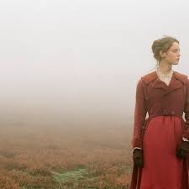
Chronology of Wuthering Heights

The story of Wuthering Heights is told through flashbacks recorded in diary entries, and events are often presented out of chronological order—Lockwood’s narrative takes place after Nelly’s narrative, for instance, but is interspersed with Nelly’s story in his journal. Nevertheless, the novel contains enough clues to enable an approximate reconstruction of its chronology, which was elaborately designed by Emily Brontë. For instance, Lockwood’s diary entries are recorded in the late months of 1801 and in September 1802; in 1801, Nelly tells Lockwood that she has lived at Thrushcross Grange for eighteen years, since Catherine’s marriage to Edgar, which must then have occurred in 1783. We know that Catherine was engaged to Edgar for three years, and that Nelly was twenty-two when they were engaged, so the engagement must have taken place in 1780, and Nelly must have been born in 1758. Since Nelly is a few years older than Catherine, and since Lockwood comments that Heathcliff is about forty years old in 1801, it stands to reason that Heathcliff and Catherine were born around 1761, three years after Nelly. There are several other clues like this in the novel (such as Hareton’s birth, which occurs in June, 1778).
The following chronology is based on those clues and should closely approximate the timing of the novel’s important events. A “~” before a date indicates that it cannot be precisely fixed from the evidence in the novel, but only closely estimated.
- 1500—The stone above the front door of Wuthering Heights, bearing the name of Hareton Earnshaw, is inscribed, possibly to mark the completion of the house.
- 1758—Nelly is born.
- 1761—Heathcliff and Catherine are born.
- 1767—Mr. Earnshaw brings Heathcliff to live at Wuthering Heights.
- 1774—Mr. Earnshaw sends Hindley away to college.
- 1777—Mr. Earnshaw dies; Hindley and Frances take possession of Wuthering Heights; Catherine first visits Thrushcross Grange around Christmastime.
- 1778—Hareton is born in June; Frances dies; Hindley begins his slide into alcoholism.
- 1780—Catherine becomes engaged to Edgar Linton; Heathcliff leaves Wuthering Heights.
- 1783—Catherine and Edgar are married; Heathcliff arrives at Thrushcross Grange in September.
- 1784—Heathcliff and Isabella elope in the early part of the year; Catherine becomes ill with brain fever; young Catherine is born late in the year; Catherine dies.
- 1785—Early in the year, Isabella flees Wuthering Heights and settles in London; Linton is born.
- 1785—Hindley dies; Heathcliff inherits Wuthering Heights.
- 1797—Young Catherine meets Hareton and visits Wuthering Heights for the first time; Linton comes from London after Isabella dies (in late 1797 or early 1798).
- 1800—Young Catherine stages her romance with Linton in the winter.
- 1801—Early in the year, young Catherine is imprisoned by Heathcliff and forced to marry Linton; Edgar Linton dies; Linton dies; Heathcliff assumes control of Thrushcross Grange. Late in the year, Lockwood rents the Grange from Heathcliff and begins his tenancy. In a winter storm, Lockwood takes ill and begins conversing with Nelly Dean.
- 1801–1802—During the winter, Nelly narrates her story for Lockwood.
- 1802—In spring, Lockwood returns to London; Catherine and Hareton fall in love; Heathcliff dies; Lockwood returns in September and hears the end of the story from Nelly.
- 1803—On New Year’s Day, young Catherine and Hareton plan to be married.

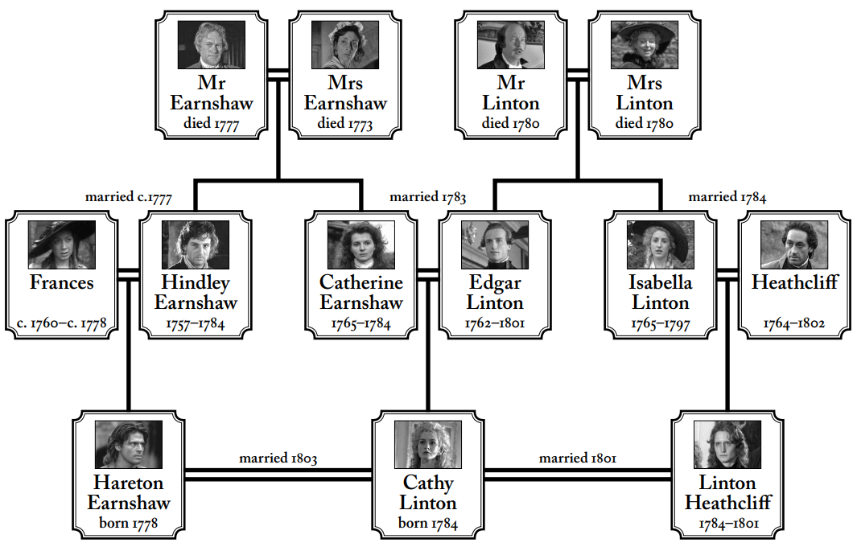
Genealogy

An Introduction to the Novel and reading of Chapter 1 – 2
Big Question: How is the opening of Wuthering Heights symbolic of the Gothic?

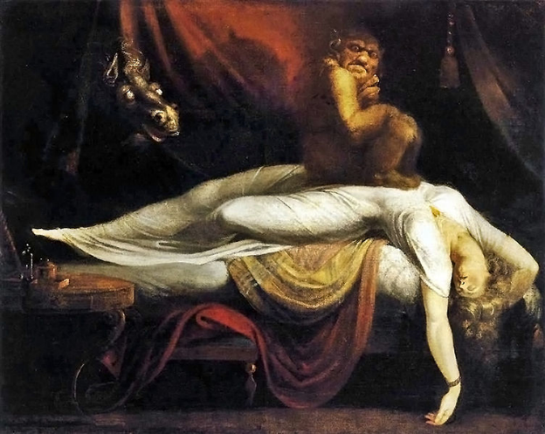

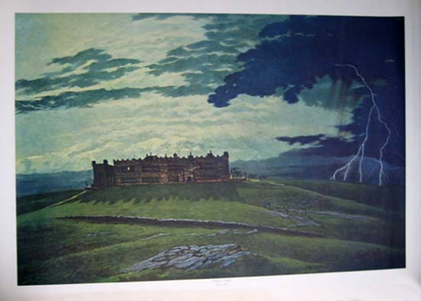

What is the novel going to be about?

What impressions do you get before reading?
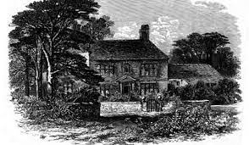
Opening description of Wuthering Heights

Wuthering Heights is the name of Mr. Heathcliff's dwelling. 'Wuthering' being a significant provincial adjective, descriptive of the atmospheric tumult to which its station is exposed in stormy weather. Pure, bracing ventilation they must have up there at all times, indeed: one may guess the power of the north wind blowing over the edge, by the excessive slant of a few stunted firs at the end of the house; and by a range of gaunt thorns all stretching their limbs one way, as if craving alms of the sun. Happily, the architect had foresight to build it strong: the narrow windows are deeply set in the wall, and the corners defended with large jutting stones.
Before passing the threshold, I paused to admire a quantity of grotesque carving lavished over the front, and especially about the principal door; above which, among a wilderness of crumbling griffins and shameless little boys, I detected the date '1500,' and the name 'Hareton Earnshaw.' I would have made a few comments, and requested a short history of the place from the surly owner; but his attitude at the door appeared to demand my speedy entrance, or complete departure, and I had no desire to aggravate his impatience previous to inspecting the penetralium.


Description of Heathcliff

But Mr. Heathcliff forms a singular contrast to his abode and style of living. He is a dark-skinned gypsy in aspect, in dress and manners a gentleman, that is, as much a gentleman as many a country squire: rather slovenly, perhaps, yet not looking amiss with his negligence, because he has an erect and handsome figure—and rather morose. Possibly, some people might suspect him of a degree of under-bred pride; I have a sympathetic chord within that tells me it is nothing of the sort: I know, by instinct, his reserve springs from an aversion to showy displays of feeling—to manifestations of mutual kindliness. He’ll love and hate, equally under cover, and esteem it a species of impertinence to be loved or hated again—No, I’m running on too fast—I bestow my own attributes over-liberally on him.


Jane Eyre
In writing Jane Eyre, Charlotte Brontë drew influence from the Gothic literary tradition that had been growing in popularity for decades. While Jane Eyre maintains its roots in realistic fiction, Brontë draws heavily upon the Gothic tradition, particularly in the setting of Thornfield Hall and the character of Bertha Mason. Thornfield, while not literally haunted, hides the dark secret of mental illness and hidden marriage, and includes mysterious, haunted-house like occurrences. Scholars identify Bertha as a dark double of Jane, a physical manifestation of the dark, angry passion that we see young Jane express against the Reeds. Like Jane Eyre’s predecessors, the Gothic elements in the novel hint at terrifying corruption lurking within a seemingly moral society and anxiety about the main character’s place in the world.
Focused link to Wuthering Heights: Gothic setting
Jane Eyre, Chapter 2
This room was chill, because it seldom had a fire; it was silent, because remote from the nursery and kitchen; solemn, because it was known to be so seldom entered. The house-maid alone came here on Saturdays, to wipe from the mirrors and the furniture a week’s quiet dust: and Mrs. Reed herself, at far intervals, visited it to review the contents of a certain secret drawer in the wardrobe, where were stored divers parchments, her jewel-casket, and a miniature of her deceased husband; and in those last words lies the secret of the red-room—the spell which kept it so lonely in spite of its grandeur.
Mr. Reed had been dead nine years: it was in this chamber he breathed his last; here he lay in state; hence his coffin was borne by the undertaker’s men; and, since that day, a sense of dreary consecration had guarded it from frequent intrusion.


Jane Eyre, Chapter 3

The next thing I remember is, waking up with a feeling as if I had had a frightful nightmare, and seeing before me a terrible red glare, crossed with thick black bars. I heard voices, too, speaking with a hollow sound, and as if muffled by a rush of wind or water: agitation, uncertainty, and an all-predominating sense of terror confused my faculties.
Ere long, I became aware that some one was handling me; lifting me up and supporting me in a sitting posture, and that more tenderly than I had ever been raised or upheld before. I rested my head against a pillow or an arm, and felt easy.
In five minutes more the cloud of bewilderment dissolved: I knew quite well that I was in my own bed, and that the red glare was the nursery fire. It was night: a candle burnt on the table; Bessie stood at the bed-foot with a basin in her hand, and a gentleman sat in a chair near my pillow, leaning over me.

Jane Eyre, Chapter 12

I did not like re-entering Thornfield. To pass its threshold was to return to stagnation; to cross the silent hall, to ascend the darksome staircase, to seek my own lonely little room, and then to meet tranquil Mrs. Fairfax, and spend the long winter evening with her, and her only, was to quell wholly the faint excitement wakened by my walk,—to slip again over my faculties the viewless fetters of an uniform and too still existence; of an existence whose very privileges of security and ease I was becoming incapable of appreciating. What good it would have done me at that time to have been tossed in the storms of an uncertain struggling life, and to have been taught by rough and bitter experience to long for the calm amidst which I now repined! Yes, just as much good as it would do a man tired of sitting still in a ‘too easy chair’ to take a long walk: and just as natural was the wish to stir, under my circumstances, as it would be under his.
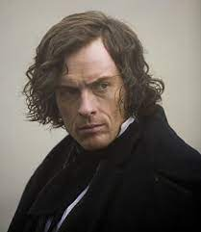
Jane Eyre, Chapter 13

Partly because it is his nature—and we can none of us help our nature; and partly because he has painful thoughts, no doubt, to harass him, and make his spirits unequal.’
‘What about?’
‘Family troubles, for one thing.’
‘But he has no family.’
‘Not now, but he has had—or, at least, relatives. He lost his elder brother a few years since.’
‘His ELDER brother?’
‘Yes. The present Mr. Rochester has not been very long in possession of the property; only about nine years.’
‘Nine years is a tolerable time. Was he so very fond of his brother as to be still inconsolable for his loss?’
‘Why, no—perhaps not. I believe there were some misunderstandings between them. Mr. Rowland Rochester was not quite just to Mr. Edward; and perhaps he prejudiced his father against him. The old gentleman was fond of money, and anxious to keep the family estate together. He did not like to diminish the property by division, and yet he was anxious that Mr. Edward should have wealth, too, to keep up the consequence of the name; and, soon after he was of age, some steps were taken that were not quite fair, and made a great deal of mischief. Old Mr. Rochester and Mr. Rowland combined to bring Mr. Edward into what he considered a painful position, for the sake of making his fortune: what the precise nature of that position was I never clearly knew, but his spirit could not brook what he had to suffer in it. He is not very forgiving: he broke with his family, and now for many years he has led an unsettled kind of life. I don’t think he has ever been resident at Thornfield for a fortnight together, since the death of his brother without a will left him master of the estate; and, indeed, no wonder he shuns the old place.’
‘Why should he shun it?’
‘Perhaps he thinks it gloomy.’
The answer was evasive. I should have liked something clearer; but Mrs. Fairfax either could not, or would not, give me more explicit information of the origin and nature of Mr. Rochester’s trials. She averred they were a mystery to herself, and that what she knew was chiefly from conjecture. It was evident, indeed, that she wished me to drop the subject, which I did accordingly.

How does Bronte present Cathy and Heathcliff as Outsiders?
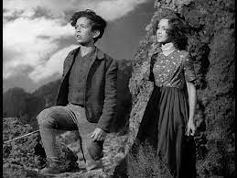
Extract from Chapter 6: Running off to the Moors

But it was one of their chief amusements to run away to the moors in the morning and remain there all day, and the after punishment grew a mere thing to laugh at. The curate might set as many chapters as he pleased for Catherine to get by heart, and Joseph might thrash Heathcliff till his arm ached; they forgot everything the minute they were together again: at least the minute they had contrived some naughty plan of revenge; and many a time I've cried to myself to watch them growing more reckless daily, and I not daring to speak a syllable, for fear of losing the small power I still retained over the unfriended creatures.
One Sunday evening, it chanced that they were banished from the sitting-room, for making a noise, or a light offence of the kind; and when I went to call them to supper, I could discover them nowhere. We searched the house, above and below, and the yard and stables; they were invisible: and, at last, Hindley in a passion told us to bolt the doors, and swore nobody should let them in that night. The household went to bed; and I, too, anxious to lie down, opened my lattice and put my head out to hearken, though it rained: determined to admit them in spite of the prohibition, should they return. In a while, I distinguished steps coming up the road, and the light of a lantern glimmered through the gate. I threw a shawl over my head and ran to prevent them from waking Mr. Earnshaw by knocking. There was Heathcliff, by himself: it gave me a start to see him alone.

Extract from Chapter 6: Being caught at Thrushcroft

We made frightful noises to terrify them still more, and then we dropped off the ledge, because somebody was drawing the bars, and we felt we had better flee. I had Cathy by the hand, and was urging her on, when all at once she fell down. "Run, Heathcliff, run!" she whispered. "They have let the bull-dog loose, and he holds me!" The devil had seized her ankle, Nelly: I heard his abominable snorting. She did not yell out - no! she would have scorned to do it, if she had been spitted on the horns of a mad cow. I did, though: I vociferated curses enough to annihilate any fiend in Christendom; and I got a stone and thrust it between his jaws, and tried with all my might to cram it down his throat. A beast of a servant came up with a lantern, at last, shouting - "Keep fast, Skulker, keep fast!" He changed his note, however, when he saw Skulker's game. The dog was throttled off; his huge, purple tongue hanging half a foot out of his mouth, and his pendent lips streaming with bloody slaver. The man took Cathy up; she was sick: not from fear, I'm certain, but from pain. He carried her in; I followed, grumbling execrations and vengeance.

Extract from Chapter 6: The contrast in treatment of Cathy and Heathcliff
"Miss Earnshaw? Nonsense!" cried the dame; "Miss Earnshaw scouring the country with a gipsy! And yet, my dear, the child is in mourning - surely it is - and she may be lamed for life!"
“What culpable carelessness in her brother!" exclaimed Mr. Linton, turning from me to Catherine. "I've understood from Shielders"' (that was the curate, sir) '"that he lets her grow up in absolute heathenism. But who is this? Where did she pick up this companion? Oho! I declare he is that strange acquisition my late neighbour made, in his journey to Liverpool - a little Lascar, or an American or Spanish castaway."
“A wicked boy, at all events," remarked the old lady, "and quite unfit for a decent house! Did you notice his language, Linton? I'm shocked that my children should have heard it."
“I recommenced cursing - don't be angry, Nelly - and so Robert was ordered to take me off. I refused to go without Cathy; he dragged me into the garden, pushed the lantern into my hand, assured me that Mr. Earnshaw should be informed of my behaviour, and, bidding me march directly, secured the door again. The curtains were still looped up at one corner, and I resumed my station as spy; because, if Catherine had wished to return, I intended shattering their great glass panes to a million of fragments, unless they let her out. She sat on the sofa quietly. Mrs. Linton took off the grey cloak of the dairy-maid which we had borrowed for our excursion, shaking her head and expostulating with her, I suppose: she was a young lady, and they made a distinction between her treatment and mine.

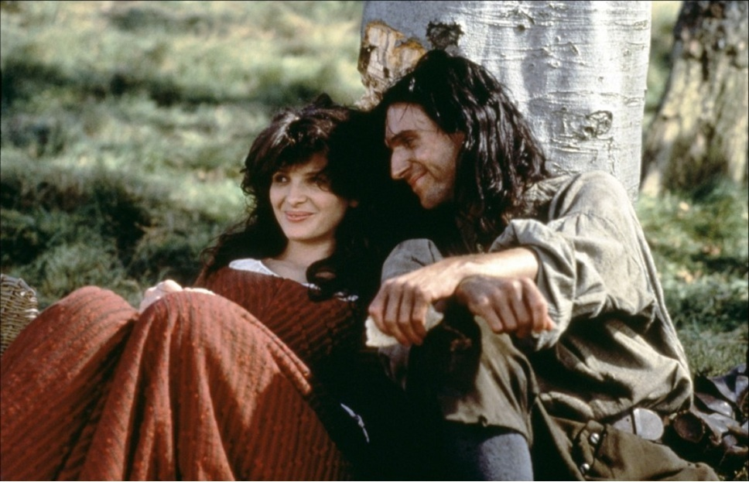

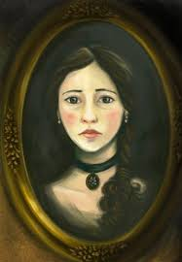
The Oval Portrait

Edgar Allan Poe (1809-1849) was an American writer, poet, editor, and literary critic. Poe is best known for his poetry and short stories, particularly his tales of mystery and the macabre. He is widely regarded as a central figure of Romanticism in the United States, and of American literature
The Oval Portrait’ (1842) is one of the shortest tales Edgar Allan Poe ever wrote. In just a few pages, he offers a powerful story about the relationship between art and life, through the narrator’s encounter with the oval portrait of a young woman in a chateau in the Italian Alps.
Focused link to Wuthering Heights: The Oval Portrait focuses on a similar setting to Lockwood in Chapter 3 – full of mystery

THE CHATEAU into which my valet had ventured to make forcible entrance, rather than permit me, in my desperately wounded condition, to pass a night in the open air, was one of those piles of commingled gloom and grandeur which have so long frowned among the Appennines, not less in fact than in the fancy of Mrs. Radcliffe. To all appearance it had been temporarily and very lately abandoned. We established ourselves in one of the smallest and least sumptuously furnished apartments. It lay in a remote turret of the building. Its decorations were rich, yet tattered and antique. Its walls were hung with tapestry and bedecked with manifold and multiform armorial trophies, together with an unusually great number of very spirited modern paintings in frames of rich golden arabesque.
In these paintings, which depended from the walls not only in their main surfaces, but in very many nooks which the bizarre architecture of the chateau rendered necessary- in these paintings my incipient delirium, perhaps, had caused me to take deep interest; so that I bade Pedro to close the heavy shutters of the room- since it was already night- to light the tongues of a tall candelabrum which stood by the head of my bed- and to throw open far and wide the fringed curtains of black velvet which enveloped the bed itself. I wished all this done that I might resign myself, if not to sleep, at least alternately to the contemplation of these pictures, and the perusal of a small volume which had been found upon the pillow, and which purported to criticise and describe them.
Long- long I read- and devoutly, devotedly I gazed. Rapidly and gloriously the hours flew by and the deep midnight came. The position of the candelabrum displeased me, and outreaching my hand with difficulty, rather than disturb my slumbering valet, I placed it so as to throw its rays more fully upon the book.
But the action produced an effect altogether unanticipated. The rays of the numerous candles (for there were many) now fell within a niche of the room which had hitherto been thrown into deep shade by one of the bed-posts. I thus saw in vivid light a picture all unnoticed before. It was the portrait of a young girl just ripening into womanhood. I glanced at the painting hurriedly, and then closed my eyes. Why I did this was not at first apparent even to my own perception. But while my lids remained thus shut, I ran over in my mind my reason for so shutting them. It was an impulsive movement to gain time for thought- to make sure that my vision had not deceived me- to calm and subdue my fancy for a more sober and more certain gaze. In a very few moments I again looked fixedly at the painting.
That I now saw aright I could not and would not doubt; for the first flashing of the candles upon that canvas had seemed to dissipate the dreamy stupor which was stealing over my senses, and to startle me at once into waking life.
The portrait, I have already said, was that of a young girl. It was a mere head and shoulders, done in what is technically termed a vignette manner; much in the style of the favorite heads of Sully. The arms, the bosom, and even the ends of the radiant hair melted imperceptibly into the vague yet deep shadow which formed the back-ground of the whole. The frame was oval, richly gilded and filigreed in Moresque. As a thing of art nothing could be more admirable than the painting itself. But it could have been neither the execution of the work, nor the immortal beauty of the countenance, which had so suddenly and so vehemently moved me. Least of all, could it have been that my fancy, shaken from its half slumber, had mistaken the head for that of a living person. I saw at once that the peculiarities of the design, of the vignetting, and of the frame, must have instantly dispelled such idea- must have prevented even its momentary entertainment.
Thinking earnestly upon these points, I remained, for an hour perhaps, half sitting, half reclining, with my vision riveted upon the portrait. At length, satisfied with the true secret of its effect, I fell back within the bed. I had found the spell of the picture in an absolute life-likeliness of expression, which, at first startling, finally confounded, subdued, and appalled me. With deep and reverent awe I replaced the candelabrum in its former position. The cause of my deep agitation being thus shut from view, I sought eagerly the volume which discussed the paintings and their histories. Turning to the number which designated the oval portrait, I there read the vague and quaint words which follow: “She was a maiden of rarest beauty, and not more lovely than full of glee. And evil was the hour when she saw, and loved, and wedded the painter. He, passionate, studious, austere, and having already a bride in his Art; she a maiden of rarest beauty, and not more lovely than full of glee; all light and smiles, and frolicsome as the young fawn; loving and cherishing all things; hating only the Art which was her rival; dreading only the pallet and brushes and other untoward instruments which deprived her of the countenance of her lover.
It was thus a terrible thing for this lady to hear the painter speak of his desire to pourtray even his young bride. But she was humble and obedient, and sat meekly for many weeks in the dark, high turret-chamber where the light dripped upon the pale canvas only from overhead. But he, the painter, took glory in his work, which went on from hour to hour, and from day to day. And be was a passionate, and wild, and moody man, who became lost in reveries; so that he would not see that the light which fell so ghastly in that lone turret withered the health and the spirits of his bride, who pined visibly to all but him. Yet she smiled on and still on, uncomplainingly, because she saw that the painter (who had high renown) took a fervid and burning pleasure in his task, and wrought day and night to depict her who so loved him, yet who grew daily more dispirited and weak. And in sooth some who beheld the portrait spoke of its resemblance in low words, as of a mighty marvel, and a proof not less of the
power of the painter than of his deep love for her whom he depicted so surpassingly well. But at length, as the labor drew nearer to its conclusion, there were admitted none into the turret; for the painter had grown wild with the ardor of his work, and turned his eyes from canvas merely, even to regard the countenance of his wife. And he would not see that the tints which he spread upon the canvas were drawn from the cheeks of her who sate beside him. And when many weeks bad passed, and but little remained to do, save one brush upon the mouth and one tint upon the eye, the spirit of the lady again flickered up as the flame within the socket of the lamp. And then the brush was given, and then the tint was placed; and, for one moment, the painter stood entranced before the work which he had wrought; but in the next, while he yet gazed, he grew tremulous and very pallid, and aghast, and crying with a loud voice, ‘This is indeed Life itself!’ turned suddenly to regard his beloved:- She was dead!

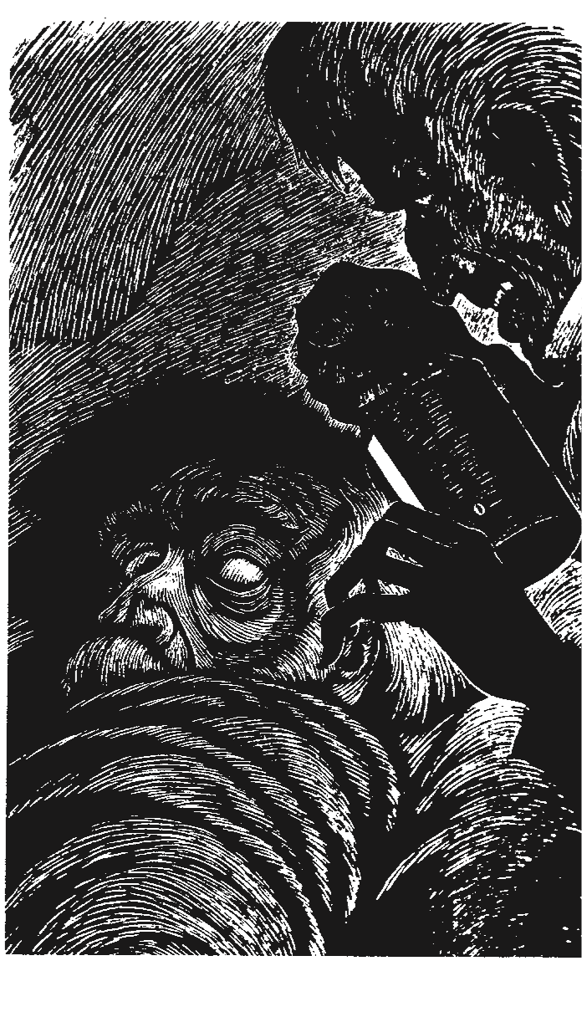
The Tell-Tale Heart, Edgar Allen Poe

It’s True! Yes, I have been ill, very ill. But why do you say that I have lost control of my mind, why do you say that I am mad? Can you not see that I have full control of my mind? Is it not clear that I am not mad? Indeed, the illness only made my mind, my feelings, my senses stronger, more powerful. My sense of hearing especially became more powerful. I could hear sounds I had never heard before. I heard sounds from heaven; and I heard sounds from hell!
Listen! Listen, and I will tell
you how it happened. You will see, you will hear how healthy my mind is.
It is impossible to say how the idea first entered my head. There was no reason for what I did. I did not hate the old man; I even loved him. He had never hurt me. I did not want his money. I think it was his eye. His eye was like the eye of a vulture, the eye of one of those terrible birds that watch and wait while an animal dies, and then fall upon the dead body and pull it to pieces to eat it. When the old man looked at me with his vulture eye a cold feeling went up and down my back; even my blood became cold. And so, I finally decided I had to kill the old man and close that eye forever!
So you think that I am mad? A madman cannot plan. But you should have seen me. During all of that week I was as friendly to the old man as I could be, and warm, and loving.
Every night about twelve o’clock I slowly opened his door. And when the door was opened wide enough I put my hand in, and then my head. In my hand I held a light covered over with a cloth so that no light showed. And I stood there quietly. Then, carefully, I lifted the cloth, just a little, so that a single, thin, small light fell across that eye. For seven nights I did this, seven long nights, every night at midnight. Always the eye was closed, so it was impossible for me to do the work. For it was not the old man I felt I had to kill; it was the eye, his Evil Eye.
And every morning I went to his room, and with a warm, friendly voice I asked him how he had slept. He could not guess that every night, just at twelve, I looked in at him as he slept.
The eighth night I was more than usually careful as I opened the door. The hands of a clock move more quickly than did my hand. Never before had I felt so strongly my own power; I was now sure of success.
The old man was lying there not dreaming that I was at his door. Suddenly he moved in his bed. You may think I became afraid. But no. The darkness in his room was thick and black. I knew he could not see the opening of the door. I continued to push the door, slowly, softly. I put in my head. I put in my hand, with the covered light. Suddenly the old man sat straight up in bed and cried, “Who’s there?”
I stood quite still. For a whole hour I did not move. Nor did I hear him again lie down in his bed. He just sat there, listening. Then I heard a sound, a low cry of fear which escaped from the old man. Now I knew that he was sitting up in his bed, filled with fear; I knew that he knew that I was there. He did not see me there. He could not hear me there. He felt me there. Now he knew that Death was standing there.
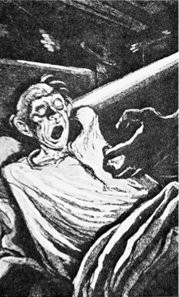
Slowly, little by little, I lifted the cloth, until a small, small light escaped from under it to fall upon — to fall upon that vulture eye! It was open — wide, wide open, and my anger increased as it looked straight at me. I could not see the old man’s face. Only that eye, that hard blue eye, and the blood in my body became like ice.
Have I not told you that my hearing had become unusually strong? Now I could hear a quick, low, soft sound, like the sound of a clock heard through a wall. It was the beating of the old man’s heart. I tried to stand quietly. But the sound grew louder. The old man’s fear must have been great indeed. And as the sound grew louder my anger became greater and more painful. But it was more than anger. In the quiet night, in the dark silence of the bedroom my anger became fear — for the heart was beating so loudly that I was sure some one must hear. The time had come! I rushed into the room, crying, “Die! Die!” The old man gave a loud cry of fear as I fell upon him and held the bedcovers tightly over his head. Still his heart was beating; but I smiled as I felt that success was near. For many minutes that heart continued to beat; but at last the beating stopped. The old man was dead. I took away the bedcovers and held my ear over his heart. There was no sound. Yes. He was dead! Dead as a stone. His eye would trouble me no more!
So I am mad, you say? You should have seen how careful I was to put the body where no one could find it. First I cut off the head, then the arms and the legs. I was careful not to let a single drop of blood fall on the floor. I pulled up three of the boards that formed the floor, and put the pieces of the body there. Then I put the boards down again, carefully, so carefully that no human eye could see that they had been moved.
As I finished this work I heard that someone was at the door. It was now four o’clock in the morning, but still dark. I had no fear, however, as I went down to open the door. Three men were at the door, three officers of the police. One of the neighbours had heard the old man’s cry and had called the police; these three had come to ask questions and to search the house.
I asked the policemen to come in. The cry, I said, was my own, in a dream. The old man, I said, was away; he had gone to visit a friend in the country. I took them through the whole house, telling them to search it all, to search well. I led them finally into the old man’s bed- room. As if playing a game with them I asked them to sit down and talk for a while.
My easy, quiet manner made the policemen believe my story. So they sat talking with me in a friendly way. But although I answered them in the same way, I soon wished that they would go. My head hurt and there was a strange sound in my ears. I talked more, and faster. The sound became clearer. And still they sat and talked.
Suddenly I knew that the sound was not in my ears, it was not just inside my head. At that moment I must have become quite white. I talked still faster and louder. And the sound, too, became louder. It was a quick, low, soft sound, like the sound of a clock heard through a wall, a sound I knew well. Louder it became, and louder. Why did the men not go? Louder, louder. I stood up and walked quickly around the room. I pushed my chair across the floor to make more noise, to cover that terrible sound. I talked even louder. And still the men sat and talked, and smiled. Was it possible that they could not hear?
No! They heard! I was certain of it. They knew! Now it was they who were playing a game with me. I was suffering more than I could bear, from their smiles, and from that sound. Louder, louder, louder! Suddenly I could bear it no longer. I pointed at the boards and cried, “Yes! Yes, I killed him. Pull up the boards and you shall see! I killed him. But why does his heart not stop beating?! Why does it not stop?”


‘The Werewolf’, Angela Carter
Angela Carter was a novelist, short story writer, poet, and journalist, known for her feminist, magical realism, and picaresque works. She is best known for the collection of short stories each reimaging classic fairy tales, The Bloody Chamber, which was published in 1979 ‘The Werewolf’, one of the short stories in The Bloody Chamber, is based on the fairy tale of Little Red Riding Hood.
Focused link to Wuthering Heights: The Werewolf addresses Satanic references similar to the descriptions surrounding Mr Earnshaw’s death in Chapter 5.

Is a northern country; they have cold weather, they have cold hearts.
Cold; tempest; wild beasts in the forest. It is a hard life. Their houses are built of logs, dark and smoky within. There will be a crude icon of the virgin behind a guttering candle, the leg of a pig hung up to cure, a string of drying mushrooms. A bed, a stool, a table. Harsh, brief, poor lives.
To these upland woodsmen, the Devil is as real as you or I. More so; they have not seen us nor even know that we exist, but the Devil they glimpse often in the graveyards, those bleak and touching townships of the dead where the graves are marked with portraits of the deceased in the naif style and there are no flowers to put in front of them, no flowers grow there, so they put out small, votive offerings, little loaves, sometimes a cake that the bears come lumbering from the margins of the forest to snatch away. At midnight, especially on Walpurgisnacht, the Devil holds picnics in the graveyards and invites the witches; then they dig up fresh corpses, and eat them. Anyone will tell you that. Wreaths of garlic on the doors keep out the vampires. A blue-eyed child born feet first on the night of St John's Eve will have second sight. When they discover a witch - some old woman whose cheeses ripen when her neighbours' do not, another old woman whose black cat, oh, sinister! follows her about all the time, they strip the crone, search for her marks, for the supernumerary nipple her familiar sucks. They soon find it. Then they stone her to death.
Winter and cold weather.
Go and visit grandmother, who has been sick. Take her the oatcakes I’ve baked for her on the hearthstone and a little pot of butter.
The good child does as her mother bids - five miles' trudge through the forest; do not leave the path because of the bears, the wild boar, the starving wolves. Here, take your father's hunting knife; you know how to use it.
The child had a scabby coat of sheepskin to keep out the cold, she knew the forest too well to fear it but she must always be on her guard. When she heard that freezing howl of a wolf, she dropped her gifts, seized her knife and turned on the beast.
It was a huge one, with red eyes and running, grizzled chops; any but a mountaineer's child would have died of fright at the sight of it. It went for her throat, as wolves do, but she made a great swipe at it with her father's knife and slashed off its right forepaw.
The wolf let out a gulp, almost a sob, when it saw what had happened to it; wolves are less brave than they seem. It went lolloping off disconsolately between the trees as well as it could on three legs, leaving a trail of blood behind it. The child wiped the blade of her knife .clean on her apron, wrapped up the wolf s paw in the cloth in which her mother had packed the oatcakes and went on towards her grandmother's house. Soon it came on to snow so thickly that the path and any footsteps, track or spoor that might have been upon it were obscured.
She found her grandmother was so sick she had taken to her bed and fallen into a fretful sleep, moaning and shaking so that the child guessed she had a fever. She felt the forehead, it burned. She shook out the cloth from her basket, to use it to make the old woman a cold compress, and the wolf’s paw fell to the floor.
But it was no longer a wolf’s paw. It was a hand, chopped off at the wrist, a hand toughened with work and freckled with old age. There was a wedding ring on the third finger and a wart on the index finger. By the wart, she knew it for her grandmother's hand.
She pulled back the sheet but the old woman woke up, at that, and began to struggle, squawking and shrieking like a thing possessed. But the child was strong, and armed with her father's hunting knife; she managed to hold her grandmother down long enough to see the cause of her fever. There was a bloody stump where her right hand should have been, festering already.
The child crossed herself and cried out so loud the neighbours heard her and come rushing in. They knew the wart on the hand at once for a witch's nipple; they drove the old woman, in her shift as she was, out into the snow with sticks, beating her old carcass as far as the edge of the forest, and pelted her with stones until she fell down dead.
Now the child lived in her grandmother's house; she prospered.

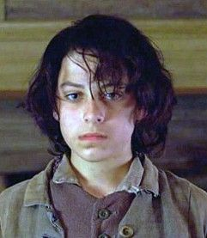
To what extent is Heathcliff ’s social position responsible for the misery and conflict so persistent in the book?
Extracts from Chapter 7

Catherine’s return

Heathcliff was hard to discover, at first. If he were careless, and uncared for, before Catherine's absence, he had been ten times more so since. Nobody but I even did him the kindness to call him a dirty boy, and bid him wash himself, once a week; and children of his age seldom have a natural pleasure in soap and water.
Therefore, not to mention his clothes, which had seen three months' service in mire and dust, and his thick uncombed hair, the surface of his face and hands was dismally beclouded. He might well skulk behind the settle, on beholding such a bright, graceful damsel enter the house, instead of a rough-headed counterpart of himself, as he expected. 'Is Heathcliff not here?' she demanded, pulling off her gloves, and displaying fingers wonderfully whitened with doing nothing and staying indoors.
'Heathcliff, you may come forward,' cried Mr. Hindley, enjoying his discomfiture, and gratified to see what a forbidding young blackguard he would be compelled to present himself. 'You may come and wish Miss Catherine welcome, like the other servants.'
Cathy, catching a glimpse of her friend in his concealment, flew to embrace him; she bestowed seven or eight kisses on his cheek within the second, and then stopped, and drawing back, burst into a laugh, exclaiming, 'Why, how very black and cross you look! and how - how funny and grim! But that's because I'm used to Edgar and Isabella Linton. Well, Heathcliff, have you forgotten me?'

Heathcliff’s reaction

'I shall not,' replied the boy, finding his tongue at last; 'I shall not stand to be laughed at. I shall not bear it!'
And he would have broken from the circle, but Miss Cathy seized him again.
'I did not mean to laugh at you,' she said; 'I could not hinder myself: Heathcliff, shake hands at least! What are you sulky for? It was only that you looked odd. If you wash your face and brush your hair, it will be all right: but you are so dirty!'
'You needn't have touched me!' he answered, following her eye and snatching away his hand.
'I shall be as dirty as I please: and I like to be dirty, and I will be dirty.'
With that he dashed headforemost out of the room, amid the merriment of the master and mistress, and to the serious disturbance of Catherine; who could not comprehend how her remarks should have produced such an exhibition of bad temper.

Extracts from Chapter 9: Catherine’s dual nature

1
‘Nelly will you keep a secret? It worries me and, I must let it out!’
‘I accepted him Nelly. Be quick and say whether I was wrong?’
‘You have pledged your word and you cannot retract.’
2
‘…you love Edgar and Edgar loves you. All seems smooth and easy, where is the obstacle?’
‘Here! And here!’ replied Catherine, striking one hand on her forehead and the other on her breast, ‘in whichever place the soul lives. In my soul and my heart, I am convinced I’m wrong!’

3
‘I’ve no more business to marry Edgar Linton than I have to be in heaven; and if the wicked man in there had not brought Heathcliffe so low, I shouldn’t have thought of it. It would degrade me to marry Heathcliffe now; so he shall never know how I love him: and that, not because he’s handsome Nelly, but because he’s more myself than I am. Whatever our souls are made of, his and mine are the same; and Linton’s is as different as a moonbeam from lightning or frost from fire.’

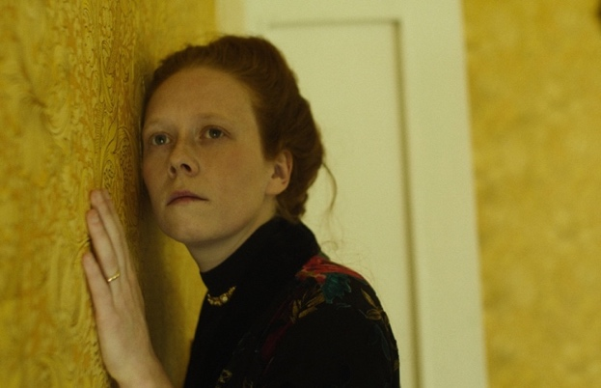
The Yellow Wallpaper

Charlotte Perkins Gilman (1860 –1935) was an American writer and a lecturer for social reform. Her best remembered work today is her semi-autobiographical short story "The Yellow Wallpaper", which she wrote after a severe bout of post-natal depression. It is regarded as an important early work of American feminist literature for its illustration of the attitudes towards mental and physical health of women in the 19th century.
Focused link to Wuthering Heights: Gradual inner conflict and insanity of key female protagonist
Extract 1
If a physician of high standing, and one's own husband, assures friends and relatives that there is really nothing the matter with one but temporary nervous depression - a slight hysterical tendency - what is one to do?
My brother is also a physician, and also of high standing, and he says the same thing. So I take phosphates or phosphites whichever it is, and tonics, and journeys, and air, and exercise, and am absolutely forbidden to "work" until I am well again. Personally, I disagree with their ideas. Personally, I believe that congenial work, with excitement and change, would do me good.
But what is one to do?
I did write for a while in spite of them; but it does exhaust me a good deal-having to be so sly about it, or else meet with heavy opposition.
I sometimes fancy that in my condition if I had less opposition and more society and stimulus - but John says the very worst thing I can do is to think about my condition, and I confess it always makes me feel bad.
Extract 2
I am getting angry enough to do something desperate. To jump out of the window would be admirable exercise, but the bars are too strong even to try.
Besides I wouldn't do it. Of course not. I know well enough that a step like that is improper and might be misconstrued.
I don't like to look out of the windows even—there are so many of those creeping women, and they creep so fast. I wonder if they all come out of that wall-paper as I did?
But I am securely fastened now by my well-hidden rope—you don't get ME out in the road there! I suppose I shall have to get back behind the pattern when it comes night, and that is hard!
It is so pleasant to be out in this great room and creep around as I please!

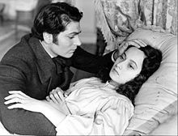
Is Catherine’s love for Heathcliff what causes her downfall?

Extract from Chapter 12: Catherine’s deterioration
'It's against the wall, as it always is,' she replied. 'It DOES appear odd - I see a face in it!'
'There's no press in the room, and never was,' said I, resuming my seat, and looping up the curtain that I might watch her.
'Don't YOU see that face?' she inquired, gazing earnestly at the mirror.
And say what I could, I was incapable of making her comprehend it to be her own; so I rose and covered it with a shawl.
'It's behind there still!' she pursued, anxiously. 'And it stirred. Who is it? I hope it will not come out when you are gone! Oh! Nelly, the room is haunted! I'm afraid of being alone!'

Extracts from Chapter 13: Isabella’s suffering

The remainder of the letter is for yourself alone. I want to ask you two questions: the first is, - How did you contrive to preserve the common sympathies of human nature when you resided here? I cannot recognise any sentiment which those around share with me.
The second question I have great interest in; it is this - Is Mr. Heathcliff a man? If so, is he mad? And if not, is he a devil? I shan't tell my reasons for making this inquiry; but I beseech you to explain, if you can, what I have married: that is, when you call to see me; and you must call, Ellen, very soon. Don't write, but come, and bring me something from Edgar.
…

Mr. Heathcliff awoke me; he had just come in, and demanded, in his loving manner, what I was doing there? I told him the cause of my staying up so late - that he had the key of our room in his pocket. The adjective OUR gave mortal offence. He swore it was not, nor ever should be, mine; and he'd - but I'll not repeat his language, nor describe his habitual conduct: he is ingenious and unresting in seeking to gain my abhorrence! I sometimes wonder at him with an intensity that deadens my fear: yet, I assure you, a tiger or a venomous serpent could not rouse terror in me equal to that which he wakens. He told me of Catherine's illness, and accused my brother of causing it promising that I should be Edgar's proxy in suffering, till he could get hold of him.
I do hate him - I am wretched - I have been a fool! Beware of uttering one breath of this to any one at the Grange. I shall expect you every day - don't disappoint me! - ISABELLA.

Extract from Chapter 14: Heathcliff’s love for Catherine

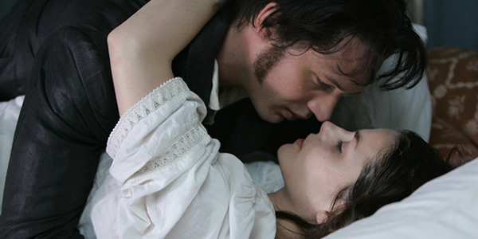

'You suppose she has nearly forgotten me?' he said. 'Oh, Nelly! you know she has not! You know as well as I do, that for every thought she spends on Linton she spends a thousand on me! At a most miserable period of my life, I had a notion of the kind: it haunted me on my return to the neighbourhood last summer; but only her own assurance could make me admit the horrible idea again. And then, Linton would be nothing, nor Hindley, nor all the dreams that ever I dreamt. Two words would comprehend my future - DEATH and HELL: existence, after losing her, would be hell. Yet I was a fool to fancy for a moment that she valued Edgar Linton's attachment more than mine. If he loved with all the powers of his puny being, he couldn't love as much in eighty years as I could in a day. And Catherine has a heart as deep as I have: the sea could be as readily contained in that horse-trough as her whole affection be monopolised by him. Tush! He is scarcely a degree dearer to her than her dog, or her horse. It is not in him to be loved like me: how can she love in him what he has not?'

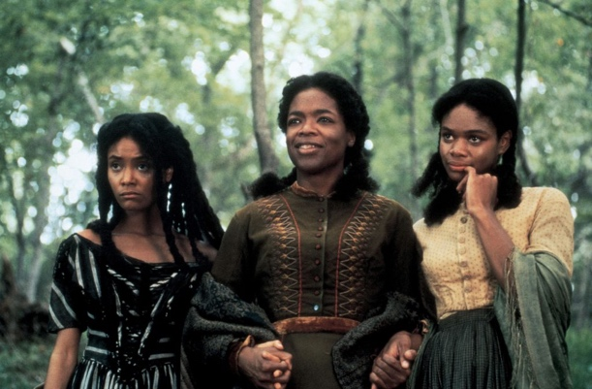
Beloved

Toni Morrison (1931-2019) was an American novelist. She became the first black female editor in fiction in New York City in the late 1960s. She developed her own reputation as an author in the 1970s and 80s. Beloved, published in 1987, tells the story of a family of former slaves whose home is haunted by a malevolent spirit.
Focused link to Wuthering Heights: Beloved addresses the inner possession of a female similar to how we see the deterioration and change in Catherine physically and mentally.
There is a quotation from the New Testament:
As he saith also in Osee, I will call them my people, which were not my people; and her beloved, which was not beloved.
Romans 9: 25
Paul D tied his shoes together, hung them over his shoulder and followed her through the door straight into a pool of red and undulating light that locked him where he stood.
"You got company?" he whispered, frowning.
"Off and on," said Sethe.
"Good God." He backed out the door onto the porch. "What kind of evil you got in here?"
"It's not evil, just sad. Come on. Just step through."
He looked at her then, closely. Closer than he had when she first rounded the house on wet and shining legs, holding her shoes and stockings up in one hand, her skirts in the other. Halle's girl--the one with iron eyes and backbone to match. He had never seen her hair in Kentucky. And though her face was eighteen years older than when last he saw her, it was softer now. Because of the hair. A face too still for comfort; irises the same colour as her skin, which, in that still face, used to make him think of a mask with mercifully punched-out eyes. Halle's woman. Pregnant every year including the year she sat by the fire telling him she was going to run. Her three children she had already packed into a wagonload of others in a caravan of Negroes crossing the river. They were to be left with Halle's mother near Cincinnati. Even in that tiny shack, leaning so close to the fire you could smell the heat in her dress, her eyes did not pick up a flicker of light. They were like two wells into which he had trouble gazing. Even punched out they needed to be covered, lidded, marked with some sign to warn folks of what that emptiness held. So he looked instead at the fire while she told him, because her husband was not there for the telling. Mr. Garner was dead and his wife had a lump in her neck the size of a sweet potato and unable to speak to anyone. She leaned as close to the fire as her pregnant belly allowed and told him, Paul D, the last of the Sweet Home men.
. . . [I]f you go there—you who was never there—if you go there and stand in the place where it was, it will happen again; it will be there, waiting for you . . . [E]ven though it’s all over—over and done with—it’s going to always be there waiting for you.

Brontë’s use of the supernatural

Extract from Chapter 15: Catherine’s decline

He neither spoke nor loosed his hold for some five minutes, during which period he bestowed more kisses than ever he gave in his life before, I daresay: but then my mistress had kissed him first, and I plainly saw that he could hardly bear, for downright agony, to look into her face! The same conviction had stricken him as me, from the instant he beheld her, that there was no prospect of ultimate recovery there - she was fated, sure to die.
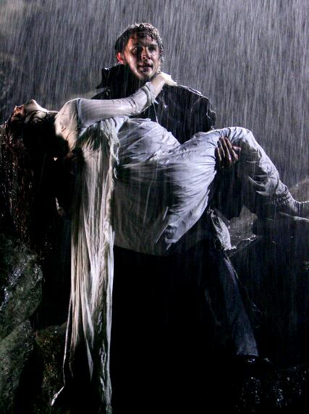
'Oh, Cathy! Oh, my life! how can I bear it?' was the first sentence he uttered, in a tone that did not seek to disguise his despair. And now he stared at her so earnestly that I thought the very intensity of his gaze would bring tears into his eyes; but they burned with anguish: they did not melt.
'What now?' said Catherine, leaning back, and returning his look with a suddenly clouded brow: her humour was a mere vane for constantly varying caprices. 'You and Edgar have broken my heart, Heathcliff! And you both come to bewail the deed to me, as if you were the people to be pitied! I shall not pity you, not I. You have killed me - and thriven on it, I think. How strong you are! How many years do you mean to live after I am gone?'

Extract from Chapter 16: Heathcliff’s grief
'May she wake in torment!' he cried, with frightful vehemence, stamping his foot, and groaning in a sudden paroxysm of ungovernable passion. 'Why, she's a liar to the end! Where is she? Not THERE - not in heaven - not perished - where? Oh! you said you cared nothing for my sufferings! And I pray one prayer - I repeat it till my tongue stiffens - Catherine Earnshaw, may you not rest as long as I am living; you said I killed you – haunt me, then! The murdered DO haunt their murderers, I believe. I know that ghosts HAVE wandered on earth. Be with me always - take any form - drive me mad! only DO not leave me in this abyss, where I cannot find you! Oh, God! it is unutterable! I CANNOT live without my life! I CANNOT live without my soul!'
He dashed his head against the knotted trunk; and, lifting up his eyes, howled, not like a man, but like a savage beast being goaded to death with knives and spears. I observed several splashes of blood about the bark of the tree, and his hand and forehead were both stained; probably the scene I witnessed was a repetition of others acted during the night. It hardly moved my compassion - it appalled me: still, I felt reluctant to quit him so. But the moment he recollected himself enough to notice me watching, he thundered a command for me to go, and I obeyed. He was beyond my skill to quiet or console!
Frankenstein

Mary Wollstonecraft Shelley (1797-1851) was an English novelist who wrote the Gothic novel Frankenstein when she was only 19. The novel is considered an early example of science fiction and tells the story of Victor Frankenstein, a young scientist who creates a sapient creature in an unorthodox scientific experiment.
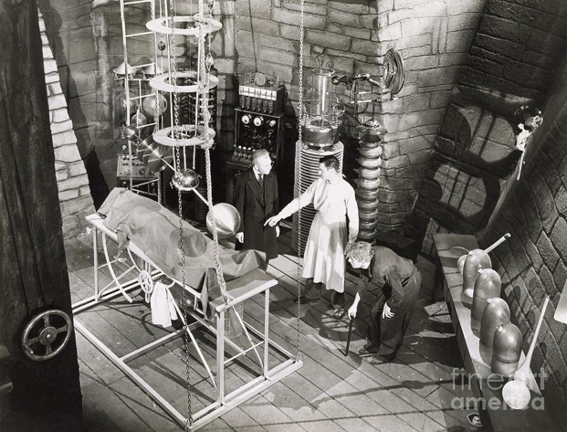
Focused link to Wuthering Heights: Frankenstein addresses the ‘violation’ of the dead and similar ‘Gothic breaking’ taboos that could link to Catherine’s sense of haunting Heathcliff and violating societal norms.

Extract 1
It was on a dreary night of November that I beheld the accomplishment of my toils. With an anxiety that almost amounted to agony, collected the instruments of life around me, that I might infuse a spark of being into the lifeless thing that lay at my feet. It was already one in the morning; the rain pattered dismally against the panes, and my candle was nearly burnt out, when, by the glimmer of the half-extinguished light, I saw the dull yellow eye of the creature open; it breathed hard, and a convulsive motion agitated its limbs.
How can I describe my emotions at this catastrophe, or how delineate the wretch whom with such infinite pains and care I had endeavoured to form? His limbs were in proportion, and I had selected his features as beautiful. Beautiful! -- Great God! His yellow skin scarcely covered the work of muscles and arteries beneath; his hair was of a lustrous black, and flowing; his teeth of a pearly whiteness; but these luxuriances only formed a more horrid contrast with his watery eyes, that seemed almost of the same colour as the dun white sockets in which they were set, his shrivelled complexion and straight black lips.
The different accidents of life are not so changeable as the feelings of human nature. I had worked hard for nearly two years, for the sole purpose of infusing life into an inanimate body. For this I had deprived myself of rest and health. I had desired it with an ardour that far exceeded moderation; but now that I had finished, the beauty of the dream vanished, and breathless horror and disgust filled my heart. Unable to endure the aspect of the being I had created, I rushed out of the room.
Extract 2
But I scarcely observed this; rage and hatred had at first deprived me of utterance, and I recovered only to overwhelm him with words expressive of furious detestation and contempt.
"Devil," I exclaimed, "do you dare approach me? and do not you fear the fierce vengeance of my arm wreaked on your miserable head? Begone, vile insect! or rather, stay, that I may trample you to dust! and, oh! that I could, with the extinction of your miserable existence, restore those victims whom you have so diabolically murdered!"
"I expected this reception," said the daemon. "All men hate the wretched; how, then, must I be hated, who am miserable beyond all living things! Yet you, my creator, detest and spurn me, thy creature, to whom thou art bound by ties only dissoluble by the annihilation of one of us. You purpose to kill me. How dare you sport thus with life? Do your duty towards me, and I will do mine towards you and the rest of mankind. If you will comply with my conditions, I will leave them and you at peace; but if you refuse, I will glut the maw of death, until it be satiated with the blood of your remaining friends."
"Abhorred monster! fiend that thou art! the tortures of hell are too mild a vengeance for thy crimes. Wretched devil! you reproach me with your creation; come on, then, that I may extinguish the spark which I so negligently bestowed."

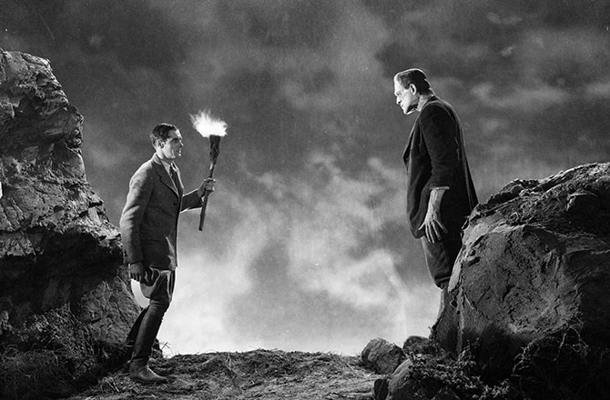

Rebecca

Dame Daphne du Maurier (1907-1989) was an English author and playwright. Although she is classed as a romantic novelist, her stories have been described as "moody and resonant" with overtones of the paranormal. The Gothic novel Rebecca, published in 1938, depicts an unnamed young woman who impetuously marries a wealthy widower, before discovering that both he and his household are haunted by the memory of his late first wife, the title character.
Focused link to Wuthering Heights: Rebecca addresses the role of relationships and the impact on the mind and inner struggle.
Extract 1, Chapter 2:
The devil does not ride us any more.We have come through our crisis, not unscathed of course. His premonition of disaster was correct from the beginning; and like a ranting actress in a different play, I might say that we have paid for freedom. But I have had enough melodrama in this life, and would willingly give my five senses if they could ensure us our present peace and security. Happiness is not a possession to be prized, it is a quality of thought, a state of mind. Of course we have our moments of depression; but there are other moments too, when time, unmeasured by the clock, runs on into eternity and, catching his smile, I know we are together, we march in unison, no clash of thought or of opinion makes a barrier between us
We have no secrets now from one another. All things are shared. Granted that our little hotel is dull, and the food indifferent, and that day after day dawns very much the same, yet we would not have it otherwise. We should meet too many of the people he knows in any of the big hotels. We both appreciate simplicity, and we are sometimes bored – well, boredom is a pleasing antidote to fear. We live very much by routine, and I – I have developed a genius for reading aloud.

Extract 2 Chapter 8
“Who is it?” I said, “who do you want?”
There was a strange buzzing at the end of the line, and then a voice came, low and rather harsh, whether that of a woman or a man I could not tell, and “Mrs. de Winter?” it said, “Mrs. de Winter?”
“I'm afraid you have made a mistake,” I said; “Mrs. de Winter has been dead for over a year.” I sat there, waiting, staring stupidly into the mouthpiece, and it was not until the name was repeated again, the voice incredulous, slightly raised, that I became aware, with a rush of colour to my face, that I had blundered irretrievably, and could not take back my words.
“It's Mrs. Danvers, Madam,” said the voice. “I'm speaking to you on the house telephone.”

Extract 3 Chapter 11
I heard myself saying boldly, brazenly, “Rebecca must have been a wonderful person.”
I could not believe that I had said the name at last. I waited, wondering what would happen. I had said the name. I had said the word Rebecca aloud. It was a tremendous relief. It was as though I had taken a purge and rid myself of an intolerable pain. Rebecca. I had said it aloud.
To what extent does it seem that history is repeating itself with the younger generation?

Extract from Chapter 19: Cathy and Linton meet

He had been greatly tried, during the journey, I felt convinced, by his fretful ailing charge. Linton slowly trailed himself off, and lay down. Cathy carried a footstool and her cup to his side. At first she sat silent; but that could not last: she had resolved to make a pet of her little cousin, as she would have him to be; and she commenced stroking his curls, and kissing his cheek, and offering him tea in her saucer, like a baby. This pleased him, for he was not much better: he dried his eyes, and lightened into a faint smile.
'Oh, he'll do very well,' said the master to me, after watching them a minute. 'Very well, if we can keep him, Ellen. The company of a child of his own age will instil new spirit into him soon, and by wishing for strength he'll gain it.'

Extract from Chapter 21: Heathcliff’s plan

'Mr. Heathcliff, it's very wrong,' I continued: 'you know you mean no good. And there she'll see Linton, and all will be told as soon as ever we return; and I shall have the blame.'
'I want her to see Linton,' he answered; 'he's looking better these few days; it's not often he's fit to be seen. And we'll soon persuade her to keep the visit secret: where is the harm of it?'
'The harm of it is, that her father would hate me if he found I suffered her to enter your house; and I am convinced you have a bad design in encouraging her to do so,' I replied.
'My design is as honest as possible. I'll inform you of its whole scope,' he said. 'That the two cousins may fall in love, and get married. I'm acting generously to your master: his young chit has no expectations, and should she second my wishes she'll be provided for at once as joint successor with Linton.'
'If Linton died,' I answered, 'and his life is quite uncertain, Catherine would be the heir.'
'No, she would not,' he said. 'There is no clause in the will to secure it so: his property would go to me; but, to prevent disputes, I desire their union, and am resolved to bring it about.'
'And I'm resolved she shall never approach your house with me again,' I returned, as we reached the gate, where Miss Cathy waited our coming.
Heathcliff bade me be quiet; and, preceding us up the path, hastened to open the door. My young lady gave him several looks, as if she could not exactly make up her mind what to think of him; but now he smiled when he met her eye, and softened his voice in addressing her; and I was foolish enough to imagine the memory of her mother might disarm him from desiring her injury.

Extract from Chapter 22: Nelly- Catherine vs Cathy

Cathy stole to his room to inquire how he was; he had fallen asleep. She returned, and asked me to sit with her in the library. We took our tea together; and afterwards she lay down on the rug, and told me not to talk, for she was weary. I got a book, and pretended to read. As soon as she supposed me absorbed in my occupation, she recommenced her silent weeping: it appeared, at present, her favourite diversion. I suffered her to enjoy it a while; then I expostulated: deriding and ridiculing all Mr. Heathcliff's assertions about his son, as if I were certain she would coincide. Alas! I hadn't skill to counteract the effect his account had produced: it was just what he intended.
'You may be right, Ellen,' she answered; 'but I shall never feel at ease till I know. And I must tell Linton it is not my fault that I don't write, and convince him that I shall not change.'
What use were anger and protestations against her silly credulity? We parted that night - hostile; but next day beheld me on the road to Wuthering Heights, by the side of my wilful young mistress's pony. I couldn't bear to witness her sorrow: to see her pale, dejected countenance, and heavy eyes: and I yielded, in the faint hope that Linton himself might prove, by his reception of us, how little of the tale was founded on fact.

Great Expectations

Charles Dickens was an English writer and social critic. He created some of the world's best-known fictional characters and is regarded by many as the greatest novelist of the Victorian era. Great Expectations is his thirteenth novel which follows the life of the orphan, Pip. One of the characters Pip meets is Miss Havisham, a wealthy spinster, once jilted at the altar, who insists on wearing her wedding dress for the rest of her life. She lives in a ruined mansion with her adopted daughter, Estella

Focused link to Wuthering Heights: Second generation and disappointment/cruelty in treatment of others; Heathcliff’s similarity to Miss Havisham; the role of the antagonist.

Extract 1
"Look at me," said Miss Havisham. "You are not afraid of a woman who has never seen the sun since you were born?" I regret to state that I was not afraid of telling the enormous lie comprehended in the answer "No."
"Do you know what I touch here?" she said, laying her hands, one upon the other, on her left side.
"Yes, ma'am." (It made me think of the young man.)
"What do I touch?"
"Your heart."
"Broken!"
She uttered the word with an eager look, and with strong emphasis, and with a weird smile that had a kind of boast in it. Afterwards, she kept her hands there for a little while, and slowly took them away as if they were heavy.
"I am tired," said Miss Havisham. "I want diversion, and I have done with men and women. Play.

Extract 2
Miss Havisham beckoned her to come close, and took up a jewel from the table, and tried its effect upon her fair young bosom and against her pretty brown hair. "Your own, one day, my dear, and you will use it well. Let me see you play cards with this boy."
"With this boy? Why, he is a common labouring-boy!"
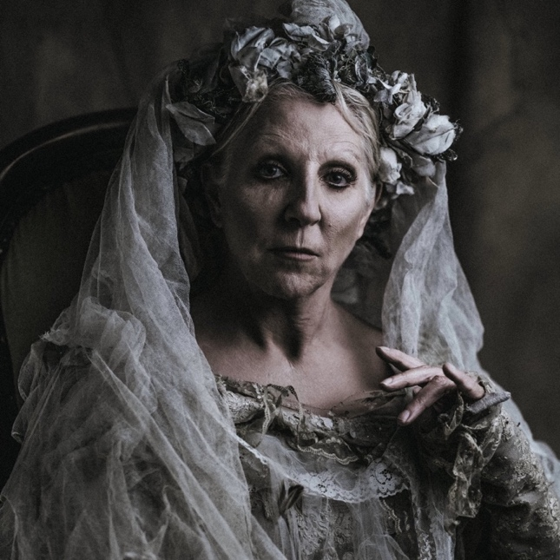
I thought I overheard Miss Havisham answer - only it seemed so unlikely - "Well? You can break his heart."

Extract 3
Then, Estella being gone and we two left alone, she turned to me, and said in a whisper:
"Is she beautiful, graceful, well-grown? Do you admire her?"
"Everybody must who sees her, Miss Havisham."
She drew an arm round my neck, and drew my head close down to hers as she sat in the chair. "Love her, love her, love her! How does she use you?"
Before I could answer (if I could have answered so difficult a question at all), she repeated, "Love her, love her, love her! If she favours you, love her. If she wounds you, love her. If she tears your heart to pieces - and as it gets older and stronger, it will tear deeper - love her, love her, love her!"
Never had I seen such passionate eagerness as was joined to her utterance of these words. I could feel the muscles of the thin arm round my neck, swell with the vehemence that possessed her.
"Hear me, Pip! I adopted her to be loved. I bred her and educated her, to be loved. I developed her into what she is, that she might be loved. Love her!"
She said the word often enough, and there could be no doubt that she meant to say it; but if the often repeated word had been hate instead of love - despair - revenge - dire death - it could not have sounded from her lips more like a curse.
"I'll tell you," said she, in the same hurried passionate whisper, "what real love is. It is blind devotion, unquestioning self-humiliation, utter submission, trust and belief against yourself and against the whole world, giving up your whole heart and soul to the smiter - as I did!"

How does Brontë use time as a structural technique within the novel?
Extract from Chapter 23: Cathy echoes her mother’s ways

'You won't go to-morrow, recollect, Miss!' I commenced, when we were out of the house. 'You are not dreaming of it, are you?'
She smiled.
'Oh, I'll take good care,' I continued: 'I'll have that lock mended, and you can escape by no way else.'
'I can get over the wall,' she said laughing. 'The Grange is not a prison, Ellen, and you are not my gaoler. And besides, I'm almost seventeen: I'm a woman. And I'm certain Linton would recover quickly if he had me to look after him. I'm older than he is, you know, and wiser: less childish, am I not? And he'll soon do as I direct him, with some slight coaxing. He's a pretty little darling when he's good. I'd make such a pet of him, if he were mine. We should, never quarrel, should we after we were used to each other? Don't you like him, Ellen?'
'Like him!' I exclaimed. 'The worst-tempered bit of a sickly slip that ever struggled into its teens. Happily, as Mr. Heathcliff conjectured, he'll not win twenty. I doubt whether he'll see spring, indeed. And small loss to his family whenever he drops off. And lucky it is for us that his father took him: the kinder he was treated, the more tedious and selfish he'd be. I'm glad you have no chance of having him for a husband, Miss Catherine.'
My companion waxed serious at hearing this speech. To speak of his death so regardlessly wounded her feelings.
'He's younger than I,' she answered, after a protracted pause of meditation, 'and he ought to live the longest: he will - he must live as long as I do. He's as strong now as when he first came into the north; I'm positive of that.’

Extract from Chapter 24: Like Father like Son

Hareton Earnshaw burst the door open: having gathered venom with reflection. He advanced direct to us, seized Linton by the arm, and swung him off the seat.
'"Get to thy own room!" he said, in a voice almost inarticulate with passion; and his face looked swelled and furious. "Take her there if she comes to see thee: thou shalln't keep me out of this. Begone wi' ye both!"
'He swore at us, and left Linton no time to answer, nearly throwing him into the kitchen; and he clenched his fist as I followed, seemingly longing to knock me down. I was afraid for a moment, and I let one volume fall; he kicked it after me, and shut us out. I heard a malignant, crackly laugh by the fire, and turning, beheld that odious Joseph standing rubbing his bony hands, and quivering.
'"I wer sure he'd sarve ye out! He's a grand lad! He's getten t' raight sperrit in him! HE knaws - ay, he knaws, as weel as I do, who sud be t' maister yonder - Ech, ech, ech! He made ye skift properly! Ech, ech, ech!"
'"Where must we go?" I asked of my cousin, disregarding the old wretch's mockery.
'Linton was white and trembling. He was not pretty then, Ellen: oh, no! he looked frightful; for his thin face and large eyes were wrought into an expression of frantic, powerless fury. He grasped the handle of the door, and shook it: it was fastened inside.
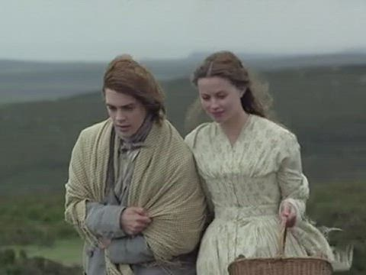
'"If you don't let me in, I'll kill you! - If you don't let me in, I'll kill you!" he rather shrieked than said. "Devil! devil! - I'll kill you - I'll kill you!"

Strange Case of Dr Jekyll and Mr Hyde
Robert Louis Stevenson (1850 – 1894) was a Scottish novelist, essayist, poet and travel writer. He is best known for adventure stories such as Treasure Island and Kidnapped. Strange Case of Dr Jekyll and Mr Hyde is a Gothic novella about a London legal practitioner named Gabriel John Utterson who investigates strange occurrences between his old friend, Dr. Henry Jekyll and the evil Edward Hyde.

Extract 1
Presently her eye wandered to the other, and she was surprised to recognise in him a certain Mr Hyde, who had once visited her master, and for whom she had conceived a dislike. He had in his hand a heavy cane, with which he was trifling; but he answered never a word, and seemed to listen with an ill-contained impatience. And then all of a sudden he broke out in a great flame of anger, stamping with his foot, brandishing the cane, and carrying on (as the maid described it) like a madman. The very old gentleman took a step back, with the air of one very much surprised and a trifle hurt; and at that Mr Hyde broke out of all bounds, and clubbed him to the earth. And next moment, with ape-like fury, he was trampling his victim under foot, and hailing down a storm of blows, under which the bones were audibly shattered and the body jumped upon the roadway. At the horror of these sights and sounds, the maid fainted.

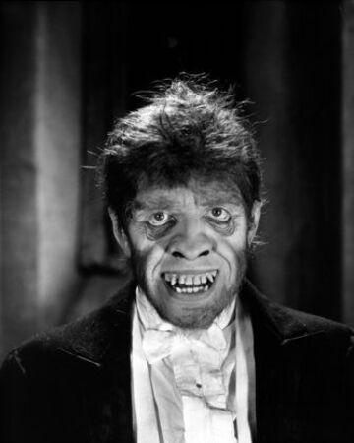
Extract 2
“And now,” said the other, “how did you know me?”
“By description,” was the reply.
“Whose description?”
“We have common friends,” said Mr. Utterson.
“Common friends?” echoed Mr. Hyde, a little hoarsely. “Who are they?”
“Jekyll, for instance,” said the lawyer.
“He never told you,” cried Mr. Hyde, with a flush of anger. “I did not think you would have lied.”
“Come,” said Mr. Utterson, “that is not fitting language.”
The other snarled aloud into a savage laugh; and the next moment, with extraordinary quickness, he had unlocked the door and disappeared into the house.
The lawyer stood a while when Mr. Hyde had left him, the picture of disquietude. Then he began slowly to mount the street, pausing every step or two and putting his hand to his brow like a man in mental perplexity. The problem he was thus debating as he walked, was one of a class that is rarely solved. Mr. Hyde was pale and dwarfish, he gave an impression of deformity without any nameable malformation, he had a displeasing smile, he had borne himself to the lawyer with a sort of murderous mixture of timidity and boldness, and he spoke with a husky, whispering and somewhat broken voice; all these were points against him, but not all of these together could explain the hitherto unknown disgust, loathing, and fear with which Mr. Utterson regarded him. “There must be something else,” said the perplexed gentleman. “There is something more, if I could find a name for it. God bless me, the man seems hardly human! Something troglodytic, shall we say? or can it be the old story of Dr. Fell? or Is it the mere radiance of a foul soul that thus transpires through, and transfigures, its clay continent? The last, I think; for, O my poor old Harry Jekyll, if ever I read Satan’s signature upon a face, it Is on that of your new friend.”

How does Bronte portray Heathcliff as inherently evil?
Chapter 27: Heathcliff’s influence on others

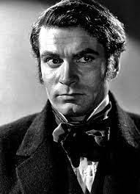
'But first - get up, Linton! Get up!' he shouted.
'Don't grovel on the ground there up, this moment!'
Linton had sunk prostrate again in another paroxysm of helpless fear, caused by his father's glance towards him, I suppose: there was nothing else to produce such humiliation. He made several efforts to obey, but his little strength was annihilated for the time, and he fell back again with a moan. Mr. Heathcliff advanced, and lifted him to lean against a ridge of turf.
'Now,' said he, with curbed ferocity, 'I'm getting angry and if you don't command that paltry spirit of yours - DAMN you! get up directly!'
'I will, father,' he panted. 'Only, let me alone, or I shall faint. I've done as you wished, I'm sure. Catherine will tell you that I - that I - have been cheerful. Ah! keep by me, Catherine; give me your hand.'
'Take mine,' said his father; 'stand on your feet. There now - she'll lend you her arm: that's right, look at her. You would imagine I was the devil himself, Miss Linton, to excite such horror. Be so kind as to walk home with him, will you? He shudders if I touch him.'

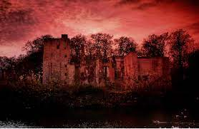
Chapter 29: Heathcliff’s torment - the supernatural

You know I was wild after she died; and eternally, from dawn to dawn, praying her to return to me her spirit! I have a strong faith in ghosts: I have a conviction that they can, and do, exist among us! The day she was buried, there came a fall of snow. In the evening I went to the churchyard. It blew bleak as winter - all round was solitary. I didn't fear that her fool of a husband would wander up the glen so late; and no one else had business to bring them there. Being alone, and conscious two yards of loose earth was the sole barrier between us, I said to myself - 'I'll have her in my arms again! If she be cold, I'll think it is this north wind that chills ME; and if she be motionless, it is sleep."
There was another sigh, close at my ear. I appeared to feel the warm breath of it displacing the sleet-laden wind. I knew no living thing in flesh and blood was by; but, as certainly as you perceive the approach to some substantial body in the dark, though it cannot be discerned, so certainly I felt that Cathy was there: not under me, but on the earth. A sudden sense of relief flowed from my heart through every limb. I relinquished my labour of agony, and turned consoled at once: unspeakably consoled. Her presence was with me: it remained while I re-filled the grave, and led me home. You may laugh, if you will; but I was sure I should see her there. I was sure she was with me, and I could not help talking to her.
Having reached the Heights, I rushed eagerly to the door. It was fastened; and, I remember, that accursed Earnshaw and my wife opposed my entrance. I remember stopping to kick the breath out of him, and then hurrying up-stairs, to my room and hers. I looked round impatiently - I felt her by me - I could ALMOST see her, and yet I COULD NOT! I ought to have sweat blood then, from the anguish of my yearning - from the fervour of my supplications to have but one glimpse! I had not one. She showed herself, as she often was in life, a devil to me! And, since then, sometimes more and sometimes less, I've been the sport of that intolerable torture! Infernal! keeping my nerves at such a stretch that, if they had not resembled catgut, they would long ago have relaxed to the feebleness of Linton's. When I sat in the house with Hareton, it seemed that on going out I should meet her; when I walked on the moors I should meet her coming in. When I went from home I hastened to return; she MUST be somewhere at the Heights, I was certain! And when I slept in her chamber - I was beaten out of that. I couldn't lie there; for the moment I closed my eyes, she was either outside the window, or sliding back the panels, or entering the room, or even resting her darling head on the same pillow as she did when a child; and I must open my lids to see.
And so I opened and closed them a hundred times a night - to be always disappointed! It racked me! I've often groaned aloud, till that old rascal Joseph no doubt believed that my conscience was playing the fiend inside of me. Now, since I've seen her, I'm pacified – a little. It was a strange way of killing: not by inches, but by fractions of hairbreadths, to beguile me with the spectre of a hope through eighteen years!'
Mr. Heathcliff paused and wiped his forehead; his hair clung to it, wet with perspiration; his eyes were fixed on the red embers of the fire, the brows not contracted, but raised next the temples; diminishing the grim aspect of his countenance, but imparting a peculiar look of trouble, and a painful appearance of mental tension towards one absorbing subject. He only half addressed me, and I maintained silence.

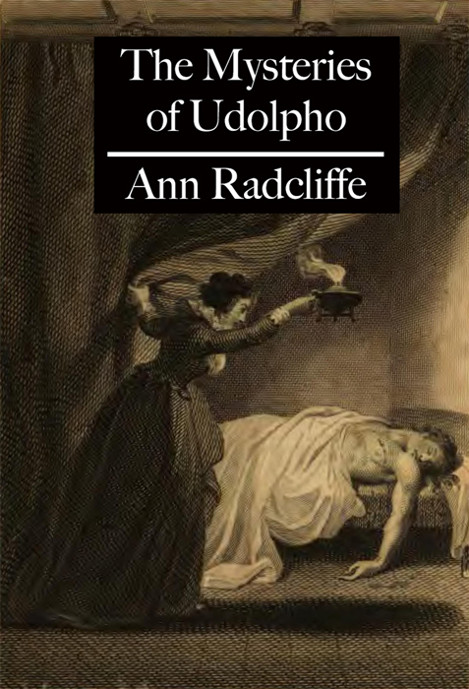
The Mysteries of Udolpho
Focused link to Wuthering Heights: The exploration of vulnerable women; Cathy’s imprisonment and the danger for Emily St Aubert
Extract 1
At this instant, recollecting Barnardine’s manner, on the preceding night, she now believed, what she had then fancied, that it expressed malignant triumph. She shuddered at the recollection, which confirmed her fears, and determined not to meet him on the terrace. Soon after, she was inclined to consider these suspicions as the extravagant exaggerations of a timid and harassed mind, and could not believe Montoni liable to such preposterous depravity as that of destroying, from one motive, his wife and her niece. She blamed herself for suffering her romantic imagination to carry her so far beyond the bounds of probability, and determined to endeavour to check its rapid flights, lest they should sometimes extend into madness. Still, however, she shrunk from the thought of meeting Barnardine, on the terrace, at midnight; and still the wish to be relieved from this terrible suspense, concerning her aunt, to see her, and to sooth her sufferings, made her hesitate what to do.

Extract 2
During the remainder of the day, Emily’s mind was agitated with doubts and fears and contrary determinations, on the subject of meeting this Barnardine on the rampart, and submitting herself to his guidance, she scarcely knew whither. Pity for her aunt and anxiety for herself alternately swayed her determination, and night came, before she had decided upon her conduct. She heard the castle clock strike eleven — twelve — and yet her mind wavered. The time, however, was now come, when she could hesitate no longer: and then the interest she felt for her aunt overcame other considerations, and, bidding Annette follow her to the outer door of the vaulted gallery, and there await her return, she descended from her chamber. The castle was perfectly still, and the great hall, where so lately she had witnessed a scene of dreadful contention, now returned only the whispering footsteps of the two solitary figures gliding fearfully between the pillars, and gleamed only to the feeble lamp they carried. Emily, deceived by the long shadows of the pillars and by the catching lights between, often stopped, imagining she saw some person, moving in the distant obscurity of the perspective; and, as she passed these pillars, she feared to turn her eyes toward them, almost expecting to see a figure start out from behind their broad shaft. She reached, however, the vaulted gallery, without interruption, but unclosed its outer door with a trembling hand, and, charging Annette not to quit it and to keep it a little open, that she might be heard if she called, she delivered to her the lamp, which she did not dare to take herself because of the men on watch, and, alone, stepped out upon the dark terrace. Every thing was so still, that she feared, lest her own light steps should be heard by the distant sentinels, and she walked cautiously towards the spot, where she had before met Barnardine, listening for a sound, and looking onward through the gloom in search of him. At length, she was startled by a deep voice, that spoke near her, and she paused, uncertain whether it was his, till it spoke again, and she then recognized the hollow tones of Barnardine, who had been punctual to the moment, and was at the appointed place, resting on the rampart wall. After chiding her for not coming sooner, and saying, that he had been waiting nearly half an hour, he desired Emily, who made no reply, to follow him to the door, through which he had entered the terrace.

Extract 3

All the horrid apprehensions, that had lately assailed her, returned at this instant with redoubled force, and no longer appeared like the exaggerations of a timid spirit, but seemed to have been sent to warn her of her fate. She now did not doubt, that Madame Montoni had been murdered, perhaps in this very chamber; or that she herself was brought hither for the same purpose. The countenance, the manners and the recollected words of Barnardine, when he had spoken of her aunt, confirmed her worst fears. For some moments, she was incapable of considering of any means, by which she might attempt an escape.

Big Question: What is the nature of love in the novel, that it can be so closely connected to vengeance?
Chapter 33: Heathcliff’s brutality and violence

It was too late: Heathcliff had caught hold of her.
'Now, YOU go!' he said to Earnshaw. 'Accursed witch! this time she has provoked me when I could not bear it; and I'll make her repent it for ever!'
He had his hand in her hair; Hareton attempted to release her looks, entreating him not to hurt her that once. Heathcliff's black eyes flashed; he seemed ready to tear Catherine in pieces, and I was just worked up to risk coming to the rescue, when of a sudden his fingers relaxed; he shifted his grasp from her head to her arm, and gazed intently in her face. Then he drew his hand over his eyes, stood a moment to collect himself apparently, and turning anew to Catherine, said, with assumed calmness –
'You must learn to avoid putting me in a passion, or I shall really murder you some time! Go with Mrs. Dean, and keep with her; and confine your insolence to her ears. As to Hareton Earnshaw, if I see him listen to you, I'll send him seeking his bread where he can get it! Your love will make him an outcast and a beggar. Nelly, take her; and leave me, all of you!
Leave me!'

Chapter 33: Heathcliff’s final declaration

'Nelly, there is a strange change approaching; I'm in its shadow at present. I take so little interest in my daily life that I hardly remember to eat and drink. Those two who have left the room are the only objects which retain a distinct material appearance to me; and that appearance causes me pain, amounting to agony. About HER I won't speak; and I don't desire to think; but I earnestly wish she were invisible: her presence invokes only maddening sensations. HE moves me differently: and yet if I could do it without seeming insane, I'd never see him again! You'll perhaps think me rather inclined to become so,' he added, making an effort to smile, 'if I try to describe the thousand forms of past associations and ideas he awakens or embodies. But you'll not talk of what I tell you; and my mind is so eternally secluded in itself, it is tempting at last to turn it out to another.
'Five minutes ago Hareton seemed a personification of my youth, not a human being; I felt to him in such a variety of ways, that it would have been impossible to have accosted him rationally. In the first place, his startling likeness to Catherine connected him fearfully with her. That, however, which you may suppose the most potent to arrest my imagination, is actually the least: for what is not connected with her to me? and what does not recall her? I cannot look down to this floor, but her features are shaped in the flags! In every cloud, in every tree - filling the air at night, and caught by glimpses in every object by day - I am surrounded with her image! The most ordinary faces of men and women - my own features - mock me with a resemblance. The entire world is a dreadful collection of memoranda that she did exist, and that I have lost her! Well, Hareton's aspect was the ghost of my immortal love; of my wild endeavours to hold my right; my degradation, my pride, my happiness, and my anguish -
'But it is frenzy to repeat these thoughts to you: only it will let you know why, with a reluctance to be always alone, his society is no benefit; rather an aggravation of the constant torment I suffer: and it partly contributes to render me regardless how he and his cousin go on together. I can give them no attention any more.
'Then you are not afraid of death?' I pursued.
'Afraid? No!' he replied. 'I have neither a fear, nor a presentiment, nor a hope of death. Why should I? With my hard constitution and temperate mode of living, and unperilous occupations, I ought to, and probably SHALL, remain above ground till there is scarcely a black hair on my head. And yet I cannot continue in this condition! I have to remind myself to breathe - almost to remind my heart to beat! And it is like bending back a stiff spring: it is by compulsion that I do the slightest act not prompted by one thought; and by compulsion that I notice anything alive or dead, which is not associated with one universal idea. I have a single wish, and my whole being and faculties are yearning to attain it. They have yearned towards it so long, and so unwaveringly, that I'm convinced it will be reached - and soon - because it has devoured my existence: I am swallowed up in the anticipation of its fulfilment. My confessions have not relieved me; but they may account for some otherwise unaccountable phases of humour which I show. O God! It is a long fight; I wish it were over!'

Pathos – something that causes pity or sadness.

