Remind yourself of ‘Significant Cigarettes’ from the Edexcel Anthology and then answer the following question:
How does the write convey a sense of loneliness in the ‘Significant Cigarettes’?
In your answer, you should write about:
• the characters
• the setting(s)
• the use of language

You should support your answer with close reference to the passage, including brief quotations.
(45mins/30marks - AO1 = 12, AO2 = 18)
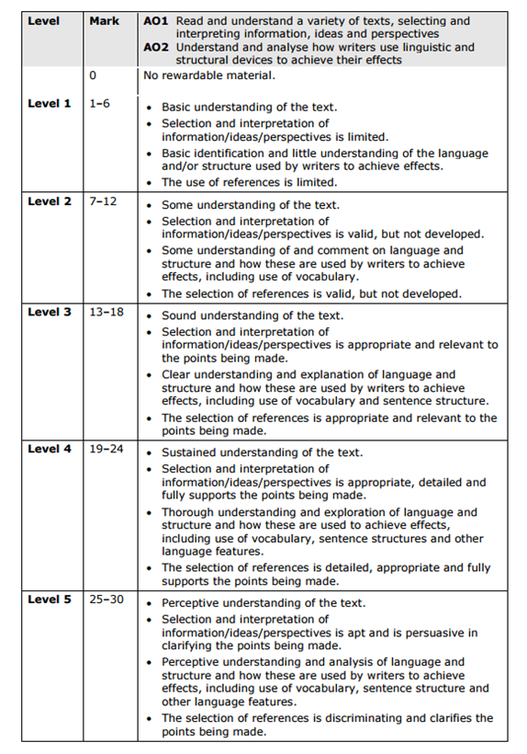
Key Things Examiner is Looking For:
A01 Your take on what you’ve read using A02 the appropriate terminology and examples of language and structure to explain and support your ideas.
- Show you are very perceptive and understand it
- Pick specifically useful quotes to support your ideas
- Say HOW these techniques convey LONELINESS

PLAN

Intro – don’t waste it. Get to the point quickly, don’t say ‘in various ways’.

Summarise in one – two sentences

a)How characters convey loneliness (although close, they are very separate and individual. Difference between loneliness = negative and not a choice (Lev) and being ‘alone’ being a positive and a choice – egg lady).
b) How setting conveys loneliness – nature to city, bus itself, the journey, contrast of all the above.

1 FOCUS ON LEV – First impressions, quote and technique?, ask the exrtract develops – quote and techniques, towards the end how he changes or reveals more of himself/background. CONNECT TO LONELINESS

2. FOCUS ON EGG LADY – Contrast with Lev and the same as above. Focus on how alone she is but not lonely? Pick out quotes to highlight her character.

- Focus on setting – Nature and how it can be a positive and a negative in terms of loneliness and the opposite – belonging. Lots of refs to nature being a good thing in Lev’s life. But that the barren-ness of wood mill suggestive of loneliness that developed. How nature merges into urban environment and how one takes over the other.

Talk about the setting of the bus – lots of people together and yet paradoxical still alone – example of how they operate in close proximity and yet remain distinctly separate. Quotes and link to LONELINESS

Talk about language as an issue in itself – different stories, lost in translation. How language can exclude and include – loneliness/separate ness – ‘other-ness’. How Lev and egg lady are very different. Motivations for moving – Lev happy with status quo whereas egg lady not.

As conclusion talks about last paragraphs – bring in character and setting and structure – how it ends and a quote that sums up what the writer has to say about loneliness as a whole…..

LONELINESS SYNONYMS, QUOTES AND CLOSE WORD ANALYSIS WITH USE OF LITERARY TERMINOLOGY THROUGHOUT.

