|  |  |
| --- | --- |
| Read the extract from *Beyond the Sky and the Earth: A Journey into Bhutan*, by Jamie Zeppa  Zeppa describes the *place, people* and *history* of Bhutan in order to convey her *thoughts and feelings* about the country.   * Use the following table to briefly explain what each quote reveals about her feelings. * Number 4 in each box has been left for you to find your own quote and analysis. | File:Beyond the Sky and Earth front cover.jpg |

# Task one

|  |  |  |
| --- | --- | --- |
|  | **Evidence** | **Connotes feelings of …** |
| Landscape | 1. ‘Mountains all around … rolling into valleys, again and again’ (line1) 2. ‘a giant child gathering earth in great armfuls …’ (line 4) 3. ‘I watch mountains rise to meet the moon’ (line 10) | 1. She is in awe of the expanse of her surroundings. |

|  |  |  |
| --- | --- | --- |
|  | **Evidence** | **Connotes feelings of …** |
| Town | 1. ‘it took five different flights over four days to get here’ (line 8) 2. ‘One-storied shops with wooden-shuttered windows open onto the street.’ (line 34) 3. ‘Thimphu is actually new’ (line 46) | 1. Shows how remote the capital city is from her home country. |
| People | 1. ‘Blue-suited policemen … using incomprehensible but graceful hand gestures’ (line 31) 2. ‘they have beautiful, aristocratic faces’ (line 56) 3. ‘I search for the right word to describe the people, the quality that impresses me most’ (lines 66-67) |  |

|  |  |  |
| --- | --- | --- |
|  | **Evidence** | **Connotes feelings of …** |
| History | 1. ‘the area is thought to have been long inhabited before that’ (line 73) 2. ‘earlier names for Bhutan are just as beautiful … Lotus grove of the Gods’ (line 80) 3. ‘Bhutan’s preservation of its independence was remarkable’ (line 96) |  |

# Task two

List all of the Bhutanese vocabulary including place names used in the extract.

* Write the translation for each word.
* What does the use of these Bhutanese words add to the impression Zeppa gives of this country?

|  |  |  |
| --- | --- | --- |
| **Bhutanese word** | **Translation** | **What does this add to our impression of the country?** |
| Thimphu | Capital of Bhutan |  |
| Druk Sherig Hotel | Name of the hotel |  |
| Dzong |  |  |
|  |  |  |
|  |  |  |
|  |  |  |
|  |  |  |
|  |  |  |
|  |  |  |
|  |  |  |

# Task three

Understanding the *structure* of the extract.

Jamie Zeppa structures her memoir in a particular way. Look at the line references below. Read back through those paragraphs and:

* summarise what each part is about
* comment on what each section is doing in terms of reflecting the writer’s thoughts about the country.

|  |  |
| --- | --- |
| **Lines  1-6** | Abstract introduction to its main geographical feature. Starts with a sense of being blinded by the strangeness of it all to grab the reader’s interest. Makes us feel as overwhelmed as she is. |
| **Lines  7-18** |  |
| **Lines  19-29** |  |
| **Lines  30-53** |  |
| **Lines  54-69** |  |

|  |  |
| --- | --- |
| **Lines  70-86** |  |
| **Lines  87-end** |  |

1. Look again at the first and last paragraphs in particular. Why do you think she opens and closes the extract in this way?
2. The whole purpose of this extract is to make us ‘full of admiration’ for the country and people of Bhutan. Write a paragraph responding to this comment.

# Task:

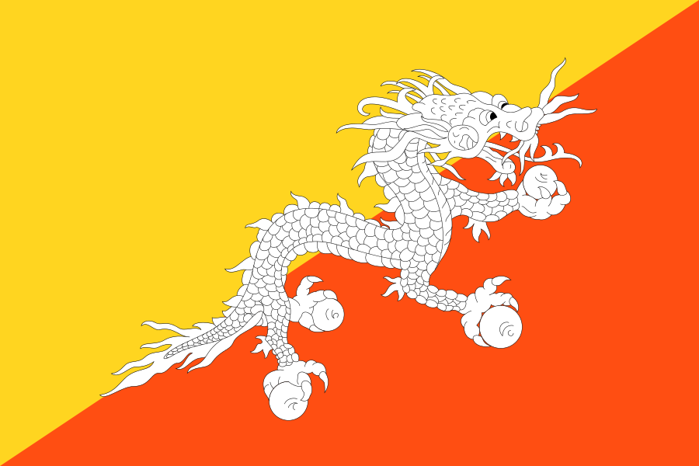*How does the writer use language and structure to convey her thoughts and feelings about Bhutan?*

*You should support your answer with close reference to the passage, including brief quotations.*

*Use the following to help you structure your answer:*

* Integrate at least eight brief quotations into the analysis.
* Comment on the ways that language shapes her thoughts and feelings.
* Comment on the structure of the extract.
* Use key words: connotes, perspective, point of view, facts, feelings, thoughts.
* Use key linguistic and structural terms*:*

|  |  |  |  |  |  |  |  |
| --- | --- | --- | --- | --- | --- | --- | --- |
| *metaphor* | *visual imagery* | *adjectives* | *facts* | *first person* | *present tense* | *temporal markers* | *Bhutanese vocab* |