Year 11

English Language Workbook

Name: _______________________________________

Teacher: ______________________________________



Introduction

This workbook contains information about how to approach each question in the English Language IGCSE exam. It includes strategies and tips for each question, mark schemes, sample answers, common errors and wrappers (success checklists) for each question as well as practice questions for you to complete.

These practice questions may be set as homework this term by your teacher. You must answer these to the best of your ability, ensuring you have read the instructions and information for each question carefully first. You must **write legibly and keep this workbook neat and tidy**. It will be a valuable revision resource for you in the run up to the exam in the summer.

If you misuse or misplace your workbook, you will need to pay for a replacement and re-write any unmarked responses.

IGCSE – ENGLISH LANGUAGE OVERVIEW

COMPONENT 1 EXAM – NON-FICTION TEXTS AND TRANSACTIONAL WRITING

(2 HOURS 15 MINS, 90 MARKS, 60% OF OVERALL ENGLISH LANGUAGE IGCSE GRADE)

The exam consists of TWO sections.

**Section A – 45 marks**:

Questions 1-3 will focus on Passage A, an unseen text printed in the exam paper. Q4 will focus on a pre-studied text from the 10 non-fiction extracts in the anthology (re-printed in the exam). Q5 will compare the unseen with the pre-studied text.

**Question 1** – Short answer, information retrieval. 2 marks

**Question 2** – Summary of information **in own words**, in full sentences. 4 marks

**Question 3** – Collate information, **with quotations** to support, in full sentences. 5 marks

**Question 4** – Question on how language and structure are used to create effects in one of the pre-studied anthology non-fiction texts. 12 marks

**Question 5** – **Comparison** of how writers present their perspectives in pre-studied anthology text and unseen passage. 22 marks

**Section B – 45 marks:**

Choice of two transactional writing tasks with given audience, form or purpose (typically a speech, letter, article etc).

27 marks for content and organisation/18 marks for spelling, grammar and punctuation

**Section A**

**Question 1:**

This question requires you to select two relevant words or phrases from a given section in the unseen text. There are 2 marks for this question, and you should spend about 4 minutes answering it.

**Example:**

Inside the ship, there were noises. Deep structural groans. I stumbled and fell. No harm done. I got up. With the help of the handrails I went down the stairwell four steps at a time. I had gone down just one level when I saw water. Lots of water. It was blocking my way. It was surging from below like a riotous crowd, raging, frothing and boiling. Stairs vanished into watery darkness. I couldn't believe my eyes. What was this water doing here? Where had it come from? I stood nailed to the spot, frightened and incredulous and ignorant of what I should do next. Down there was where my family was.

1. From the *above paragraph*, select **two** words or phrases used to describe how the narrator feels*. (2 marks)*:

a)___________________________________________________________________

b)___________________________________________________________________

Q1. STEP BY STEP APPROACH:

1. Identify the section you have been asked to select information from. Mark this on the passage. (In the exam you will have a longer passage of text, but line numbers will identify which section to focus on.)
2. Underline or highlight the key words in the question. E.g.

From the *above paragraph*, select **two** words or phrases used to describe how the narrator feels*. (2 marks)*

1. Identify words or phrases from the marked section which answer the question:

Inside the ship, there were noises. Deep structural groans. I stumbled and fell. No harm done. I got up. With the help of the handrails I went down the stairwell four steps at a time. I had gone down just one level when I saw water. Lots of water. It was blocking my way. It was surging from below like a riotous crowd, raging, frothing and boiling. Stairs vanished into watery darkness. I couldn't believe my eyes. What was this water doing here? Where had it come from? I stood nailed to the spot, frightened and incredulous and ignorant of what I should do next. Down there was where my family was

1. Remember not to leave out parts of a phrase which affect the meaning. For example, if you answered that the narrator felt, “ignorant”, this would be incorrect, as the narrator only feels “ignorant of what [he] should do next” which is different.
2. Pick the two words or phrases which are most straightforward and obviously answer the question. In this case, the most straightforward answers would be:

a)_______frightened___________________________________________________

b)_______incredulous__________________________________________________

You could also have a mark for:

a)_______Couldn’t believe his eyes________________________________________

b)_______Ignorant of what to do next_____________________________________

**Q1. Practice**

**Answer the three practice questions below:**

1. Where the path wended across the ridge, the bushes of huckleberry and sweet fern swarmed at it in two curling waves until it was a mere winding line traced through a tangle. There was no interference by clouds, and as the rays of the sun fell full upon the ridge, they called into voice innumerable insects which chanted the heat of the summer day in steady, throbbing, unending chorus.

From the above paragraph, select **two** words or phrases used to describe the weather *(2 marks)*:

a)___________________________________________________________________

b)___________________________________________________________________

1. I lolled on the rope, scarcely able to hold my head up. An awful weariness washed through me, and with it a fervent hope that this endless hanging would soon be over. There was no need for the torture. I wanted with all my heart for it to finish.

From the above paragraph, select **two** words or phrases used to describe how Joe is feeling.  *(2 marks)*:

a)____________________________________________________________

b)____________________________________________________________

1. Currently vast areas of east Africa are in the grip of a famine emergency, with 16 million people on the brink of starvation and in desperate need of food, water and medical treatment. By contrast, in Australia our supermarkets groan with choice; water pours freely from a tap leaving us oblivious to its scarcity elsewhere and free, high-quality medical care is a basic human right. It seems for many it is impossible to relate to the millions of people existing – not living, just existing – in deplorable and desperate conditions on the other side of the world.

From the above paragraph, select **two** words or phrases used to describe Australia.  *(2 marks)*:

a)____________________________________________________________

b)____________________________________________________________

**Section A**

**Question 2:**

This question requires you to retrieve relevant information from a given section in the unseen text and rewrite it **in your own words**. You should include 4 points for the 4 marks available. You should spend about 8 minutes on this question.

**Example:**

*The wind swung me in a gentle circle. I looked at the crevasse1 beneath me, waiting for me. It was big. Twenty feet wide at least. I guessed that I was hanging fifty feet above it. It stretched along the base of the ice cliff. Below me it was covered with a roof of snow, but to the right it opened out and a dark space yawned there. Bottomless, I thought idly. No. They’re never bottomless. I wonder how deep I will go? To the bottom … to the water at the bottom? God! I hope not!*

**Look again at the above paragraph. In your own words, explain what the crevasse looks like and what Joe thinks about it. (4 marks)**

________________________________________________________________________________________________________________________________________________________________________________________________________________________________________________________________________________________________________________________________________________________________________________________________________________________________________________________________________________________________________________________________________________________________________________________________________________________________________________________________________________________________________________________________________________________________________________________________

________________________________________________________________________________________________________________________________________________________________________________________________________________________________________________________________________________________________________________________________

Q2. STEP BY STEP APPROACH:

1. Identify the section you have been asked to select information from. Mark this on the passage. (In the exam you will have a longer passage of text, but line numbers will identify which section to focus on.)
2. Underline or highlight the key words in the question. E.g.

Look again at the above paragraph. **In your own words**, explain what the crevasse looks like **and** what Joe thinks about it. (4 marks)

1. Highlight or underline words or phrases from the marked section which answer the question:

*The wind swung me in a gentle circle. I looked at the crevasse1 beneath me, waiting for me. It was big. Twenty feet wide at least. I guessed that I was hanging fifty feet above it. It stretched along the base of the ice cliff. Below me it was covered with a roof of snow, but to the right it opened out and a dark space yawned there. Bottomless, I thought idly. No. They’re never bottomless. I wonder how deep I will go? To the bottom … to the water at the bottom? God! I hope not!*

1. You will need to pick four of these points to rewrite in your own words. Make sure you have points which answer both parts of the question if it has two parts like this one does. E.g. what the crevasse looks like AND what Joe thinks of it.
2. When rewriting in your own words, think of synonyms for key adjectives or another way to say the same thing. (If you find one point really difficult to re-word, consider picking another one. There are usually more than four points to choose from.) E.g.

**Big** > **huge/large/massive**

**Twenty feet wide** > **as wide as the length of a bus**

**Covered with a roof of snow** > **snowflakes lay on top of the crevasse**

**Bottomless** > **Joe thought the crevasse was infinite in depth**

1. Write your response using your own words and including at least four points. E.g.

**The crevasse was huge, with a width about as long as a bus. Snowflakes lay on top of the crevasse. There was a black opening which gaped on one side. Joe thought the crevasse might be infinite in depth.**

1. Remember, this question is about retrieving information and rewriting it in your own words. You DO NOT need to make inferences, give your opinions or analyse the language in the passage.

**~~The writer uses an adjective, “bottomless,” to make the crevasse seem terrifying to Joe.~~**

and

**~~I think the writer must be terrified because he is dangling on a rope above a huge crevasse and he might die if he falls in.~~**

are both examples of common mistakes students make with this question.

**Q2 Practice Questions**

**Answer the three practice questions below:**

**1.**

That this famine has been caused by the strongest El Niño on record, driven by western carbon emissions and crazed capital consumption which burns through natural resources our governments have, quite literally, pulled from under the feet of African people, seems an irony too complex for many to comprehend.

Plundering oil from Nigeria, gold from west Africa and diamonds from the Congo under legal systems established in the colonial period which continue to leave African nations one step behind, we trap the continent in poverty. Following centuries of exploitation, how can these countries generate their own gross domestic product? Without a functional national economy, building infrastructure – roads to transport emergency food supplies, schools to educate the next generation, adequately staffed health systems equipped with life-saving drugs – remains impossible.

**Look again at the above extract. *In your own words*, explain what the writer’s thoughts and feelings are about the cause of famine in east Africa. [4 marks]**

**________________________________________________________________________________________________________________________________________________________________________________________________________________________________________________________________________________________________________________________________________________________________________________________________________________________________________________________________________________________________________________________________________________________________________________________________________________________________________________________________________________________________________________________________________________________________________________________________________________________________________________________________________________________________________________________________________________________________________________________________________________________________________________________________________________________________________________________________________________________________________________________________**

2.

As we drew near the railway station, we became part of a large crowd queuing to go inside. Everybody was trying to get to the front of the barriers the police had put on the platforms. The soldiers were now lining up on the other side of the barriers awaiting the arrival of the trains. We were pushed about, and I held on tight to my grandmother’s hand as the crowd shoved their way around us. Then by a stroke of luck we found ourselves on the bridge that spanned the railtracks and joined the two platforms. I felt a little bit crushed but now I had an excellent view of everything that was happening.

**Look again at the above extract.**

***In your own words*, explain what the writer’s thoughts and feelings are about being on the platform. [4 marks]**

________________________________________________________________________________________________________________________________________________________________________________________________________________________________________________________________________________________________________________________________________________________________________________________________________________________________________________________________________________________________________________________________________________________________________________________________________________________________________________________________________________________________________________________________________________________________________________________________________________________________________________________________________________________________________________________________________________________________________________________________________________________________________________________________

3.

Suddenly from some unknown and yet near place in advance there came a dry, shrill whistling rattle that smote motion instantly from the limbs of the man and the dog. Like the fingers of a sudden death, this sound seemed to touch the man at the nape of the neck, at the top of the spine, and change him, as swift as thought, to a statue of listening horror, surprise, rage. The dog, too--the same icy hand was laid upon him, and he stood crouched and quivering, his jaw dropping, the froth of terror upon his lips, the light of hatred in his eyes.

**Look again at the above extract. *In your own words*, explain what effect the sound of the snake’s rattle had on the man and the dog. [4 marks]**

**_________________________________________________________________________________________________________________________________________________________________________________________________________________________________________________________________________________________________________________________________________________________________________________________________________________________________________________________________________________________________________________________________________________________________________________________________________________________________________________________________________________________________________________________________________________________________________________________________________________________________________________________________________________________________________________________________________________________________________________________________________________________________________________________________________________________________________________________________________________________________________________________________________________________________________________________________________________________________________________________________**

**Section A**

**Question 3:**

This question requires you to retrieve relevant information from a given section in the unseen text. You may use quotations (embedded quotations are ideal). You must write in full sentences and you should include 5 points for the 5 marks available. You should spend about 10 minutes on this question.

**Example:**

There was no feeling in my arms and legs. Everything slowed and softened. Thoughts became idle questions, never answered. I accepted that I was to die. There was no alternative. It caused me no dreadful fear. I was numb with cold and felt no pain; so senselessly cold that I craved sleep and cared nothing for the consequences. It would be a dreamless sleep. Reality had become a nightmare, and sleep beckoned insistently; a black hole calling me, pain-free, lost in time, like death.

**In the above extract, explain what we learn about how Joe feels at this point. You may use brief quotations to support your answer (5 marks).**

**___________________________________________________________________________________________________________________________________________________________________________________________________________________________________________________________________________________________________________________________________________________________________________________________________________________________________________________________________________________________________________________________________________________________________________________________________________________________________________________________________________________________________________________________________________________________________________________________________________________________________________________________________________________________________________________________________________________________________________________________________________________________________________________________________________________________________________________________________________________________________________________________________________________________________________________________________________**

Q3. STEP BY STEP APPROACH:

1. Identify the section you have been asked to select information from. Mark this on the passage. (In the exam you will have a longer passage of text, but line numbers will identify which section to focus on.)
2. Underline or highlight the key words in the question. E.g.

**In the above extract, explain what we learn about how Joe feels at this point. You may use brief quotations to support your answer (5 marks).**

1. Highlight or underline words or phrases from the marked section which answer the question. There should be **at least 5 points**:

There was no feeling in my arms and legs. Everything slowed and softened. Thoughts became idle questions, never answered. I accepted that I was to die. There was no alternative. It caused me no dreadful fear. I was numb with cold and felt no pain; so senselessly cold that I craved sleep and cared nothing for the consequences. It would be a dreamless sleep. Reality had become a nightmare, and sleep beckoned insistently; a black hole calling me, pain-free, lost in time, like death.

1. Write your five points in full sentences, using quotation to support each point. Try to embed your quotation where possible, and avoid using points which are repetitive or very similar, e.g “craved sleep” and “sleep beckoned insistently”.

**E.g. Joe is “numb with cold” at this point in the extract. Though he “feels no pain”, he is so “senselessly cold” that he “craved sleep” and did not care about the consequences. He has “accepted” that he is going to die and “it caused...no dreadful fear”.**

1. Notice that the answer does not have to be very long, as long as it is written in full sentences and includes at least five points **which answer the question.**
2. **Remember that you DO NOT need to analyse the language or give your opinions in this question.**

**EXAMINER’S REPORT**

**Every year the chief examiner writes a report on the exam, giving valuable information and advice on what to aim for and what to avoid. Below is the advice given by the chief examiner for Q3.**

* There is **no need for comments on the language used in the quotations** and examiners noted that a number of candidates spent time on analysis of language and structure, an AO2 requirement, for which they **could not here be credited**.
* There were a number of possible points that could be made and most candidates gained full or nearly full marks, but **where this was not the case** it was because they **had made only a couple of points or failed to focus on the question and offered points that related to other parts of the text.**
* Some candidates moved away from the topic to **offer their own perspectives** on the issues raised in the extract but this was **not a requirement of the question** and therefore meant that they **could not be rewarded.**
* Some candidates expected long quotations to act as a substitute for their own understanding and commentary but **answers including overlong quotations rarely gained full marks.**

**Here are some examples of answers which did not gain full marks. See the examiner’s mark and comments below to avoid making the same mistakes.**

* **“There was no feeling in my arms and legs. Everything softened and slowed.” Joe has accepted he’s going to die. “I was numb with cold and felt no pain; so senselessly cold that I craved sleep and cared nothing for the consequences.”**

**(2 marks) The candidate uses excessively long quotations, and though they do show how Joe is feeling, there is no clear evidence that the candidate understands the quotations fully.**

* **The writer uses a powerful adverb, “senselessly” to describe how cold Joe felt. The writer is trying to convey that Joe cannot understand how he could be so cold and still be alive. It makes the reader empathise with Joe as most readers won’t have been in this situation before.**

**(1 mark) The candidate only makes one clear point about how Joe is feeling. The candidate’s comments on use of language and their effect cannot be rewarded in this question.**

* **Joe thinks his reality is a “nightmare” and he’s terrified of falling into a black hole. I think this is pretty understandable as anyone would feel the same if they were hanging over a crevasse. It’s still possible that he can be saved but he doesn’t seem to think there’s much hope as he’s “accepted” that he’s going to die.**

**(2 marks) The candidate has misunderstood some of the extract as the “black hole” reference is metaphorical in the text. The candidate makes two clear points about how Joe is feeling, but the rest of the response offers the candidates own perspective which cannot be rewarded in this question.**

**Q3. Practice Questions**

**Answer the three practice questions below:**

**1.**

As an Australian paediatric doctor working in Kenya, I have the opportunity to connect with the children and families behind the statistics on a daily basis. Each day I observe the parent-child bond that I know well as a mother of four children: that deep, primitive yearning to love, protect and care for your child. On the ward where I work, mothers and fathers rotate in shifts around the clock to swat the flies from their children’s comatose bodies, sitting in plastic chairs for hours on end willing them to open their eyes, squeezing their hands and massaging their arms with desperation, hoping their child will be one of the lucky ones to survive.

**In the above extract, what do we learn about the actions and feelings of the parents of children in the ward? You may support your points with brief quotations. [5]**

**____________________________________________________________________________________________________________________________________________________________________________________________________________________________________________________________________________________________________________________________________________________________________________________________________________________________________________________________________________________________________________________________________________________________________________________________________________________________________________________________________________________________________________________________________________________________________________________________________________________________________________________________________________________________________________________________________________**

**2.**

Slowly the man moved his hands toward the bushes, but his glance did not turn from the place made sinister by the warning rattle. His fingers, unguided, sought for a stick of weight and strength. Presently they closed about one that seemed adequate, and holding this weapon poised before him the man moved slowly forward, glaring. The dog with his nervous nostrils fairly fluttering moved warily, one foot at a time, after his master.

But when the man came upon the snake, his body underwent a shock as if from a revelation, as if after all he had been ambushed. With a blanched face, he sprang forward and his breath came in strained gasps, his chest heaving as if he were in the performance of an extraordinary muscular trial. His arm with the stick made a spasmodic, defensive gesture.

**In the extract above, what do we learn about the actions of the man and the dog as they face the snake? You may use brief quotations to support your answer. [5 marks]**

**_________________________________________________________________________________________________________________________________________________________________________________________________________________________________________________________________________________________________________________________________________________________________________________________________________________________________________________________________________________________________________________________________________________________________________________________________________________________________________________________________________________________________________________________________________________________________________________________________________________________________________________________________________________________________________________________________________________________________________________________________________________________________________________________________________________________________________________________________________________________________________________________________________________**

**3.**

I ran for the stairs to the bridge. Up there was where the officers were, the only people on the ship who spoke English, the masters of our destiny here, the ones who would right this wrong. They would explain everything. They would take care of my family and me. I climbed to the middle bridge. There was no one on the starboard side. I ran to the port side. I saw three men, crew members. I fell. I got up. They were looking overboard. I shouted. They turned. They looked at me and at each other. They spoke a few words. They came towards me quickly. I felt gratitude and relief welling up in me. I said, "Thank God I've found you. What is happening? I am very scared. There is water at the bottom of the ship. I am worried about my family. I can't get to the level where our cabins are. Is this normal? Do you think-"

One of the men interrupted me by thrusting a life jacket into my arms and shouting something in Chinese. I noticed an orange whistle dangling from the life jacket. The men were nodding vigorously at me. When they took hold of me and lifted me in their strong arms, I thought nothing of it. I thought they were helping me. I was so full of trust in them that I felt grateful as they carried me in the air. Only when they threw me overboard did I begin to have doubts.

**Look again at the above two paragraphs of the extract. Explain what you learn about the crew of the ship. You may use brief quotations to support your answer. [5 marks]**

**___________________________________________________________________________________________________________________________________________________________________________________________________________________________________________________________________________________________________________________________________________________________________________________________________________________________________________________________________________________________________________________________________________________________________________________________________________________________________________________________________________________________________________________________________________________________________________________________________________________________________________________________________________________________________________________________________________________________________________________________________________**

**Section A**

**Question 4**

This question is about a text you will have previously studied in class. You will have a copy of the text printed in the exam.

The question is worth 12 marks, and you should spend about 24 minutes answering it.

The question will look like this:

* Use a PEE (or similar) structure to answer this question.
* Aim for three main points, and one bonus one if time.
* Your three main points should include:
  + Structure (whole text and/or sentence structure)
  + Vocabulary
  + Language Device
* Use clear topic sentences, focusing on the language point you are making. E.g. *The writer uses a series of short sentences in the second paragraph in order to emphasise the pace at which the events unfolded.*
* Develop your explanations FULLY. Consider:
  + Zooming in to a particular word or phrase and discussing associations/connotations
  + Exploring alternative interpretations using tentative language (i.e. this **could** suggest…)
  + Exploring the effect on the reader
  + Linking to context within the text
  + Linking to the writer’s aims and purpose in writing the text

**Here is the mark scheme for Question 4:**

**Examiner’s Report – some common errors to avoid:**

* There does not need to be an equal number of points on language and structure but both should be addressed as, indeed, they were by nearly all candidates.
* Some candidates spent too long on an introduction that set out what they intended to do and a conclusion that summed up what they had done, neither of which contributed usefully to the acquisition of marks and time could have been spent more wisely by starting with an immediate focus on the use of language or structure.
* Many candidates were able to select apt quotations to support their points and use subject terminology but sometimes this led to little more than feature spotting with some comment on the generic effect of these such as ‘short sentences create impact’ or ‘this encourages the reader to read on’ rather than considering the effect within this particular text.
* Some candidates also tended to simply describe what the writer had written in chronological order or spent too long on the opening paragraph.

**In summary:**

* You must have points on language **and** structure
* Don’t waste time on introductions or conclusions
* Avoid general or vague comments on effect
* Avoid just describing what the writer has written

**EXAMPLE ANSWER TO QUESTION 4:**

**How does the writer use language and structure to engage the reader in “H is for Hawk”?**

**H is for Hawk Q 4 Exemplar**

One way the writer uses language to engage the reader is by building up tension when the bird is about to be released. One way she does this is by using the onomatopoeia, “Thump.” This helps the reader to visualise the build up of the bird being released as we can hear the noises the bird is making. This is further reinforced with the repetition of “thump” later on. This is seen when she says, “Another thump. And another. Thump.” The repetition adds tension as we anticipate when it is going to happen.

Another way the writer engages the reader is by structure. For example the writer uses a one word paragraph. This is seen when she says, “Oh.” This really impacts the reader as it puts emphasis on the one word “Oh.” It also relays her shock as it suggests she is speechless and all she can think to say is, “oh”. It also suggests her disappointment which is later backed up when she begs to have the first hawk.

The writer also engages us by mixing a narrative account with her internal commentary. This is seen when she says, “This isn’t my hawk”, and later repeats, “but this isn’t my hawk.” This helps us to realise the impending panic the writer is feeling as she knows she prefers the other hawk. This is strengthened by the narrative in between as it shows she is running out of time to speak to the dealer as the ring numbers are being checked and the bird is being boxed.

Another way the writer uses language to engage the reader is by using lots of metaphors to convey the beauty of the bird she is seeing. You can see this when she says, “She is a conjuring trick. A reptile. A fallen angel.” The use of this imagery in describing the bird helps convey its majesty to us. When she says the bird is a “conjuring trick” it suggests that the bird seems supernatural and has to be seen to be believed. It also suggests her surprise that a bird could naturally be this beautiful and she must have artfully created to be this striking. The use of the short sentences shows her amazement and astonishment at the bird.

The candidate explores a range of features including vocabulary, language devices and structure. She uses clear topic sentences which directly link to the question and develops her explanations in some depth, though not always fully. The candidate is able to successfully support each point with relevant evidence and sometimes supports the same point with more than one feature. The answer could be improved by ordering the points chronologically as they appear in the text, and making reference to the context of the passage, e.g.”**When the writer first sees the bird**, she conveys her amazement by using a range of metaphors.”

10/12

**Q.4 Practice Question**

Answer the following question, and then use the mark scheme on page 20 and the wrapper following to mark your answer.

**Q4.**

**Remind yourself of the passage from “127 Hours: Between a Rock and a Hard Place” in your anthology.**

**How does the writer use language and structure to create suspense and tension?**

**You should support your answer with close reference to the passage, and include brief quotations. [12 marks]**

**________________________________________________________________________________________________________________________________________________________________________________________________________________________________________________________________________________________________________________________________________________________________________________________________________________________________________________________________________________________________________________________________________________________________________________________________________________________________________________________________________________________________________________________________________________________________________________________________________________________________________________________________________________________________________________________________________________________________________________________________________________________________________________________________________________________________________________________________________________________________________________________________________________________________________________________________________________________________________________________________________________________________________________________________________________________________________________________________________________________________________________________________________________________________________________________________________________________________________________________________________________________________________________________________________________________________________________________________________________________________________________________________________________________________________________________________________________________________________________________________________________________________________________________________________________________________________________________________________________________________________________________________________________________________________________________________________________________________________________________________________________________________________________________________________________________________________________________________________________________________________________________________________________________________________________________________________________________________________________________________________________________________________________________________________________________________________________________________________________________________________________________________________________________________________________________________________________________________________________________________________________________________________________________________________________________________________________________________________________________________________________________________________________________________________________________________________________________________________________________________________________________________________________________________________________________________________________________________________________________________________________________________________________________________________________________________________________________________________________________________________________________________________________________________________________________________________________________________________________________________________________________________________________________________________________________________________________________________________________________________________________________________________________________________________________________________________________________________________________________________________________________________________________________________________________________________________________________________________________________________________________________________________________________________________________________________________________________________________________________________________________________________________________________________________________________________________________________________________________________________________________________________________________________________________________________________________________________________________________________________________________________________________________________________________________________________________________________________________________________________________________________________________________________________________________________________________________________________________________________________________________________________________________________________________________________________________________________________________________________________________________________________________________________________________________________________________________________________________________________________________________________________________________________________________________________________________________________________________________________________________________________________________________________________________________________________________________________________________________________________________________________________________________________________________________________________________________________________________________________________________________________________________________________________________________________________________________________________________________________________________________________________________________________________________________________________________________________________________________________________________________________________________________________________________________________________________________________________________________________________________________________________**

Question 4 Wrapper

Use this checklist and the mark scheme on page 20 to mark your answer.

|  |  |
| --- | --- |
| I wrote about the “127 Hours” extract only |  |
| I underlined the key words in the question and made sure my response referred to how the writer created “suspense” and “tension” throughout |  |
| I covered the points in the text chronologically |  |
| I linked my explanation to the context of the text – i.e. what is happening at that point in the text |  |
| I wrote in PEE (or similar structure, e.g. TEAR) paragraphs throughout |  |
| I wrote at least 3 or 4 fully developed paragraphs |  |
| I explicitly included one or more points on structure (using the word “structure” in my answer) |  |
| I explicitly explored the effect of sentence/paragraph structures |  |
| I explicitly explored the effect of language devices used (e.g. metaphor, onomatopoeia etc) |  |
| I explicitly explored the effect of vocabulary chosen by the writer |  |
| I developed my explanations of the effect of each feature the writer used |  |
| I did not use vague explanations, such as “…lets the reader know what’s happening” or “makes the reader want to read on” |  |
| I avoided using imprecise words to explain reader/narrator emotions, e.g. “happy” or “sad” |  |
| I checked my answer for accuracy of spelling and grammar |  |

Mark achieved: _______

Notes for next time: ________________________________________________________________________________________________________________________________________________________________________________________________________________________________________________________________________________________________________________________________________________________________________________________________

**Section A**

**Question 5**

This question requires you to compare how writers present their perspectives in both the unseen and the pre-studied text from the anthology. You will have a copy of both texts in the exam. This question is worth 22 marks, and you should spend about 44 minutes answering it.

The question will look like this:

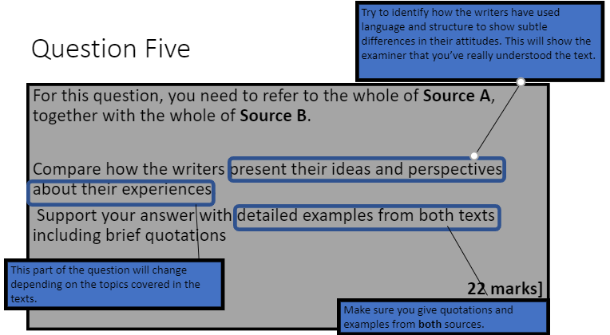

* Make a brief plan to identify the different PERSPECTIVES of the writers in each text. Aim for 3-5. E.g.
  + 1. Writer feels dread about her future, which is as yet unknown.
  + 2. Writer feels ostracized by her family.
  + 3. Writer presents her father as omnipotent and fearsome.
  + 4. Writer feels elated by her unexpected good fortune.
* Once you have identified the perspectives and how they are similar or different from each other, identify HOW the writer has portrayed this perspective, using linguistic terminology.

E.g. The writer uses pathetic fallacy, “warned of a possible typhoon”, to convey a sense of dread to the reader.

* The next step is to develop your explanation of this in the same way as you have for Q4. E.g.
  + Zooming in to a particular word or phrase and discussing associations/connotations
  + Exploring alternative interpretations using tentative language (i.e. this **could** suggest…)
  + Exploring the effect on the reader
  + Linking to context within the text
  + Linking to the writer’s aims and purpose in writing the text
* Then link to the second text using connectives such as: *similarly, on the other hand, in contrast, however etc* and repeat the process to finish the comparative point.
* You should aim for **at least** three FULLY DEVELOPED COMPARATIVE POINTS in this response.

**Here is the mark scheme for this question:**

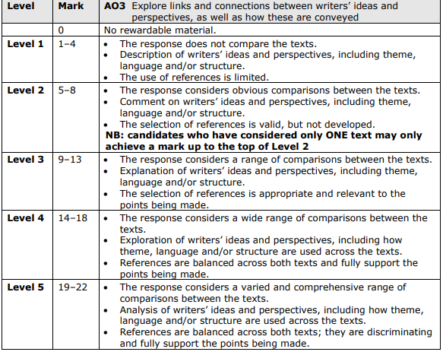**Examiner’s Report – some advice:**

* It is **extremely important** that candidates allow time to **plan carefully** and then aim to make a good range of relevant points.
* At the **lower end, candidates tended to make obvious comparisons** for example ‘both extracts are about birds’ and ‘both are written in the first person’ and **often these responses became narrative** with greater emphasis on one text.
* The most successful responses made **each point a valid and appropriate comparison** with supporting references from both extracts; this led to the balance required for marks within levels 4 and 5.

**EXAMPLE RESPONSE**

**This question is based on “H is for Hawk” and “An Unexpected Meeting” (Y10 exam).**

**Compare how the writers present their ideas and perspectives about their experiences. Support your answer with detailed examples from both texts including brief quotations.**

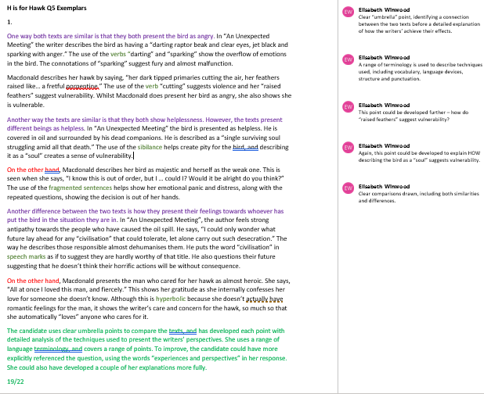

**Q.5 Practice Question**

Answer the following question, and then use the mark scheme on page 26 and the wrapper following to mark your answer.

The question is based on the following extract, and the extract “127 Hours: Between a Rock and a Hard Place” in your anthology.

**Compare how the writers present their ideas and perspectives about their experiences. Support your answer with detailed examples from both texts including brief quotations. [22 marks]**

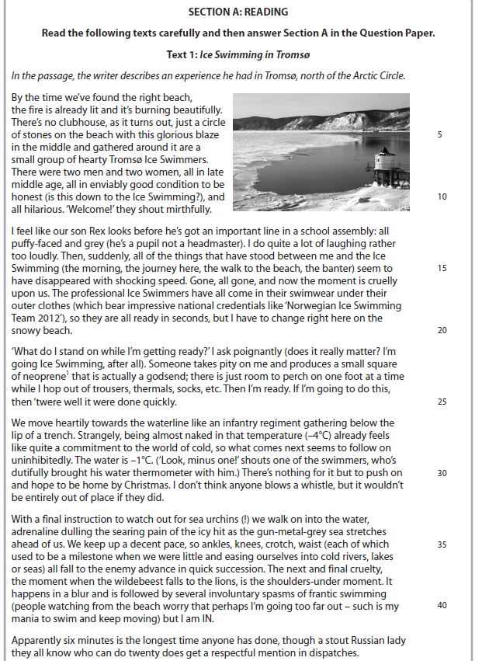

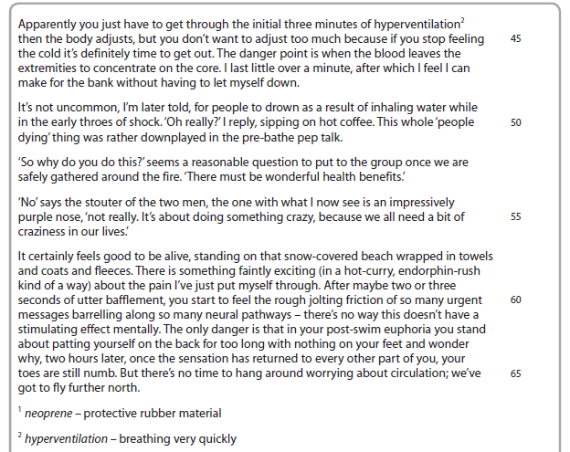

**________________________________________________________________________________________________________________________________________________________________________________________________________________________________________________________________________________________________________________________________________________________________________________________________________________________________________________________________________________________________________________________________________________________________________________________________________________________________________________________________________________________________________________________________________________________________________________________________________________________________________________________________________________________________________________________________________________________________________________________________________________________________________________________________________________________________________________________________________________________________________________________________________________________________________________________________________________________________________________________________________________________________________________________________________________________________________________________________________________________________________________________________________________________________________________________________________________________________________________________________________________________________________________________________________________________________________________________________________________________________________________________________________________________________________________________________________________________________________________________________________________________________________________________________________________________________________________________________________________________________________________________________________________________________________________________________________________________________________________________________________________________________________________________________________________________________________________________________________________________________________________________________________________________________________________________________________________________________________________________________________________________________________________________________________________________________________________________________________________________________________________________________________________________________________________________________________________________________________________________________________________________________________________________________________________________________________________________________________________________________________________________________________________________________________________________________________________________________________________________________________________________________________________________________________________________________________________________________________________________________________________________________________________________________________________________________________________________________________________________________________________________________________________________________________________________________________________________________________________________________________________________________________________________________________________________________________________________________________________________________________________________________________________________________________________________________________________________________________________________________________________________________________________________________________________________________________________________________________________________________________________________________________________________________________________________________________________________________________________________________________________________________________________________________________________________________________________________________________________________________________________________________________________________________________________________________________________________________________________________________________________________________________________________________________________________________________________________________________________________________________________________________________________________________________________________________________________________________________________________________________________________________________________________________________________________________________________________________________________________________________________________________________________________________________________________________________________________________________________________________________________________________________________________________________________________________________________________________________________________________________________________________________________________________________________________________________________________________________________________________________________________________________________________________________________________________________________________________________________________________________________________________________________________________________________________________________________________________________________________________________________________________________________________________________________________________________________________________________________________________________________________________________________________________________________________________________________________________________________________________________________________________________________________________________________________________________________________________________________________________________________________________________________________________________________________________________________________________________________________________________________________________________________________________________________________________________________________________________________________________________________________________________________________________________________________________________________________________________________________________________________________________________________________________________________________________________________________________________________________________________________________________________________________________________________________________________________________________________________________________________________________________________________________________________________________________________________________________________________________________________________________________________________________________________________________________________________________________________________________________________________________________________________________________________________________________________________________________________________________________________________________________________________________________________________________________________________________________________________________________________________________________________________________________________________________________________________________________________________________________________________________________________________________________________________________________________________________________________________________________________________________________________________________________________________________________________________________________________________________________________________________________________________________________**

**Now, using the mark scheme on p26, and the checklist below, mark your answer.**

Q5. Tick all that apply:

|  |  |
| --- | --- |
| I briefly annotated or highlighted key points of comparison in the texts as I read them |  |
| I made a brief plan (using Venn diagram or other visual technique) |  |
| I underlined key words in the question, and made sure my response referred to “ideas and perspectives” of the writers |  |
| I compared texts throughout my response – i.e. didn’t write about first one text and then the other |  |
| I used a clear comparative structure in each of my paragraphs, e.g. PEECEE |  |
| I introduced the comparison with an overview of the different attitudes and perspectives shown in each text |  |
| I made an explicit comparison of structure (and included the term “structure” in my response) e.g. whole structure, paragraphs or sentence types |  |
| I used linguistic terminology in each of my points (e.g. use of abstract nouns/adverbs/metaphors/triplets/onomatopoeia etc) |  |
| I made at least three fully developed comparative points about the texts (PEECEE) |  |

Mark achieved: _______

Notes for next time: ________________________________________________________________________________________________________________________________________________________________________________________________________________________________________________________________________________________________________________________________________________________________________________________________

**Section B – Transactional Writing**

**In this section you have a choice of two questions. You must answer one of them. Choose quickly and once you’ve made up your mind, stick with your choice.**

You will be given a statement on which to base your response. You should consider your opinion on this statement and take 5 minutes to consider a range of views and make a brief plan.

There are 45 marks available for this question – 27 for content and organisation and 18 for accuracy and range of spelling, grammar and punctuation.

You should spend about 45 minutes on this question.

Here’s an example:

**‘In our busy twenty-first century lives, hobbies and interests are more important than ever.’ Write an article for a newspaper expressing your views on this statement.**

**Your article may include:**

**• what hobbies and interests you enjoy**

**• the benefits of hobbies and interests, especially in today’s world**

**• any other points you wish to make.**

**Your response will be marked for the accurate and appropriate use of vocabulary, spelling, punctuation and grammar. [45 marks]**

TIPS FOR SUCCESS:

* HAVE AN OPINION! IF YOU DON’T HAVE ONE, MAKE SOME UP!
* You need 4-6 developed points in your response.
* Use DAFOREST as a helpful reminder to include a range of language devices and features in your writing. Show off!

D – Direct address

A - Alliteration/anecdote

F – Facts

O – Opinion (present this as fact)

R – Rhetorical Question/Repetition

E – Emotive language

S – Statistic

T – Triplet

You could be asked to write any of the following:

* Leaflet
  + Use a relevant title
  + Use subheadings for each section
  + Consider including a fact/information box
  + Use language devices appropriate for giving advice
* Speech
  + Address your audience at relevant points throughout
  + Make your speech accessible – not overly formal
  + Think about what you would respond well to if you were listening to the speech
  + Use a range of language devices, including facts, statistics, emotive language, direct address, imperatives, triplets, alliteration, rhetorical questions etc
* Letter
  + Use an appropriate layout – address top right, date, then salutation, and sign off at the end
  + Use a clear structure, and range of paragraph lengths for effect
  + If in doubt, be more rather than less formal.
  + Consider the viewpoint of the person you are writing to
  + Use a range of language devices to persuade
* Essay
  + Outline your argument clearly to begin with
  + Use clear paragraphs with topic sentences
  + Use a formal register and range of sophisticated vocabulary, use a range of paragraph and sentence types and lengths
  + Conclude by summarising your argument effectively
* Article
  + Use appropriate headline, strapline, byline
  + Use clear paragraphs and a range of paragraph lengths for effect
  + Use a mixed register - formal and informal, aiming to connect with your reader

**Examiner’s Report - Advice**

* consider given form and audience for the writing task and use these to inform register and tone
* try to use a wide vocabulary and varied sentence structures
* aim for a structured, cohesive and complete piece of writing
* allow time to proof-read in order to achieve the highest possible degree of accuracy

**Mark Scheme**

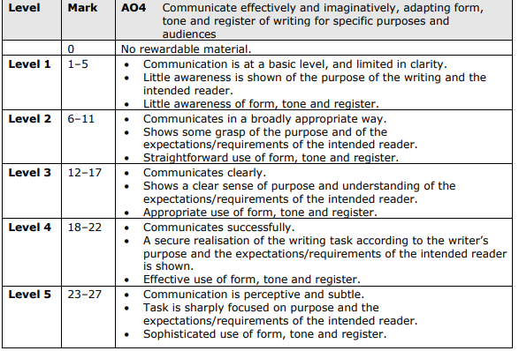

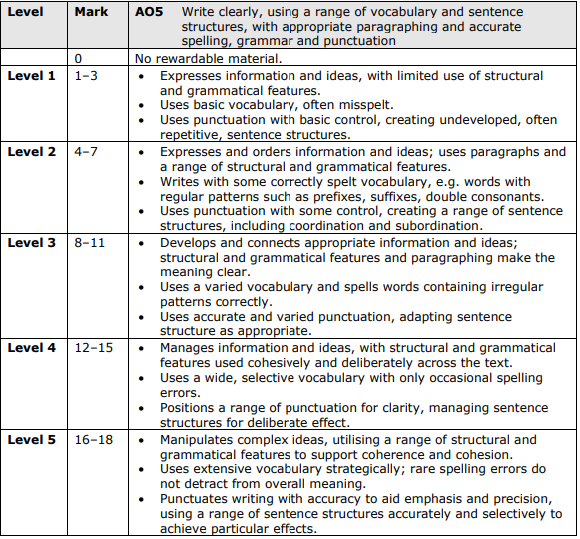

**Example Answer – Article on Hobbies**

No Hobbies? No Happiness!

By A.Candidate

Have a report to finish? Me too. Need to pop to the shop? You’re not the only one. Our lives are busy. Very busy. I often feel like I’m sinking, drowning in jobs, work, favours, travel and upkeep of a presentable appearance. Sometimes struggling to get to the surface for a breath can be difficult, impossible even. But it is needed. Before we know it, we could sink to the sea bed and the weight of all we need to do might just crush us. But there is a solution.

After a long day of work, I find nothing relaxes me and soothes my soul more than a ride out on my horse. The luscious, green, rolling hills do wonders for the mind and the body, like a light in the darkest of caves.

So much has changed now. The modern world has opened corridors and corridors of doors for us to open. Opportunities to grab as they whiz past. But perhaps it has closed the door to a walk at the weekend, an afternoon of baking or a swim at the beach. A survey shows that 60% of those surveyed can’t find the time for hobbies or can’t facilitate them. This is a disheartening fact. Without something we like to balance out all that we don’t, what is the point?

Our lives can be confusing, alienating and lonely. Hobbies allow us to connect with those of similar interests to our own. I have met some of my closest friends through horses. Hobbies also have other benefits. You can develop your skills, gain some exercise and unwind from a long day. I think it’s safe to say, hobbies are more important than ever.

While this is on the brief side, the candidate uses a range of appropriate features for a newspaper article, and creates a convincing voice with an appropriate and engaging register. She uses figurative language, lists, triplets, rhetorical questions, direct address, facts and statistics, sophisticated vocabulary and onomatopoeia. To improve, the candidate could have included a range of points about hobbies, such as different types of hobbies, ( including really unusual ones), how you can find a hobby to suit you, hobbies in the past etc.

A04 21/27

This is an accurate and controlled response, using a range of sentence types for effect, a range of sophisticated vocabulary and accurate spelling. The candidate could have included a greater range of punctuation, including semi-colon, brackets, ellipses, speech marks etc.

AO5 14/18

**Transactional Writing Practice Questions**

**1 A newspaper has published a report stating that all young people should do two hours of unpaid voluntary work a week.**

Write a letter to the Editor of the newspaper giving your views on the subject.

Your letter may include:

* whether young people should have to do this kind of unpaid work
* what kinds of voluntary work young people might do
* any other points you wish to make

*Your response will be marked for the accurate and appropriate use of vocabulary, spelling, punctuation and grammar.*

**2 Write a contribution to a guide for new teachers with the title: ‘What makes a good teacher’.**

Your contribution may include:

* what qualities a teacher should have
* the ways in which teachers can help and inspire their students
* any other points you wish to make.

*Your response will be marked for the accurate and appropriate use of vocabulary, spelling, punctuation and grammar.*

**3 There is no point in travelling when you can see everything and learn about places on television and the internet.’**

Write an article for a magazine giving your views on this statement.

Your article may include:

• the advantages and disadvantages of travel

• the advantages and disadvantages of learning about places on television and the internet

• any other points you wish to make.

*Your response will be marked for the accurate and appropriate use of vocabulary, spelling, punctuation and grammar.*

**4 ‘Schools and colleges have a duty to ensure their students keep fit.’**

You have been asked to give a speech in which you express your views on this statement.

Your speech may include:

• who should have responsibility for the fitness of students

• whether extra time for physical education should be found in schools and colleges

• any other points you wish to make.

*Your response will be marked for the accurate and appropriate use of vocabulary, spelling, punctuation and grammar.*

*___________________________________________________________________________****TASK:***

***Cmplete the grid below to create a transactional writing success checklist and use it to check your answers to the practice questions.***

Tick all that apply:

|  |  |
| --- | --- |
| I underlined key words in the question, including the text type, topic and audience (if given) |  |
| I made a plan, including four or five key points, as well as a list of language devices to include |  |
|  |  |
|  |  |
|  |  |
|  |  |
|  |  |
|  |  |
|  |  |
|  |  |
|  |  |
|  |  |