H is for Hawk
By Helen Macdonald
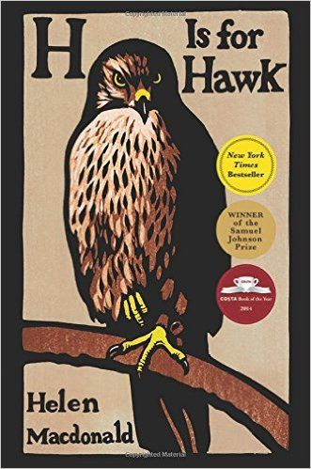
Helen Macdonald is an English writer, naturalist, and an Affiliated Research Scholar at the University of Cambridge Department of History and Philosophy of Science. She is best known as the author of H is for Hawk, which won the 2014 Samuel Johnson Prize and Costa Book Award.
This true story opens with the protagonist, Helen, talking about her love for birds. Helen has been a falconer for several years, and has recently become interested in a specific type of bird of prey, the Goshawk. Goshawks are notoriously hard to train because they are considered to be one of the most savage birds. Helen returns home one day after watching Goshawks in the woods to hear the shocking news that her father has passed away suddenly, of a heart attack. Helen was incredibly close to her father and considered him a legend, so the news devastates her.
Part of her grieving involves getting a Goshawk of her own and in this extract she meets the Goshawk for the very first time. It is a tense moment, a time when she is encountering a wild bird which is trained to hunt. When she meets with the breeder, he tells her that he brought two birds because he is selling another. She intends to get the older one, but after meeting the younger goshawk, she feels more of a connection with it. The older one is overwhelmingly big, male, and had a wild look, something that she doesn't think she can deal with. She pleads with the breeder to let her have the smaller, younger, female hawk instead.
Helen has been interviewed about her father passing away and training the bird in a number of YouTube clips. Here she is being interviewed by a news channel about her experiences:
https://www.youtube.com/watch?v=CV5ZK68OkEY
Exploring

Helen uses numerous examples of figurative language in a row to describe the bird.
Explore what these metaphors and similes mean when describing the bird:
She is a conjuring trick | A reptile
A fallen angel | A griffon from the pages of an illuminated bestiary*
Like gold falling through water | A broken marionette of wings

Overall, the culmination of all of these examples creates an image of a magical, mythical creature, an awe-inspiring, legendary bird.
*Illuminated bestiary = an illustrated book of fables with a moral about mythical or actual creatures
The use of the first person pronoun emphasises the personal nature of the account and the impact it has on her.
Who do you think the intended audience is for this book? Write your thoughts below:
________________________________________________________________________
________________________________________________________________________
The author uses humour when she says the hawk is supposed to be protected from fearful sights – ‘Like us.’
To build up drama and suspense, the writer uses a series of short sentences from line 11 followed by a long sentence in which the bird finally emerges from the box. Some words seem to need a pause between them, like ‘Concentration. Infinite caution.’ Then there is a long sentence as the hawk comes out of the box. What is the effect of the long and short sentences?
________________________________________________________________________
________________________________________________________________________
________________________________________________________________________
________________________________________________________________________
________________________________________________________________________
________________________________________________________________________
There is repetition of the word ‘enormous’ on line 16. What is the effect of the repetition?
________________________________________________________________________
________________________________________________________________________
The writer uses a much simpler simile on line 24, ‘like a turkey in a butcher’s shop.’ Why is this a worrying image for her?
________________________________________________________________________
________________________________________________________________________

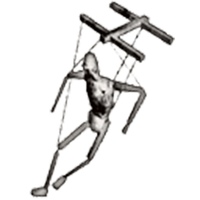 | 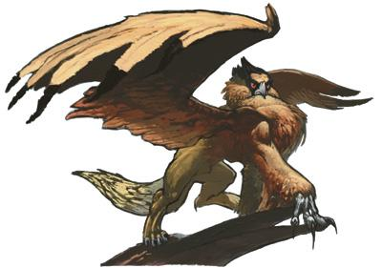
‘A broken marionette of wings’ is a metaphor – when a puppet operated by strings is broken the arms and body are strangely misshapen. | Creatures of mythology, griffons have the head, claws, and wings of an eagle and the body and hindquarters of a lion.

The onomatopoeic ‘thump’ is italicised to emphasise the sound the bird makes hitting the box. It is a word which suggests the noise and that it has power.
Helen is like the Goshawk as she struggles with her grief. She wants to run away from society and live in the wild, to escape from the pressures people place you under. The jesses are symbolic of connection, of replacing a relationship she had with her father who has now died. Helen’s twin brother also died when she was young and she finds out after getting the Goshawk. She admits that she always felt a part of her was missing.
The writer is able to empathise with the Goshawk’s point of view and feelings from the very beginning, realising that the Goshawk’s world consisted of being in a box and now that she was out of the box the world was wondrous and new.
Explain, in your own words, four things the bird can now see in lines 27-31:
________________________________________________________________________
________________________________________________________________________
________________________________________________________________________
________________________________________________________________________
________________________________________________________________________
________________________________________________________________________
Helen sums up this new experience of the Goshawk being able to see everything in a wondrous, hyperbolic way: ‘they stared because the whole world had fallen into them at once.’ (line 42).
Her feelings, her deep emotions for the bird are reflected in the man as he has cared for the bird from birth. He has fed her, been patient and made sure she was looked after. Not only does the writer say ‘All at once I loved this man’ (lines 39-40) but she uses the adverb ‘and fiercely’. Why does that adverb reflect the relationship she has with the bird?
________________________________________________________________________
________________________________________________________________________
There is a strong sense of an anti-climax when she discovers the bird isn’t hers. Which word(s) show her disappointment?
________________________________________________________________________
________________________________________________________________________
When the other bird, her bird is revealed to her she also uses a lot of figurative language, but not in a positive way.
Explain what is meant by ‘She came out like a Victorian melodrama’. For example, you might like to think about melodrama as typically exaggerating plot and characters, often including a villain, a wronged maiden and a noble hero. Research what a Victorian melodrama is and why this is a suitable quote:

________________________________________________________________________
________________________________________________________________________
________________________________________________________________________
________________________________________________________________________
Helen says the Goshawk is ‘a sort of madwoman in the attack.’ (Line 51) ‘The Madwoman in the Attic’ is the name of a book written in 1979 which examines Victorian literature from a feminist perspective. It specifically comes from Jane Eyre as Rochester keeps his ‘mad’ wife, Bertha, locked in the attic. It is therefore a pun, because the bird is not in the attic but in the attack. Explain as fully as you can how this shows the crazy, irrational nature of the larger bird before her:
________________________________________________________________________
________________________________________________________________________
________________________________________________________________________
________________________________________________________________________
Instead of making a pleasant noise, she ‘wailed’. What does wailed make you think of?
________________________________________________________________________
________________________________________________________________________
The constant use of questions shows us how she wanted the other bird, the smaller one. Does she sound convincing? Why or why not?
________________________________________________________________________
________________________________________________________________________
Towards the end the writer uses a theatrical metaphor, another example of how this is turning into a major performance involving heroes, heroines, villains and drama. She says her ‘hands held out as if she were in a seaside production of Medea.’ (line 68). Maybe you know Medea – who does? – but if you don’t here are some facts about her from Wikipedia:
‘Medea is female given name, From the Greek Μηδεια Medeia, possibly meaning either to ponder or cunning. In Greek mythology Medea was a sorceress from Colchis who helped Jason gain the Golden Fleece. They were married, but eventually Jason left her for another woman. For revenge Medea slew Jason's new lover and also had her own children by Jason killed. Georgian popular tradition attributes the origins of the term Medicine to Medea's name.’
Now you know this, how does that knowledge help inform you of the image of her, standing by the quayside, pleading with the man to change the bird?
________________________________________________________________________
________________________________________________________________________
________________________________________________________________________
________________________________________________________________________
________________________________________________________________________
________________________________________________________________________
The episode ends on a cliffhanger: ‘There was a moment of total silence.’ Why is this a good way to end the extract?
________________________________________________________________________
________________________________________________________________________
Finally, Helen Macdonald stated she wanted to be like a hawk. How does her attention to detail in the description show you that she and the bird are connected?
________________________________________________________________________
________________________________________________________________________
Finally, the jesses are very important in the book and a symbol of connection. Helen sees Jesses as being a symbolic representation of the connection that falconers feel with their birds. Having lost her father and twin, this bird is extremely important to her.
- On line 11 the writer uses an interesting image when she says ‘Daylight irrigating the box.’ What do you understand by ‘irrigating’ in this sentence?

- Why would the air be ‘syrupy’ on line 12? How can air be like a syrup?

- Find some examples of onomatopoeia and comment on their effect.

- Find some examples that prove this is a highly emotional experience for the writer.
- How does the writer succeed in creating a vivid picture of incident being described? You should use brief quotes.

- How does the writer convey the importance of the smaller bird and what it means to her?
You should use brief quotes.

- Write about an encounter with an animal that both fascinated and appalled you when you met it for the first time.

- Write about a time / something you have done to cope with sadness or grief. Try to make it as interesting as possible for the reader.

