**Answer the questions below in full sentences.**

1. What does Zeppa compare the landscape in Bhutan to in paragraph one? What does the comparison suggest about the landscape?
2. Why do you think Zeppa writes the account in the present tense?
3. Describe Zeppa’s journey from Toronto to Thimphu in paragraph two.
4. Find the expression commenting on how high the mountains are.
5. How many times does the writer use the word ‘mountains’ in paragraph two? What effect does this repetition have?
6. What does the word ‘convulsion’ mean? (Use a dictionary if you need to.)
7. Which words make the breakfast Zeppa eats sound unappetising?
8. Describe Lorna and Sasha.
9. Why does Zeppa ‘stay close to them’?
10. How is the traffic controlled in Thimphu?
11. What language feature does Zeppa use to describe the signs of the Western world contrasting with the ‘Bhutanese-ness’ of everything?
12. Quote the words that make the seat of the Royal Government of Bhutan sound impressive.
13. Describe the Bhutanese people.
14. Read lines 67 to 69 and write about the impression these people make on the writer.
15. Write down all the names that Bhutan (and its districts) has had in the past. What do these names have in common?
16. What happened when the westerner, Ashley Eden, went to try and stop the Bhutanese raiding British territory in 1864?

17. What does the writer admire Bhutan for?

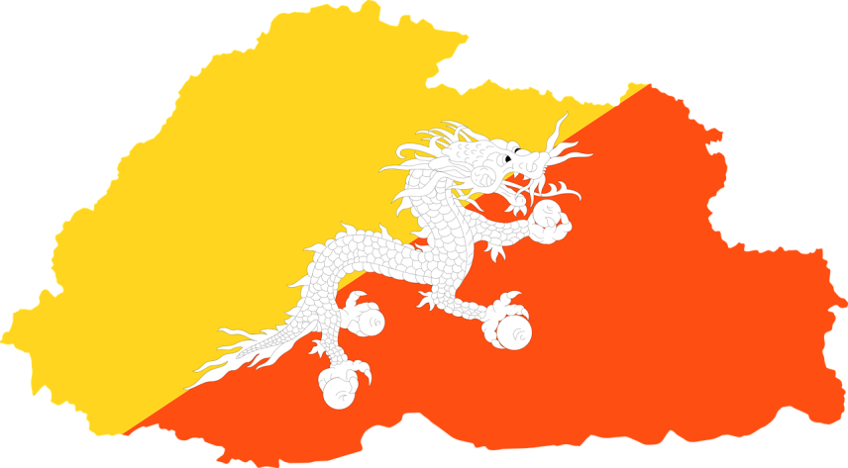

**Suggested answers**

1. Zeppa compares the landscape to ‘a giant child gathering earth in great armfuls’ and ‘piling’ and ‘pinching’ the rocks into shape. This gives the impression that the landscape is full of chaotic mountainous rocks.
2. Zeppa writes the account in the present tense to involve the reader more. The present tense adds an immediacy and sense of realism to the account.
3. Zeppa’s journey was four days long and consisted of a fairly long drive and several flights.
4. Zeppa describes the extreme height of the mountains by saying, ‘I watch mountains rise to meet the moon’.
5. The writer repeats the word ‘mountains’ six times, which emphasises how many mountains there are.
6. ‘Convulsion’ means a sudden, violent, irregular movement of the body, caused by involuntary contraction of muscles. A fit or spasm. This makes the landscape sound as if it is alive and moving.
7. Words and descriptions like ‘powdered milk’, ‘plasticky’, ‘flavorless red jam’ make the breakfast sound artificial and tasteless.
8. Lorna appears to be a homely kind of person with her ‘freckles’ and ‘home-on-the-farm demeanor’ but she is actually rather high-spirited, telling tales of her life in Saskatchewan and laughing loudly. She has travelled far and wide. Sasha is slim and has darker hair than Lorna’s. She seems mischievous, with her ‘impish smile’. She has worked in an orphanage for a year, which shows she is caring and committed to helping others. They both love Bhutan.
9. Zeppa stays close to them because she wants to share the girls’ excited interest in Bhutan.
10. The traffic in Thimphu is controlled by policemen who direct the traffic with arm movements.
11. Zeppa uses a triple to describe the build-up of western influence on Bhutan, ‘teenagers in acid washed jeans, Willie Nelson’s greatest hits …, a Rambo poster in a bar’.
12. The seat of the Royal Government of Bhutan sounds impressive when the writer describes it as ‘grand, whitewashed, red-roofed, golden-tipped fortress’. The list of adjectives creates a sumptuous effect.
13. The Bhutanese people are very good looking. They are dark-skinned and dark-haired. They have refined faces with high cheekbones, almond-shaped eyes and soft smiles. They are not particularly tall but are strong. The women wear long dresses, which are brightly striped. The men wear a knee-length dress, which has a large amount of material in the top section.
14. These people have made a significant impression on the writer. She searches for a word to sum up the quality that ‘impresses’ her the most but decides that the western world does not have a name for it, implying that this quality does not exist in western culture.

|  |  |
| --- | --- |
|  | * Druk Yul (Land of the Thunder Dragon) * Southern Land of Medicinal Herbs and South Sandalwood Country * Rainbow District of Desires * Lotus Grove of the Gods * Blooming Valley of Luxuriant Fruits * the Land of Longing and Silver Pines |

These names are all dramatic and add to the romantic, picturesque, magical and even healing nature of Bhutan.

1. Ashley Eden ‘had his back slapped, his hair pulled, and his face rubbed with wet dough’. The Bhutanese insisted he sign a treaty in their favour.
2. Zeppa admires Bhutan for remaining fiercely independent at a time when colonial powers, like Britain, were taking over small countries.