**“Every age constructs Shakespeare in its own image”**

**Terry Eagleton**

**“He’s fat and scant of breath”**

**Gertrude observing Hamlet fencing, Act V**

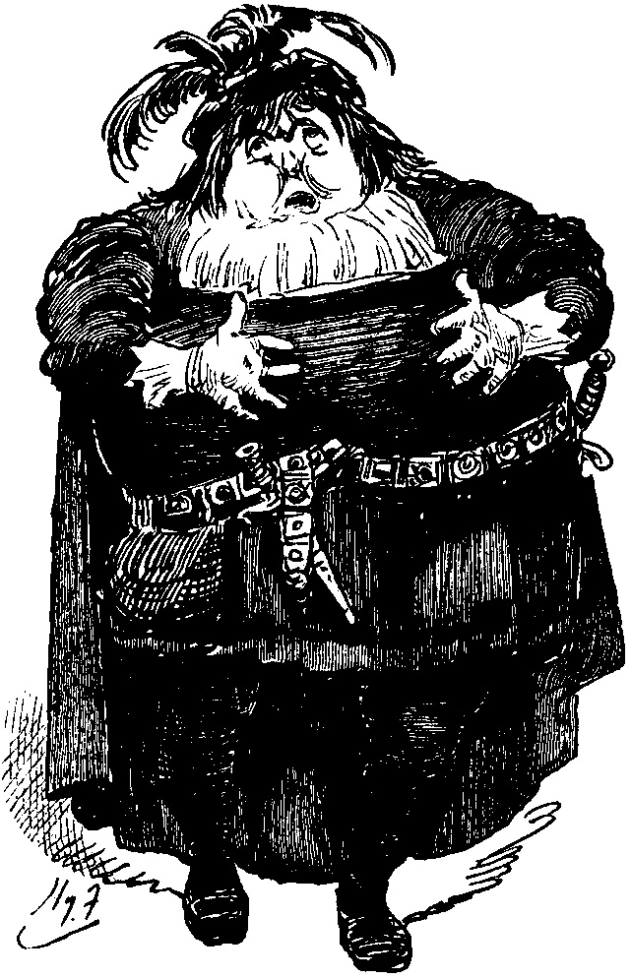

“Unremarkable in the eighteenth century, the line becomes the center of debate in the nineteenth century at precisely the period in which fat bodies come to be seen as having an essential nature, assumed to be cowardly, lazy, and undisciplined. Attributed to Goethe and developed by a German Shakespeare tradition, Hamlet’s supposed weakness of character is explained by his fat character. In response, English-speaking Shakespeare critics develop scholarly methods to distance Hamlet from “fat” altogether, initially by offering bibliographical arguments for emending the word and finally by offering etymological arguments that redefine it to mean anything other than corpulent.” (Elena Levy-Navarro, *“He’s fat, and scant of breath”: The Rise of a Modern Fatphobia in Nineteenth- and Twentieth-Century Commentary on Hamlet*, 2014)

**Before the Invention of Shakespeare: Early Hamlets**

In 1901, 285 years after Shakespeare’s death, George Bernard Shaw invented the term 'bardolotry' to describe the almost religious worship of Shakespeare and his work that had become standard in global culture. This is the Shakespeare you inherit in 2021: an author whose work is considered so central to Britishness that it became a required subject of study for all key stages in the 1989 National Curriculum for English in England and Wales. However, neither Shakespeare nor Hamlet as we understand them now existed in the decades immediately following the author's death.

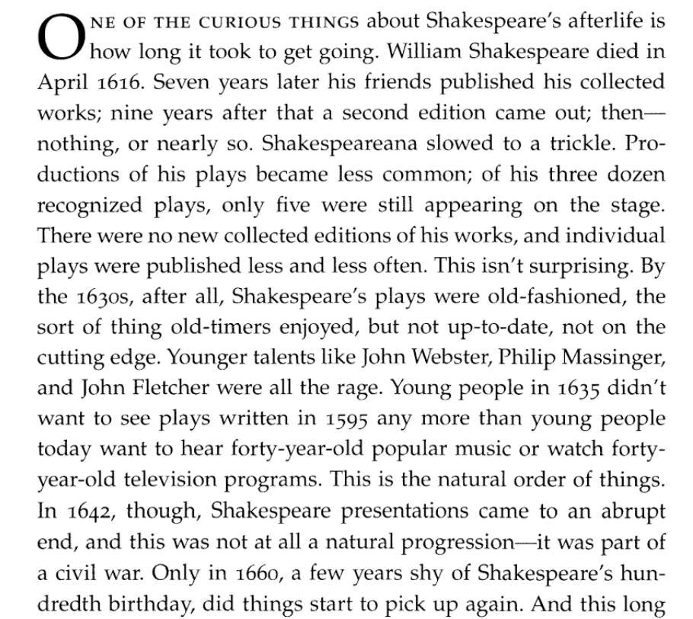

Jack Lynch, *Becoming Shakespeare: The Unlikely Afterlife That Turned a Provincial Playwright into the Bard*, 2009.

***Memorial to John Heminge and Henry Condell. City of London, 1895-96.* (Note the date: the heart of bardolotry)**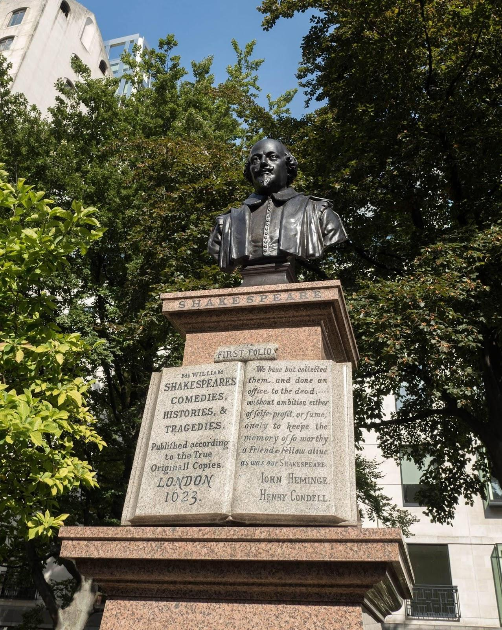

"An important milestone came seven years after the funeral: in 1623, two members of Shakespeare's company, Heminges and Condell, decided to collect his surviving plays and to publish them in a deluxe edition, in the large format usually reserved for serious literature. The result was the "First Folio," now the most famous book in the English Language." (Lynch, *Becoming Shakespeare*)

T**ext on the monument:** "The fame of Shakespeare rests on his incomparable dramas. There is no evidence that he ever intended to publish them and his premature death in 1616 made this the interest of no one else. Heminge and Condell had been co-partners with him in the Globe Theatre Southwark, and from the accumulated plays there of thirty five years with great labour selected them. No men then living were so competent having acted with him in them for many years and well knowing his manuscripts they were published in 1623 in folio thus giving away their private rights therein. What they did was priceless. For the whole of his manuscripts with almost all those of the dramas of the period have perished."

***Comments on Hamlet from diaries and letters written around the 1660 Restoration and the return of theatre to London life.***

Abraham Wright, Commonplace Book, 1655: The tragedy is “but an indifferent[1] play, the lines but meane.”

John Evelyn, diary, 1661: “The old playe [has begun] to disgust this refined age: since his Majestie being so long abroad.”[2]

***Thomas Rymer, A Short View of Tragedy, 1693.***

On Shakespeare’s tragedies: In Tragedy he appears quite out of his Element: his Brains are turn'd, he raves and rambles, without any coherence, any spark of reason, or any rule to controul him, or set bounds to his phrenzy. His imagination was still running after his masters, the coblers, and parish clerks, and Old Testament Stroulers. So he might make bold with Portia as they had done with the Virgin Mary. Who, in a church acting their play called the Incarnation, had usually the Ave Mary mumbled over to a stradling wench (for the blessed Virgin), straw-hatted, blue-aproned, big-bellied with her immaculate conception up 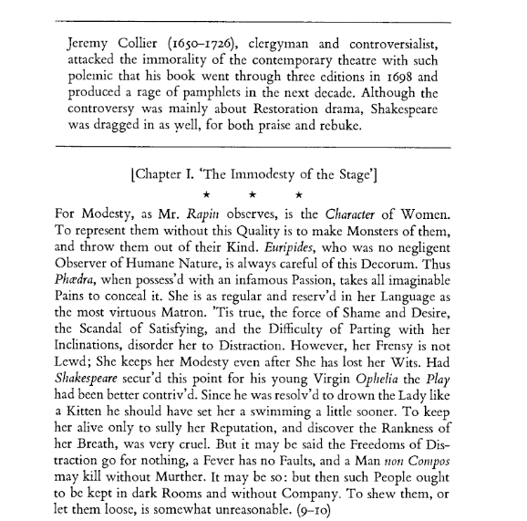to her chin… But to him a Tragedy in Burlesk, a merry Tragedy was no Monster, no absurdity, nor at all preposterous. [Such a dramatic mixture will, “delude our senses, disorder our thoughts, addle our brain, pervert our affections.”

***Jeremy Collier, A Short View of the Immorality, and Profaneness of the English Stage, 1698.***

**Post-Restoration performances: dominated by Betterton**

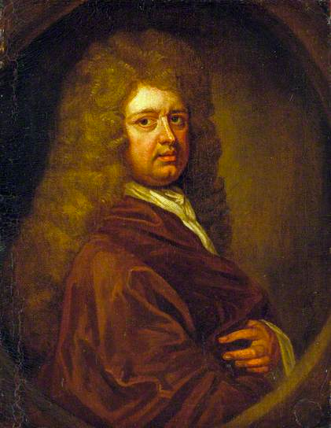

**Royal Shakespeare Company website:** "Thomas Betterton was in his mid twenties when he first played Hamlet in 1661 and he held on to the role for the next half-century. According to contemporary accounts, he continued to persuade audiences that he was a 'young man of great expectation, vivacity and enterprise' even when he was well into his seventies."

**Diary of Samuel Pepys, Saturday 24 August 1661**: "Home and there met Capt. Isham inquiring for me to take his leave of me, he being upon his voyage to Portugal, and for my letters to my Lord which are not ready. But I took him to the Mitre and gave him a glass of sack, and so adieu, and then straight to the Opera, and there saw “Hamlet, Prince of Denmark,” done with scenes very well, but above all, Betterton did the prince’s part beyond imagination."

**Thomas Betterton as Hamlet and Elizabeth Barry as Gertrude in Nicholas Rowe's 1709 edition of 'Hamlet'.**

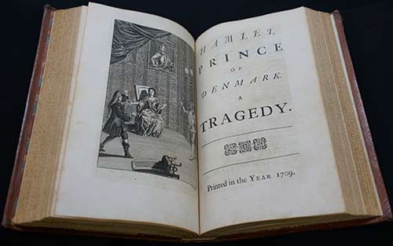

**Romantic Hamlet: Man of Thought in a World of Action**

**At the beginning of the nineteenth-century, Hamlet made a great leap towards becoming the Hamlet we expect to see on stage in 2022 - a physically and metaphorically slender man tragically aware of philosophy and thought in a world of violence and brutality, and thus unable to take action. This is sometimes called the "weakness of will theory" or the Schlegel-Coleridge theory (mostly by people who are trying to sound clever).**

**Samuel Taylor Coleridge, Lectures on Shakespeare, 1811-1819:**

The seeming inconsistencies in the conduct and character of Hamlet have long exercised the conjectural ingenuity of critics ; and, as we are always loth to suppose that "the cause of defective apprehension is in ourselves, the mystery has been too commonly explained by the very easy process of setting it down as in fact inexplicable, and by resolving the phenomenon into a misgrowth or lusus of the capricious and irregular genius of Shakespeare. The shallow and stupid arrogance of these vulgar and indolent decisions I would fain do my best to expose. I believe the character of Hamlet may be traced to Shakespeare' s deep and accurate science in mental philosophy. Indeed, that this character must have some connection with the common fundamental laws of our nature may be assumed from the fact, that Hamlet has been the darling of every country in which the literature of England has been fostered. In order to understand him, it is essential that we should reflect on the constitution of our own minds. Man is distinguished from the brute animals in proportion as thought prevails over sense: but in the healthy processes of the mind, a balance is constantly maintained between the impressions from outward objects and the inward operations of the intellect; — for if there be an overbalance in the contemplative faculty, man thereby becomes the creature of mere meditation, and loses his natural power of action. Now one of Shakespeare' s modes of creating characters is, to conceive any one intellectual or moral faculty in morbid excess, and then to place himself, Shakespeare, thus mutilated or diseased, under given circumstances. In Hamlet he seems to have wished to exemplify the moral necessity of a due balance between our attention to the objects of our senses, and our meditation on the workings of our minds, — an equilibrium between the real and the imaginary worlds. In Hamlet this balance is disturbed : his thoughts, and the images of his fancy, are far more vivid than his actual perceptions, and his very perceptions, instantly passing through the medium of his contemplations, acquire, as they pass, a form and a colour not naturally their own. Hence we see a great, an almost enormous, intellectual activity, and a proportionate aversion to real action, consequent upon it, with all its symptoms and accompanying qualities. This character Shakespeare places in circumstances, under which it is obliged to act on the spur of the moment: — Hamlet is brave and careless of death ; but he vacillates from sensibility, and procrastinates from thought, and loses the power of action in the energy of resolve. Thus it is that this tragedy presents a direct contrast to that of Macbeth; the one proceeds with the utmost slowness, the other with a crowded and breathless rapidity. 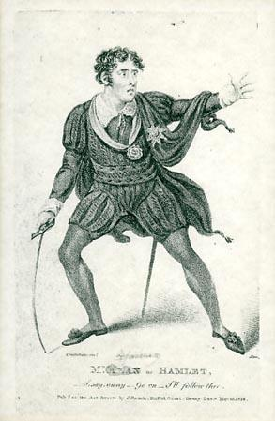

The effect of this overbalance of the imaginative power is beautifully illustrated in the everlasting broodings and superfluous activities of Hamlet's mind, which, unseated from its healthy relation, is constantly occupied with the world within, and abstracted from the world without, -- giving substance to shadows, and throwing a mist over all common-place actualities. It is the nature of thought to be

indefinite; — definiteness belongs to external imagery alone. Hence it is that the sense of sublimity arises, not from the sight of an outward object, but from the beholder's reflection upon it; — not from the sensuous impression, but from the imaginative reflex. Few have seen a celebrated waterfall without feeling something akin to disappointment: it is only subsequently that the image comes back full into the mind, and brings with it a train of grand or beautiful associations. Hamlet feels this; his senses are in a state of trance, and he looks upon external things as hieroglyphics. His soliloquy —

O ! that this too too solid flesh would melt, &c.

springs from that craving after the indefinite — for that which is not — which most easily besets men of genius; and the self-delusion common to this temper of mind is finely exemplified in the character which Hamlet gives of himself : —

— It cannot be

But I am pigeon-livered, and lack gall

To make oppression bitter.

He mistakes the seeing his chains for the breaking them, delays action till action is of no use, and dies the victim of mere circumstance and accident.

**William Hazlitt, Characters of Shakespeare's Plays, 1817. The opposite of douchebag Hamlet**

This is that Hamlet the Dane, whom we read of in our youth, and whom we seem almost to remember in our after-years; he who made that famous soliloquy on life, who gave the advice to the players, who thought ‘this goodly frame, the earth, a sterile promontory, and this brave o’er-hanging firmament, the air, this majestical roof fretted with golden fire, a foul and pestilent congregation of vapours’; whom ‘man delighted not, nor woman neither’; he who talked with the grave-diggers, and moralized on Yorick’s skull; the schoolfellow of Rosencrantz and Guildenstern at Wittenberg; the friend of Horatio; the lover of Ophelia; he that was mad and sent to England; the slow avenger of his father’s death; who lived at the court of Horwendillus five hundred years before we were born, but all whose thoughts we seem to know as well as we do our own, because we have read them in Shakespeare.

Hamlet is a name: his speeches and sayings but the idle coinage of the poet’s brain. What then, are they not real? They are as real as our own thoughts. Their reality is in the reader’s mind. It is WE who are Hamlet. This play has a prophetic truth, which is above that of history. Whoever has become thoughtful and melancholy through his own mishaps or those of others; whoever has borne about with him the clouded brow of reflection, and thought himself ‘too much i’ th’ sun’; whoever has seen the golden lamp of day dimmed by envious mists rising in his own breast, and could find in the world before him only a dull blank with nothing left remarkable in it; whoever has known “the pangs of despised love, the insolence of office, or the spurns which patient merit of the unworthy takes”; he who has felt his mind sink within him, and sadness cling to his heart like a malady, who has had his hopes blighted and his youth staggered by the apparitions of strange things; who cannot be well at ease, while he sees evil hovering near him like a spectre; whose powers of action have been eaten up by thought, he to whom the universe seems infinite, and himself nothing; whose bitterness of soul makes him careless of consequences, and who goes to a play as his best resource to shove off, to a second remove, the evils of life by a mock-presentation of them—this is the true Hamlet.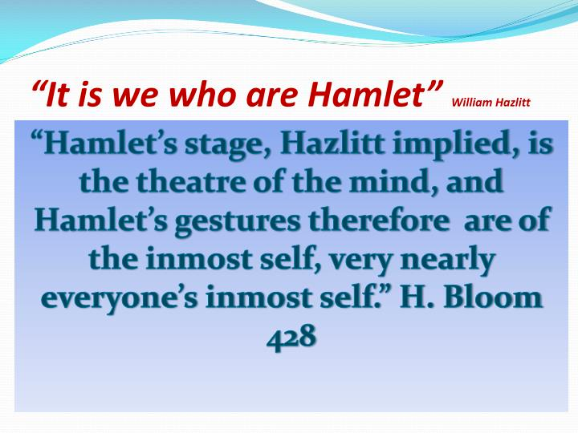

We have been so used to this tragedy that we hardly know how to criticize it any more than we should know how to describe our own faces. But we must make such observations as we can. It is the one of Shakespeare’s plays that we think of oftenest, because it abounds most in striking reflections on human life, and because the distresses of Hamlet are transferred, by the turn of his mind, to the general account of humanity. Whatever happens to him, we apply to ourselves, because he applies it so himself as a means of general reasoning. He is a great moralizer; and what makes him worth attending to is, that he moralizes on his own feelings and experience. He is not a commonplace pedant. If Lear shows the greatest depth of passion, Hamlet is the most remarkable for the ingenuity, originality, and unstudied development of character. Shakespeare had more magnanimity than any other poet, and he has shown more of it in this play than in any other. There is no attempt to force an interest: everything is left for time and circumstances to unfold. The attention is excited without effort, the incidents succeed each other as matters of course, the characters think and speak and act just as they might do, if left entirely to themselves. There is no set purpose, no straining at a point. The observations are suggested by the passing scene—the gusts of passion come and go like sounds of music borne on the wind. The whole play is an exact transcript of what might be supposed to have taken place at the court of Denmark, at the remote period of time fixed upon, before the modern refinements in morals and manners were heard of. It would have been interesting enough to have been admitted as a bystander in such a scene, at such a time, to have heard and seen something of what was going on. But here we are more than spectators. We have not only ‘the outward pageants and the signs of grief; but ‘we have that within which passes show’. We read the thoughts of the heart, we catch the passions living as they rise. Other dramatic writers give us very fine versions and paraphrases of nature: but Shakespeare, together with his own comments, gives us the original text, that we may judge for ourselves. This is a very great advantage.

The character of Hamlet is itself a pure effusion of genius. It is not a character marked by strength of will or even of passion, but by refinement of thought and sentiment. Hamlet is as little of the hero as a man can well be: but he is a young and princely novice, full of high enthusiasm and quick sensibility—the sport of circumstances, questioning with fortune and refining on his own feelings, and forced from the natural bias of his disposition by the strangeness of his situation. He seems incapable of deliberate action, and is only hurried into extremities on the spur of the occasion, when he has no time to reflect, as in the scene where he kills Polonius, and again, where he alters the letters which Rosencraus and Guildenstern are taking with them to England, purporting his death. At other times, when he is most bound to act, he remains puzzled, undecided, and sceptical, dallies with his purposes, till the occasion is lost, and always finds some pretence to relapse into indolence and thoughtfulness again. For this reason he refuses to kill the King when he is at his prayers, and by a refinement in malice, which is in truth only an excuse for his own want of resolution, defers his revenge to some more fatal opportunity, when he shall be engaged in some act ‘that has no relish of salvation in it’:

He kneels and prays,

And now I’ll do’t, and so he goes to heaven,

And so am I reveng’d; that would be scann’d.

He kill’d my father, and for that,

I, his sole son, send him to heaven.

Why this is reward, not revenge.

Up sword and know thou a more horrid time,

When he is drunk, asleep, or in a rage.

He is the prince of philosophical speculators, and because he cannot have his revenge perfect, according to the most refined idea his wish can form, he misses it altogether. So he scruples to trust the suggestions of the Ghost, contrives the scene of the play to have surer proof of his uncle’s guilt, and then rests satisfied with this confirmation of his suspicions, and the success of his experiment, instead of acting upon it. Yet he is sensible of his own weakness, taxes himself with it, and tries to reason himself out of it.

1. Indifferent = mediocre. Meane = rough, vulgar
2. Majesty = Charles II, who had been in exile in France – and thus surrounded by French theatre – until 1660.