**Act 4, scenes 5-7 – Ophelia and Laertes**

**Key Points:**

* Ophelia’s madness and the treatment of it (4.5)
* Laertes as the third avenger of the play in 4.5, 4.6, 4.7
* Gender roles

**Consider these ‘ideas’ about women… why might people have believed/ believe them?**

1. Women, by nature, are sexually deviant – they need to be controlled by men. If their sexual desires are allowed to run free, they will go mad.
2. Women are mutilated men who have to live with the deformity of not having a penis (!)
3. Female madness is a result of a disturbance of the womb.
4. A diagnosis of ‘moral insanity’ was common for women in the Victorian era and included being loud or sexually promiscuous; women outnumbered men two to one in asylums, leading doctors to believe that women were more vulnerable to insanity than women.

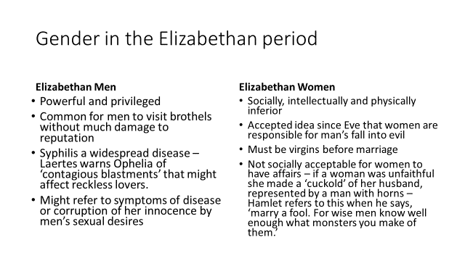

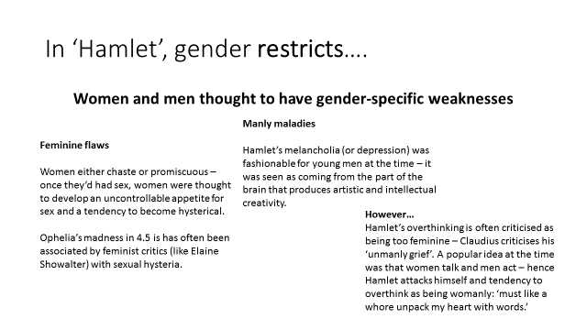

***Hysteria*,** more commonly observed in women than in men, was once supposed to be an exclusively feminine disorder and was blamed on a disturbance of the womb.

This belief is reflected in the Greek *hysterikos*, meaning 'hysterica' or 'of the womb' (from *hysteria*, 'womb'), a standard term for the womb, and *rising of the mother*, *fits of the mother*, and even simply *mother* were hysterical fits brought on by disturbance of the womb.

**Stage directions – Ophelia – what is their symbolism?**

First quarto:

‘Enter Ophelia, playing on a lute, and her hair down singing.’

Second quarto:

‘Enter Ophelia, distracted.’

**‘Reason in madness’?**

Before this point, Ophelia says little, able to play the role of the obedient daughter with skill…it’s ironic that when she goes mad, Shakespeare gives her a voice and freedom she once lacked…

**Question:** What might be the sense or truth of Ophelia’s madness? Select at least two of her lines that suggest some truth – either about the situation or her true self…

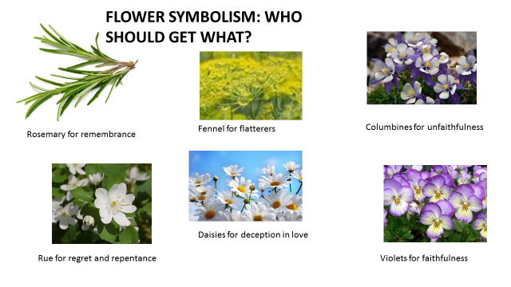

**LAERTES AS ANOTHER REVENGER**

‘That drop of blood that’s calm proclaims me bastard’ (4.5,118)

‘I’ll not be juggled with./ To hell allegiance, vows to the blackest devil,/ Conscience and grace to the profoundest pit.’ (4.5, 129-131)

‘By heaven, thy madness shall be paid with weight’ (4.5, 155)

‘And so I have a noble father lost,/ A sister driven to desperate terms’ (4.7, 26-27)

**DISCUSSION QUESTIONS:**

Which of these lines best conveys Laertes’ reasons for and desire for revenge?

Is Laertes a more powerful avenger than Hamlet/Fortinbras? Why? Why not?

**Ophelia’s Drowning**

* ‘Of all the characters in *Hamlet*, Ophelia is the most persistently presented in terms of symbolic meanings.’ (**Bridget Lyons**)
* ‘Ophelia’s symbolic meanings, moreover are specifically feminine. Whereas for Hamlet, madness is metaphysical, linked with culture, for Ophelia, it is a product of the female body and female nature…On the Elizabethan stage, the conventions of female insanity were sharply defined. Ophelia dresses herself in white, decks herself with ‘fantastical garlands’ of wild flowers…her speeches are marked by extravagant metaphors, lyrical free associations and explosive sexual imagery.’ (**Elaine Showalter**)
* Drowning was associated with the feminine – female fluidity rather than masculine aridity – **Gaston Bachelard** traced the connections between women, water and death, suggesting drowning is the truly ‘feminine death’ in literature. Females immersed in water suggest a return to the organic symbol of liquid woman; her body consists of blood, amniotic fluid and milk.

**\*\*\*LOOK AT THE IMAGES USED BY GERTRUDE IN THE SPEECH WHICH DESCRIBES THE DROWING AND CONSIDER THEIR SYMBOLIC VALUE.**

PREP – Read Elaine Showalter’s article on Ophelia <http://www.houseofideas.com/mscornelius/resources/hamlet/hamlet_vol_59__elaine_showalter_essay_date_1985_276850-.pdf>

1. What does Showalter suggest Lacan’s view of Ophelia involves?
2. How often does Ophelia appear in the text? What does this imply about her personal ‘story’?
3. How is Ophelia viewed by French Feminist theory?
4. How might Ophelia represent Hamlet’s effeminate side?
5. What role do visual illustrations of Ophelia have?
6. What, according to Lyons, is Ophelia’s ‘symbolic meaning’, encapsulated in her appearance and her suicide method?
7. What is erotomania?
8. What stage representations of Ophelia are discussed?

PREP – Read Elaine Showalter’s article on Ophelia <http://www.houseofideas.com/mscornelius/resources/hamlet/hamlet_vol_59__elaine_showalter_essay_date_1985_276850-.pdf>

1. What does Showalter suggest Lacan’s view of Ophelia involves?
2. How often does Ophelia appear in the text? What does this imply about her personal ‘story’?
3. How is Ophelia viewed by French Feminist theory?
4. How might Ophelia represent Hamlet’s effeminate side?
5. What role do visual illustrations of Ophelia have?
6. What, according to Lyons, is Ophelia’s ‘symbolic meaning’, encapsulated in her appearance and her suicide method?
7. What is erotomania?
8. What stage representations of Ophelia are discussed?

PREP – Read Elaine Showalter’s article on Ophelia <http://www.houseofideas.com/mscornelius/resources/hamlet/hamlet_vol_59__elaine_showalter_essay_date_1985_276850-.pdf>

1. What does Showalter suggest Lacan’s view of Ophelia involves?
2. How often does Ophelia appear in the text? What does this imply about her personal ‘story’?
3. How is Ophelia viewed by French Feminist theory?
4. How might Ophelia represent Hamlet’s effeminate side?
5. What role do visual illustrations of Ophelia have?
6. What, according to Lyons, is Ophelia’s ‘symbolic meaning’, encapsulated in her appearance and her suicide method?
7. What is erotomania?
8. What stage representations of Ophelia are discussed?