Mrs Jones

I used to think that playing rugby was the best decision I ever made. My England A, Students and North of England caps hang proudly on the wall as treasured memories of lifelong friendships, travel, achievements and the exhilaration of playing such a wonderful game to the best of my ability.

Before playing rugby, I was a competitive swimmer and represented my school in many sports, reaching the National Finals in swimming, lacrosse & discus.

I still play rugby and hockey today, but I can now say that coaching rugby is the best decision I have ever made. Helping others on their sporting journey and working to bring out the best in all teams and individuals I work with is an absolute pleasure. Away from school, I coach Cheshire Women U15, Wirral Women & Wirral U13’s.

Lockdown has presented the opportunity to expand my knowledge and expertise as a sports coach. Finding ways to engage and motivate athletes remotely has been a challenge. It has been fascinating to see how ‘gameifictaion’ and social media support participation and engagement. I cannot wait to get back on the field, and I will keep using these skills, so please don’t worry if I mention somebody “doing a streak”!

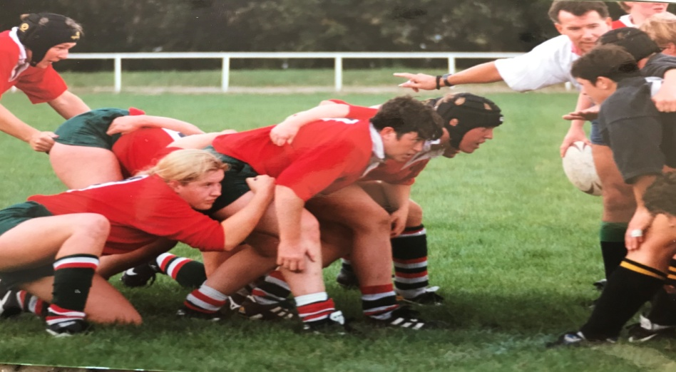

Hooker for Waterloo. This was a memorable cup win against Wasps in 2000

North of England Legends 2016.

