ESSAY QUESTION – ASSESSMENT

Remind yourself of the passage Young and dyslexic? You’ve got it going on, by Benjamin Zephaniah.
How does the writer use language and structure to show his readers the challenges and triumphs of having dyslexia?

Marking criteria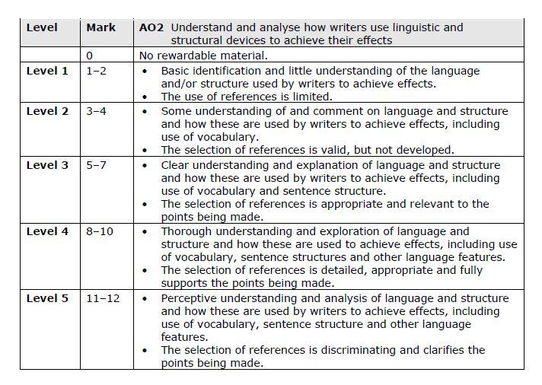

This means you must:
- Answer the question, discussing both the challenges and triumphs.
- Fully evaluate the writer’s language/structural techniques and how these effect the reader.
- Choose the best quotes to use, and link them to your argument.

Vocabulary building:
- Perceptive?
- Discriminating?
- Clarifying?
- Detailed?
- Analyse?

ESSAY PLANNING

My overall opinion about this text?

In the table below, address the question by listing the challenges/triumphs outlined, and the language devices which best demonstrate these! At least one device per challenge/triumph

Challenges | Triumphs

Now, how can we group these challenges and triumphs? What do they have in common?

