The siege of Sarajevo (1992-1996)

The city of Sarajevo

Sarajevo was the capital of the state of Bosnia-Herzegovina, which was one of the six states that made up the country of Yugoslavia. It was a large, modern city, comparable in size to Manchester, Edinburgh or Liverpool. It had a university, theatres, hotels, office blocks, a parliament building and a tram network. In 1984, it had hosted the Winter Olympics. It had its own airport.

Sarajevo was home to around half a million people at the start of the Bosnian War. About 50% were Bosniaks (Bosnian Muslims), with Serbs and Croats making up most of the other 50%. Marriages between people of these different ethnic groups were quite common. The official language was Serbo-Croatian, although the three main ethnic groups also had their own dialects.

Where in the poem has the poet reflected these features of the population?

The Bosnian war (1992-1995)

Bosnia-Herzegovina declared its independence from Yugoslavia in 1992. Bosnian Serbs, and Serbs from other areas of Yugoslavia, were unhappy with the way Yugoslavia was being broken up. They wanted to form a new Serbian Republic, which would include regions and cities that at the time were part of the newly-independent Bosnia. This led directly to the Bosnian War as the two sides fought for control.

In order to capture the city of Sarajevo, Serb soldiers put their tanks and artillery in the surrounding hills. They cut off the water and electricity, took control of the roads to block supplies of food, medicines and fuel and started to bomb it. Sarajevo was under siege.

Find evidence in the poem of how people's lives were affected by having

- no running water in their homes
- no electricity
- no petrol or heating oil
- very little food available.

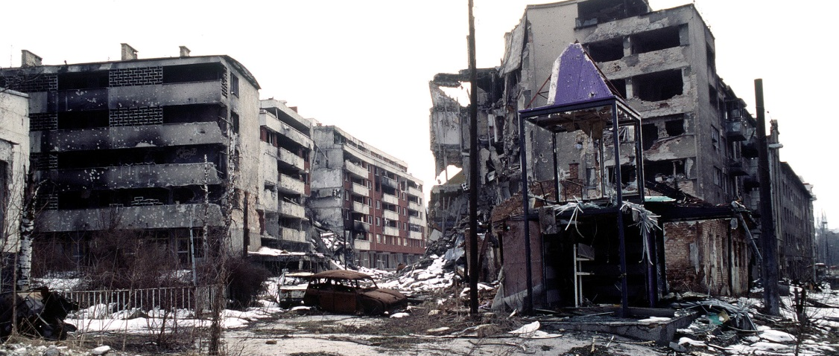
A city under siege

Within the city there were some soldiers of the Bosnian army, as well Serb soldiers who had been inside at the start of the siege. They fought each other for control of different areas, and each side had snipers in the taller buildings along two major roads. These snipers fired at civilians as well as at enemy soldiers.

Where has the poet mentioned how this affects the people in the city?

On average, Sarajevo suffered hits from 330 bombs and rockets every day. On the worst single day 3,777 shells hit the city. Much of the shelling was random. Civilian neighbourhoods as well as military targets were hit. Hospitals, shops, a market, houses and apartments, a football match - nowhere was safe.

In stanza 2, what civilian target is described as being hit?

Food and fuel (for heating and cooking) was scarce. There were few sources of running water, and no mains electricity, only generators. The people of Sarajevo relied on humanitarian aid such as food and medicine distributed by the Red Cross or air-dropped by United Nations planes. A little fuel was allowed or smuggled in.

What details has the poet included that show people lacked

- petrol for cars
- electric lights
- water supplies in their homes?

What item of aid does Tony Harrison refer to in the final stanza of the poem?

The death toll

The siege lasted almost four years, from 5 April 1992 to 29 February 1996.

Approximately 10,000 people were killed or otherwise died from cold or starvation during the siege. Some 56,000 people were wounded.

Use your notes and quotations to do one of the three tasks below.
Write a short essay explaining how the poet has incorporated historical facts in his poem. | Make a spider diagram of key features of the siege, and add a quotation that illustrates each fact. | Annotate your copy of the poem with the relevant background facts.

