2022JANR Explorer’s Daughter vs Rhino Mark Scheme and Exemplars
1 Accept any of the following, up to a maximum of two marks: • ‘(grass) cracks’ (1) • ‘(grass) swishes’ (1) • ‘(my) chest vibrates’ (1) • ‘rumble / of heavy feet moving fast’ (1) • ‘“Quickly, quickly!” / Hemanta / whispers’ (1) (2)
2 Accept any reasonable explanation of what we learn about the people and animals of Nepal’s Chitwan National Park, in own words where possible, up to a maximum of four marks. For example: • Hemanta has been a guide in the park for many years • walking in the park can be dangerous • 14 villagers lost their lives after being attacked by animals in the park in 2017 • an elephant, which they called Ronaldo, has killed 15 local people • the local people do not seek revenge on the animals who kill, so Ronaldo has not been shot - this would probably have happened elsewhere • Ronaldo recently destroyed part of a hotel • the local people’s attitude towards the damage and death caused by the animals is very tolerant, perhaps because they believe in the natural cycle of life • the guides in the park do not carry guns and only have bamboo sticks to ward off the animals • there is a sign in the park warning people not to scare the animals Reward all valid points. (4)
3. Accept any reasonable explanation of what we learn about the people and animals of Nepal’s Chitwan National Park, in own words where possible, up to a maximum of four marks. For example: • Hemanta has been a guide in the park for many years • walking in the park can be dangerous • 14 villagers lost their lives after being attacked by animals in the park in 2017 • an elephant, which they called Ronaldo, has killed 15 local people • the local people do not seek revenge on the animals who kill, so Ronaldo has not been shot - this would probably have happened elsewhere • Ronaldo recently destroyed part of a hotel • the local people’s attitude towards the damage and death caused by the animals is very tolerant, perhaps because they believe in the natural cycle of life • the guides in the park do not carry guns and only have bamboo sticks to ward off the animals • there is a sign in the park warning people not to scare the animals Reward all valid points. (4)
4. Exemplar response (it is not expected that yours is this long!):
The passage begins as a narrative recount, drawing the readers into the story. As a build-up to the hunt, time markers are used to show how the watchers are waiting and observing the approach of the narwhal pods: ‘Two hours after’, ‘Within an hour’. The poetic description of the narwhal spray ‘catching the light in a spectral play of colour’ adds a mystical quality to the description, with the adjective ‘spectral’ making it sound ghostly. The adverbs used to describe the narwhal moving ‘slowly, methodically’ create a sense of anticipation, and the contrast with the manner in which the writer is ‘Scrambling back’ highlights her excitement; the writer’s ‘sharp intake of breath’ indicates her sense of anticipation as to what may happen. The utter stillness of the scene, and the fact that the hunters appeared close enough to touch the narwhal but ‘never moved’, add to a sense of tension. The visual imagery with its references to light in ‘glittering kingdom’ and ‘The evening light was turning butter-gold’ show how the writer was awed and overwhelmed by the beauty of the landscape. There is a dreamlike quality to the description reinforced by the metaphor of the ‘kingdom’.
The writer muses on whether the narwhal might be ‘mischievous tricks of the shifting light’, which gives them an ethereal quality. The juxtaposition of the nouns ‘man and whale’ leads the reader to anticipate a confrontation of epic proportions. The use of the plural pronoun in ‘we sat at the lookout’ shows how the writer feels connected to the other women who are watching; the fact that they need binoculars shows how they are too distant to do anything but watch as events unfold. The atmosphere of suspense is lifted in the third paragraph where the writer moves away from describing the build-up to the hunt and adopts a very factual tone; the present tense is used to expound on how the Inughuit benefit from the narwhal. The use of the adjective ‘essential’ to explain how the narwhal is necessary for ‘the survival of the hunters’ highlights the importance of the hunt to the community; this is reinforced further on in the passage with the adjectives ‘crucial’, ‘staple’ and ‘much-needed’, leading the reader to consider what the consequences of a failed hunt might be. The writer returns to the hunt in the fourth paragraph, starting with a long complex sentence that moves from all the women to ‘each woman focusing on her husband’; in this way the intensity of the experience for each individual is expressed. The fact that the women are described as ‘occasionally spinning round at a small gasp or jump’ shows how on edge they are and conveys the taut atmosphere. The connection between each wife and her husband, whom she watches ‘intently’, stresses the significance of the hunt to every family. The use of the analogy ‘it was like watching a vast, waterborne game’ allows the reader to link to their own (possibly tense) experiences of spectating a sport.
The danger that each man faces is emphasised through the fact that he is ‘so brave’ and in a ‘flimsy’ kayak ‘miles from land’. The information that he has ‘only one harpoon’, that the narwhal are ‘huge’ and that the exercise is ‘foolhardy’ (as he ‘could easily be capsized and drowned’) conveys a sense of vulnerability. The silence and lack of movement as ‘the hunters had to sit so very still’ because of the narwhal’s acute hearing, and then the manner in which the hunter ‘gently picked up his harpoon and aimed’, leave the writer and the reader holding their breath. The way in which the writer says how ‘in that split second my heart leapt for both hunter and narwhal’ shows her intense physical reaction to what she witnesses. The use of longer, multi-clause sentences in the penultimate paragraph conveys the mounting tension of the scene. The use of the tricolon of infinitive verbs urging the narwhal ‘to dive, to leave, to survive’, with its rhythm and rhyme, engages the reader in the writer’s powerful and conflicted feelings about the hunt and we want to know what the outcome will be. The final paragraph returns to a calmer tone and the impersonal statement ‘one cannot afford to be sentimental in the Arctic’ contrasts with the immediacy and pace of the previous paragraph.
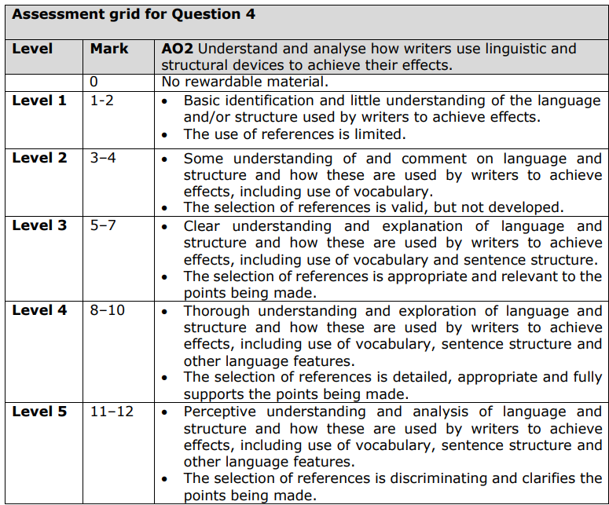
5. Exemplar 22 Marker:
Both texts are written in the first person and describe the writers’ experiences of observing wild animals in their natural habitat. In both texts, the animals studied are very large and the writers provide some mention of measurement to help us imagine the size: in Text One we are told that the rhino has a ‘vast head’, ‘weighs more than a jeep’ and is ‘over 6ft’, and in Text Two the narwhal are ‘huge’ and their single tusks ‘can grow up to six feet in length’.
Both the animals are shown to have heightened senses: in Text One the rhino ‘sniffs hard…tasting the scent of us’, and in Text Two the narwhal’s ‘hearing is particularly developed’. Both writers make reference to distance: in Text One the rhino is ‘only 50 metres away’ and in Text Two, although the narwhal appear ‘very close’, the hunt is in fact ‘miles from land’ and the wives watch though binoculars. Both writers create a sense of danger: in Text One we are told that ‘‘‘a startled rhino will charge’’’ and that ‘Fourteen villagers were killed by wild animals in 2017’; in Text Two the hunters ‘could easily be capsized and drowned’.
In both texts, the humans seem ill-equipped against the might of the animals and forms of the same adjective are used to portray vulnerability: in Text One their only protection is ‘bamboo hiking sticks’ which ‘look flimsier than they did before’, and in Text Two the hunter is in a ‘flimsy kayak’. Both writers build up to the moment of encounter. Both writers create moments of tension. In Text One the writer uses a very short sentence ‘This time’ to show how they have had a narrow escape as the rhino has ‘bolted in the other direction’, and the inclusion of Hemanta’s whispered ‘‘‘Quickly, quickly!’’’ with its repetition and exclamation mark gives a sense of urgency; in Text Two there are many examples.
Both texts include facts: in Text One the writer gives information about the numbers of rhinos on the planet and in Nepal, and in Text Two the writer tells the reader about the ways in which the Inughuit make use of the different parts of the narwhal. In both texts, man goes into the habitat of the animals: in Text One the writer says how he has never been ‘so conscious of being an outsider in the domain of another’, but in Text Two there is no sense that the hunters feel out of place. Both writers show how at times they have a physical reaction to events: in Text One the writer states that ‘Heartbeats fill my head’ as he thinks the rhino may be close; in Text Two the writer tells us that her ‘heart leapt for both hunter and narwhal’.
Text Two describes the landscape in poetic terms, e.g. ‘glittering kingdom’, and sets a stunning scene for the hunt; in Text One the description is briefer and we are just told that the action takes place on ‘a trail through a forest, a passage hemmed in by straight-trunked sal trees’. In Text Two the atmosphere seems always to be one of stillness and silence. In Text One, however, whilst Hemanta ‘raises a hand for silence’ and ‘whispers’, we learn of a range of sounds in the park, e.g. onomatopoeia is used to describe the sound of the grass, which ‘cracks and swishes’; ‘there’s a thrashing in the branches’; ‘a jungle fowl crows like a cockerel’; ‘crows start to caw’ and ‘a fish eagle cackles’.
Text One includes dialogue and names other people involved in the scene, but in Text Two there is no direct interaction with any of the other people. In Text One, the writer simply hopes to see a rhinoceros whereas in Text Two the writer is witnessing a hunt. In Text One the animals pose a threat to humans and cause ‘grief and destruction’, but in Text Two it is the humans who attack the narwhal. Text Two is serious and reflective in tone, whereas Text One has moments that seem light-hearted, e.g. the writer’s response, ‘Fat chance’, to the sign warning people not to frighten the animals and the description of the four men trying to hide from the rhino ‘like cartoon burglars behind a lamppost’.
In Text One the men do not have very effective weapons, as ‘Guides carry sticks, not guns’, whereas in Text Two, although the hunter ‘had no rifle’, he had ‘one harpoon with two heads’. In Text One it is made clear that ‘Chitwan was declared a national park in 1970 specifically to conserve’ the single-horned rhinos, but in Text Two the writer emphasises how the Inughuits’ survival depends on hunting narwhal. In Text Two the focus is entirely on the narwhal, but in Text One a number of other animals such as various birds, monkeys, elephants and deer are mentioned. In Text Two the writer explains her ‘dilemma’ about the hunt, but in Text One the writer faces no such conflict. Text Two has a clear conclusion with the main message of the piece that ‘Hunting is still an absolute necessity in Thule’, whereas Text One ends on a moment of suspense with Hemanta declaring ‘‘‘Tiger!’’’. 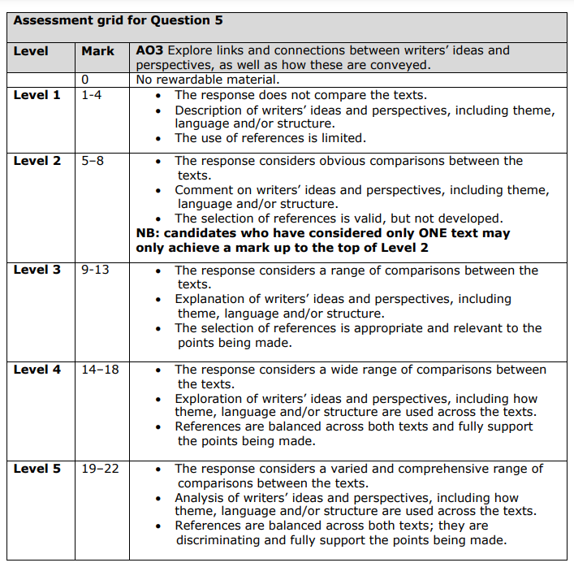
6. Speech exemplar (not perfect – use to critique!)
Ladies and gentlemen, esteemed guests, and fellow animal lovers,
What truly defines the finest quality a person can possess? Is it their intelligence, their strength, or their wealth? While these attributes undoubtedly hold merit, I stand before you today to argue that the most admirable quality a person can possess is a deep and unwavering love for all living creatures.
Think about it for a moment. What does it say about a person who extends their compassion not only to their fellow human beings but also to the animals that share our planet? It speaks volumes about their empathy, their kindness, and their capacity for love.
Consider the story of Jane Goodall, whose lifelong dedication to studying and protecting chimpanzees has inspired millions around the world. Her boundless love for these creatures has not only advanced our understanding of primates but has also raised awareness about the importance of conservation and animal welfare.
Or take Mahatma Gandhi, whose philosophy of nonviolence extended not only to humans but to all living beings. He once said, "The greatness of a nation and its moral progress can be judged by the way its animals are treated." These words resonate deeply with me, as they highlight the interconnectedness of all life on Earth and the responsibility we have to protect and cherish it.
But it's not just famous figures who embody this quality. Every day, ordinary people perform acts of kindness and compassion towards animals, whether it's rescuing a stray cat, volunteering at an animal shelter, or simply showing kindness to the creatures they encounter in their daily lives.
And let's not forget the countless benefits that come from loving and caring for animals. Studies have shown that pet ownership can reduce stress, lower blood pressure, and improve overall well-being. Animals have a unique ability to bring joy and comfort into our lives, and by loving them, we in turn enrich our own.
So, I ask you, what could be more admirable than a love for all living creatures? In a world that often feels divided and fractured, this quality serves as a powerful reminder of our shared humanity and our interconnectedness with the natural world. Let us strive to cultivate this love within ourselves and spread it to every corner of the globe, for the benefit of all beings.
Thank you.

7. Article exemplar (ditto):
Taking a Risk: Navigating the Fine Line Between Opportunity and Peril
In the pursuit of success and fulfilment, one often encounters the age-old adage: "If you never take a risk, then you will never know what you might achieve." Yet, juxtaposed against this sentiment is the cautionary idea that "taking risks is dangerous and should be discouraged." So where does the truth lie? Is risk-taking a courageous leap towards greatness, or a reckless gamble with dire consequences? Let's explore this dichotomy further.
When Taking a Risk Might Be Advisable
There are moments in life when taking a risk can lead to remarkable rewards. Consider the entrepreneur who gambles their savings to start a business venture. While the path is fraught with uncertainty, the potential payoff – financial independence, creative fulfilment, and societal impact – outweighs the fear of failure. Similarly, in the realm of personal growth, stepping outside one's comfort zone and taking calculated risks can lead to profound self-discovery and development. Whether it's pursuing a passion, embarking on a new career path, or pursuing a dream, risk-taking can be the catalyst for transformative change.
Moreover, in the dynamic landscape of innovation and progress, risk-taking is often synonymous with advancement. History is replete with examples of visionaries who dared to challenge the status quo and revolutionise their fields. From Thomas Edison's relentless experimentation to Steve Jobs' bold vision for Apple, these pioneers embraced risk as an integral part of the journey towards innovation and success. In today's rapidly evolving world, those who dare to push the boundaries and take calculated risks are often the ones who shape the future.
Occasions When Taking a Risk Would Be Inadvisable
However, it would be remiss to overlook the inherent dangers of reckless risk-taking. While venturing into the unknown can yield rewards, it can also lead to catastrophic consequences if not approached with caution and prudence. For instance, financial speculation without proper research and planning can result in devastating losses. Similarly, engaging in risky behaviours such as substance abuse or dangerous stunts can have severe and irreversible consequences for one's health and well-being.
Moreover, in certain situations, the potential costs of failure outweigh the potential benefits of success. For example, in matters of personal safety or ethical integrity, taking unnecessary risks can jeopardize not only one's own well-being but also that of others. Whether it's driving recklessly, ignoring safety protocols, or engaging in illegal activities, the consequences of irresponsible risk-taking can have far-reaching and irreparable repercussions.
Navigating the Fine Line
In conclusion, the decision to take a risk is a nuanced and multifaceted one. While risk-taking can open doors to new opportunities and propel us towards our goals, it also carries inherent dangers that must be carefully weighed and considered. As individuals, it is our responsibility to navigate this fine line with wisdom, discernment, and integrity. By embracing calculated risks that align with our values and aspirations, while exercising caution and prudence, we can harness the transformative power of risk-taking while minimizing its potential pitfalls. So, dare to dream, dare to innovate, but above all, dare to take risks wisely.

